ECE 370
MACHINES & POWER

LAB 3
TESTING OF A TWO-WINDING POWER
TRANSFORMER

Objective
The objectives of this laboratory experiment are summarized below:
- Perform tests and obtain the equivalent circuit model of a single-phase
two-winding transformer
- Measure the efficiency and voltage regulation of a single-phase two-winding
transformer and compare it with the predicted values from the model
- Gain an understanding of the usefulness of modeling a single-phase two-winding
transformer as an equivalent electrical circuit.

Pre - Lab
The Maple program that was developed in Lab 2 for a two-winding transformer should be available to you during this lab session. The Maple program provided transformer parameter values of Figure 1 based on one sample test results.

Figure 1. Exact Equivalent Circuit of a Single-Phase Two-Winding Transformer.

Procedure
Read the specification sheet for Model T-100-3A transformer of Figure 2, and pay attention to the ratings of this transformer. Document ratings (V, I, and S) of the transformer for configuration of Figure 3.

Proceed with the following steps:

- Use the 2.0 A fuse box between the voltage source and the transformer, as shown in Figure 4.

2. Connect the Yokogawa digital meter for measurement of the circuit voltage, current, and power. Connect Channel 1 of Yokogawa to the primary (marked H) of the transformer.

Figure 2. Model T-100-3A Transformer.
Figure 3. Configuration for Finding
Transformer Ratings.
- Wire the single-phase two-winding transformer according to Figure 4.

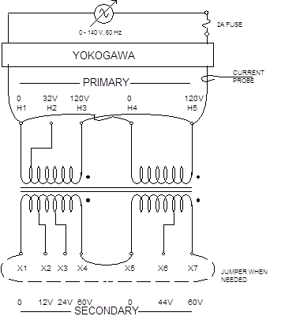

Figure 4. Transformer Connections for Step #3.
- Perform the open-circuit test by leaving the jumper (shown by dashed lines) out. With
the power supply set at 120 V (rms), and no load on the transformer, record the Yokogawa readings of the voltage, current, and active power.

5. Observe the input current wave shape on the oscilloscope with an source voltages of 90 V, 120 V, and 130 V. Use the CompactFlash Card to save these current traces, and then print them.

6. Perform the short-circuit test by turning the power supply down to zero volts, and placing the jumper between terminals X1 and X7. Be sure that your connection is correct. Slowly increase the supply voltage until the current display indicates 1.0 A (rated current). Record the Yokogawa readings of the voltage, current, and active power.

7. Measure the dc resistance of the primary and secondary windings with the Fluke multimeter. Note that the source, Yokogawa, and the jumper should be disconnected from the transformer for resistance measurements. Utilize the results of the open-circuit and short-circuit tests to obtain parameters of the transformer equivalent circuit with use of your computer program.

8. Perform the voltage regulation and efficiency measurements under various load conditions, as shown in Figure 5. Note that Channel 2 of Yokogawa should be connected to the secondary (Marked X) of the transformer. Maintain a voltage of 120 V on the secondary terminals of the transformer for all load conditions. Take readings for various load configurations, and do not exceed the rated current of 1.0 ampere. Take readings for three (3) unity power factor loads, three (3) lagging power factor loads that have some resistance R, and three (3) leading power factor loads that also have some resistance R. Plot the measured values on the computer generated graphs. Also, make a table and compare results by calculating % error.

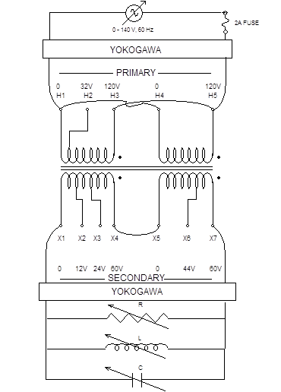

Figure 5. Transformer Connections for Step #8.

Documentation
Turn this instruction into a readable gray color and include in it the addition information that you collect during the lab in black color. Your documentation should be complete and clear. The computer-based calculations of the voltage regulation and efficiency are your analytical results. The laboratory measurement of the voltage regulation and efficiency are your experimental results. There will be a discrepancy between your analytical and experimental results. The discrepancies should be described and explained in the conclusion section of the report.

