ECE 370
MACHINES & POWER

LAB 1
FARADAY'S LAW & FERROMAGNETIC MATERIALS

Objective
The objectives of this laboratory experiment are summarized below:
1. Gain an understanding of the effects of electromagnetic fields as described by the
Faraday's Law
2. Gain an understanding of the dependency of mutual coupling between two coils on physical orientation, proximity, and the field strength
3. Gain an understanding of the effects of magnetic flux density on the ferromagnetic material saturation, hysteresis characteristic, and the energy dissipation
4. Observe the permeability of a saturated ferromagnetic material which is nearly
the same as the permeability of air.

Pre - Lab
From Faraday’s Law obtain the flux equation in a coil in terms of the applied voltage of v_{s}(t) = V_{M} cos(ωt) to the coil. Remember that magnetic flux is proportional to integral of the applied voltage.

Also, from the voltage current relationship of a coil (inductor) obtain the current equation in terms of the applied voltage to the coil and the inductance.

What is the relationship between the input current and the associated flux in a coil? Determine the phase angle between the input current and the produced flux.

Procedure
You will find the following in the cabinet under your bench:
1. Two coils made of a thin and a thick wire.
2. A permanent magnet rod.
3. A black box containing an integrator.
4. Iron strips.

To set the oscilloscope, current probe, and multimeters you should follow the procedure below:
1. Setting up the oscilloscope:
a. You need to set the oscilloscope to match the scale of your voltage probe.
To set the scale follow these steps:
1. Connect the voltage probe to Channels 1, 2, or 3.
2. Push the channel Menu button.
3. Push the Probe option button.
4. Push the Voltage option button.
5. Push the Attenuation option button and select 20X.

b. Current probe provides a voltage signal proportional to the current. You need to
set the oscilloscope to match the scale of your current probe. To set the scale
follow these steps:
- Connect the current probe to Channel 4, and set the range
switch on the probe to 100mV/A.
2. Push Channel 4 Menu button.
3. Push the Probe option button.
4. Push the Current option button.
5. Push the Scale option button and select 10X.

c. Oscilloscope traces can be stored on the CompactFlash (CF) Card.
To clear the CF card follow these steps:
1. Insert a CF card into the card slot.
2. Push the Utility button.
3. Push File Utilities and select More then select Format.
4. Select Yes to format the CF card.

To store a waveform on the CF card:
Either:
1. Push the oscilloscope Print button.
Or:
1. Push the Save/Recall button.
2. Push the Action button and select Save Image.
3. Push the File Format button and select BMP.
4. Push the Save Button and wait a few seconds for the red LED to
turn on and the wavform is stored.

To print the stored waform(s):
1. Remove the CF card from the oscilloscope and insert it into the
lab computer.
2. Select the Drive E to display the stored waveform(s).
3. Push the print button and select the waveform then choose the 4 x 6 size.

2. Setting up the other meters:
a. The voltmeters and the oscilloscope probes can be overlaid on the circuit. Therefore, it is recommended to construct the entire voltage measuring circuit after the power circuit has been built.

b. Set all of the multimeters for ac or dc measurements. Choose the Auto Scale
measuring mode.

Part 1
The thin wire coil is used for this part of the experiment, since it has a larger number of turns. Your task is to observe the induced voltage resulting from a time-varying magnetic field. The permanent magnet movement inside the coil will produce this time-varying magnetic field. According to the Faraday's Law, the magnetic flux linking a coil will induce a voltage. Therefore:
v = N dφ/dt

Setup the circuit of Figure 1 and use the oscilloscope to display the induced voltage and magnetic flux (integrator output) signals versus time.

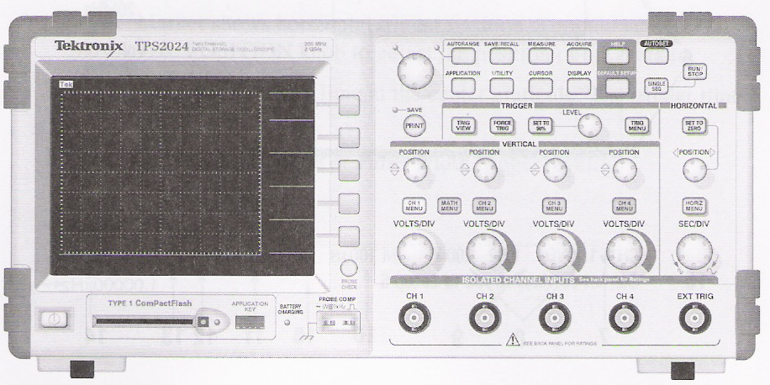

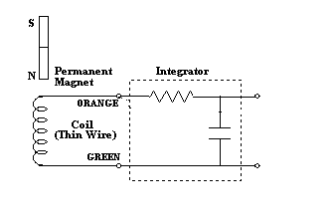

BLUE
ORANGE

GREEN
GREEN

Figure 1. Circuit Setup for Measuring Induced Voltage and Magnetic Flux Linking the Coil.

Proceed with the following steps:
1. Set the oscilloscope time scale (SEC/DIV) to 250 msec./div.
2. Set the channels 1 and 2 voltage scales (VOLTS/DIV) to 40 mV.
3. Push the SINGLE SEQ button to start the acquisition of a single-shot waveform.
Try to push this button when the flat line trace starts at the far left hand side of the
oscilloscope LCD display. To cancel the acquisition mode push the RUN/STOP
button twice.
4. Insert the permanent magnet in and out of the coil.
5. Observe the traces of the magnetic flux and the induced voltage. Try to obtain a nearly
sinusoidal waveform. You can adjust the channels (VOLTS/DIV) and the time
(SEC/DIV) scales to display a good picture after storing a single shot of the
waveforms.
6. Use the CompactFlash Card to save this trace of the voltage and flux, then print it.

Investigate the impact of different magnet movement speeds on the traces. Explain your observations in detail and draw solid conclusions.

Part 2
The thick wire coil is used for this part of the experiment. Since the coil is rated for a maximum current of 3 amperes, a resistor is placed in series with the coil (inductor) to limit the current. You have the freedom of choosing the resistance.

Keep the general concepts of electromagnetic forces and energy conversion principles in mind while you are performing this part of the experiment.

Begin the experiment by setting up the circuit of Figure 2. Set the dc supply voltage to zero volts and gradually increase the voltage. Monitor the line current and make sure that the current is not exceeding 3 amperes at any time.

Figure 2. Circuit Setup for Studying the Effects of Magnetic Field Due
to a Current Carrying Coil.

Your task is to investigate the effect of the energized coil on the permanent magnet. The energized coil produces a magnetic field with north and south poles. The strength of this magnetic field will be a function of the coil current. The permanent magnet also has north and south poles with a fixed field strength. Verify that opposite poles will attract one another and the similar poles will repel one another.

Investigate the impact of the coil current on the attraction and repulsion forces by trying different current magnitudes, different magnet polarities, different magnet positions, etc.

Explain your observations in detail, and draw solid conclusions.

Part 3
Both coils are used for this part of the experiment. The thick wire coil will be connected to the ac voltage supply.

You have studied the magnetic coupling in previous courses, but this may be your first opportunity to observe the effects of angle of the coil axes and the distance on the induced voltages.

Setup the circuit of Figure 3. Pay attention to the direction of the winding turns for both coils.

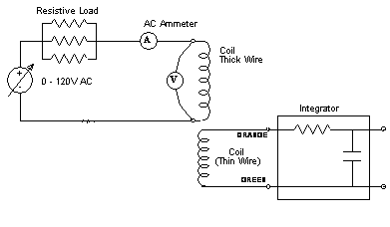

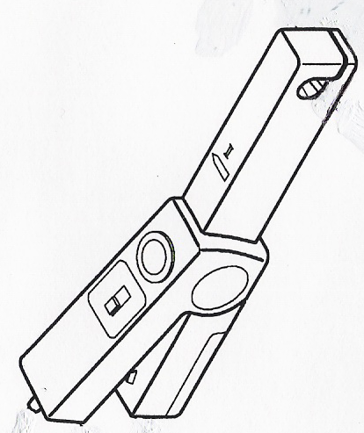
BLUE
ORANGE

GREEN
GREEN

Figure 3. Circuit Setup for Studying the Effects of Magnetic Coupling Between Two Coils.

Proceed with the following steps:
1. Place the two coils near each other, so the mutual coupling will be maximum.
2. Gradually increase the supply voltage from zero volts until the rms value of the thick wire coil current is 1.5 amperes.
3. Now experiment with the orientation of the thin coil axis ( 0 degree, 90 degrees, and
180 degrees). Observe the impact of rotation of the coil axis on the induced voltage in
the unexcited coil, and the impact on the current of the excited coil.
4. Use the CompactFlash Card to save traces of the voltage, flux, and current, then print
it.
5. Repeat the Step 3 and 4 while increasing the separation of the two coils.
6. Increase the current to 3 amperes, and repeat Steps 3 and 4.

Next, place the two coils directly next to each other in the position of maximum coupling. Make sure that the energized coil current is 3 amperes and measure the coil voltage. The coil voltage is your control variable and must be kept constant while you are performing this part of the experiment.

Proceed with the following steps:
1. Insert one iron strips through the coil windows so that it passes through both windows.
2. Observe the shape and magnitude of the exciting current and the flux (integrated
signal from the coil with the thinner wire) waveforms.
3. Use the CompactFlash Card to save traces of the voltage, flux, and current,
then print it.
4. Increase the number of iron strips in three or four steps.
Observe the shape and magnitude of the exciting current and the flux waveforms.
5. Use the CompactFlash Card to save traces of the voltage, flux, and current,
then print it.
6. Increase the separation of the two coils.
Observe the shape and magnitude of the exciting current and the flux waveforms.
7. Use the CompactFlash Card to save traces of the voltage, flux, and current,
then print it.

Explain your observations in detail and draw solid conclusions.

Now reconfigure the oscilloscope into an x-versus-y display mode with the current displayed on the channel 1 and flux displayed on the channel 2. Then proceed with the following steps:
1. Push the DISPLAY button.
2. Change the FORMAT from YT to XY.
3. Observe the hysteresis (B-H) curve of the ferromagnetic material by displaying the integral of the induced voltage (proportional to flux) versus the exciting current of
the coil. Adjust the channels scales (VOLTS/DIV) until you see an acceptable
hysteresis curve. Pay attention to the shape of the curve while gradually increasing
the number of iron strips sequentially from zero to four. Explain your observations in
detail, and verify that the permeability of a highly saturated iron is about the same as
air.
4. Use the CompactFlash Card to save the B-H curve, then print it. Make sure that persist
is turned on before saving the hysteresis curve (B-H curve).

Documentation
Turn this instruction into a readable gray color, and insert your comments at appropriate locations in black color. Your documentation should be complete and clear. All of your observations should be accompanied with accurate prints of the waveforms in your report, and detail explanations of the observed phenomena. Make sure that you have satisfied all of the objectives of this experiment before leaving the laboratory. Your report should have a conclusion section at the end.

