Example 16
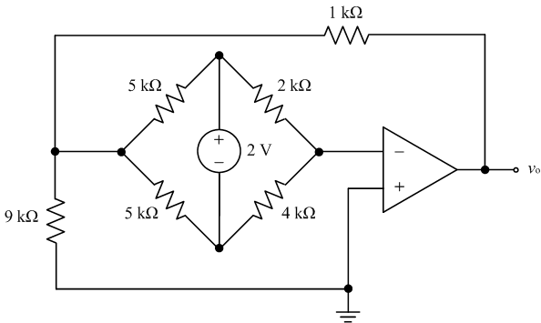
$$v_{1}$$
$$v_{2}$$
$$v_{3}$$
Find the output voltage of the bridge amplifier.

In this problem, we are trying to find the output voltage of the ideal op amp.
Given an op amp circuit, we often use node-voltage method to analyze the circuit. Let us identify all the nodes in the circuit first. This is a node connects 4 branches and I will label the node voltage as $v_{1}$. 5kΩ, 2kΩ resistors and the 2V power supply meet here so that this is a node. The node voltage is labeled as $v_{2}$. The inverting terminal of the op amp is also a node which connects 2 resistors and to the op amp. As we know, the two input terminals of the ideal op amp have the same voltages. The inverting terminal should be 0V since the non inverting terminal is grounded. We don’t need a variable name here. This is a node and the voltage is $v_{3}$. The output terminal is the connection between to components, the resistor and the op amp. The node voltage is already labeled as $v_{o}$. The bottom node is grounded and it can be used as reference node.
So we have 4 unknown variables and we need to supply 4 equations to be able to solve the problem.
The first nodal equation can be written at node 1.
Summing the currents at node 1.
$\frac{v_{o}−v_{1}}{1}+\frac{0−v_{1}}{9}+\frac{v_{3}−v_{1}}{5}+\frac{v_{2}−v_{1}}{5}=0$ (1)
There are 3 branches connected with node 2. We cannot write a current expression in terms of the node voltage. Hence, we cannot write a KCL at node 2. We have the same problem at node 3 if we try to write the KCL equation here. One method to take care of the problem is to introduce a supernode. If we consider node 2 and 3 as a supernode, we can write a nodal equation here. KCL says that the algebraic sum of the currents entering a supernode is zero. We apply KCL to the supernode in the same way that we apply KCL to a node.
$\frac{v_{1}−v_{2}}{5}+\frac{v_{1}−v_{3}}{5}+\frac{0−v_{2}}{2}+\frac{0−v_{3}}{4}=0$ (2)
This supernode consists of two nodes, so that we need supply 2 equations.
$v_{2}−v_{3}=2$ (3)
For the output node, we cannot figure out the output current of the op amp. Consequently, KCL won’t work. For the input node, it is possible to sum the currents at this node.
$\frac{v_{2}−0}{2}+\frac{v_{3}−0}{4}=0$ (4)
We have got 4 equations for 4 unknown variables. I am going to use maple to solve the equations. Here are the 4 equations set up in Maple. The final answer to this problem is
$v_{o}=−\frac{\text{10}}{\text{27}}=−0\text{.}\text{37}V$.