EM121: Statics and Mechanics of Materials I
Spring 2008-2009 Project
Landing Gear Design

Objective:
Your objective is to design a lightweight link for a landing gear mechanism that will allow the landing gear to safely retract to a specified angle.

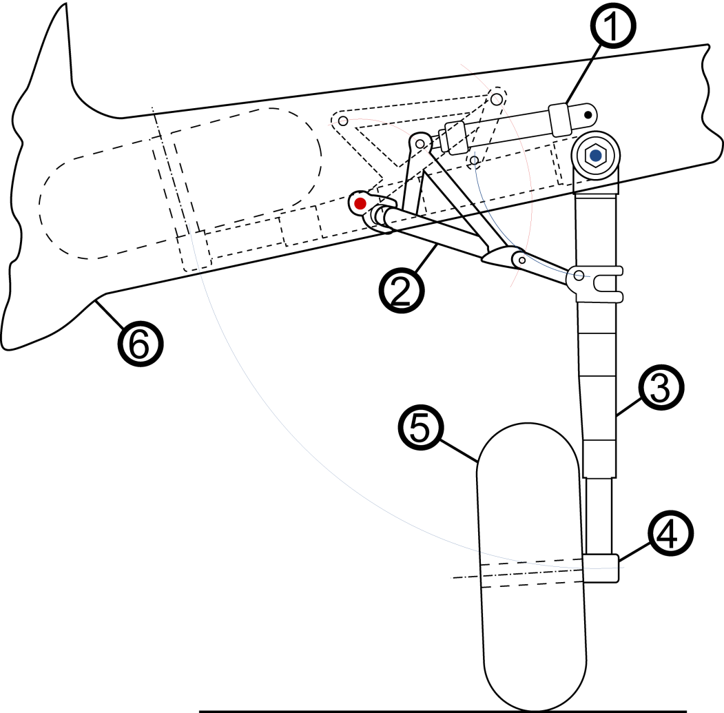
Figure 1 shows a typical landing gear mechanism used to retract the wheel into the wing near the fuselage. Initially, the strut is vertical. After retracting, the strut must be held at an angle of 10º below the horizontal.
Link

Figure 1: Typical landing gear mechanism.
(1: Hydraulic Ram, 2: Hinge Mechanism, 3: Strut, 4: Wheel Boss, 5: Wheel, 6: Fuselage/Wing.
Source: http://commons.wikimedia.org/wiki/File:Landing_gear_schematic.svg)

Background
Figure 2 shows a schematic of the prototype mechanism which we will use in this project.

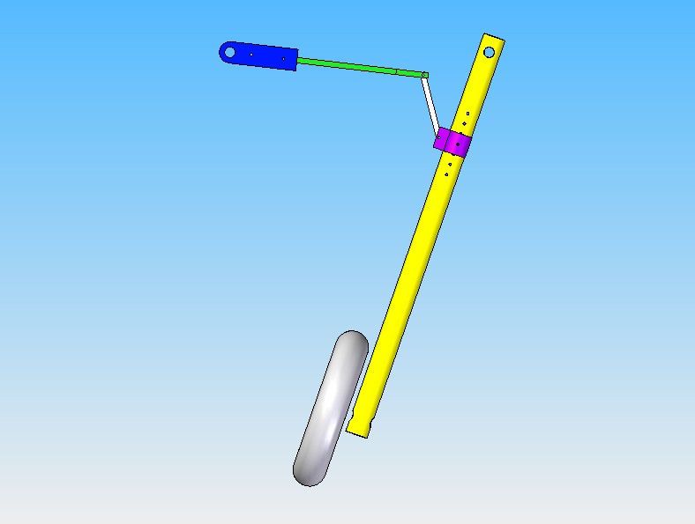
Wheel
Strut
Your Link
Shackle
Pin
Shoulder Screws
7 possible hole locations on strut
Driven Arm: Long Link
Driven Arm: Short Link

Figure 2: Prototype landing gear mechanism.

You will design the link that initially holds the wheel and strut in the vertical position, and allows the wheel to be lifted up into the retracted position. One end of the link is joined to the shackle by a shoulder screw, and the shackle is pinned at one of 7 possible hole locations on the strut. You will get to choose which hole you will use. The other end of the link is joined (again by a shoulder screw) to the long link on the driven arm of the landing gear mechanism. The diameter of the shoulder screws is 0.250”.

The SolidEdge files and drawings that describe the geometry of the landing gear mechanism are provided on the “Labs” page on the course website. The prototype mechanism is in the ME machine shop (EL202). You are encouraged to visit the machine shop to view the mechanism, but remember that long pants, closed-toe shoes, and safety glasses are required in the shop.

The material that you will use to create the link is Nylon 6/6 sheet (a rigid plastic). We supply the material, and the thicknesses available to you are 0.062 inches, 0.094 inches, and 0.124 inches. The manufacturer’s material property data sheet has been posted on the “Labs” page of the course website, along with tensile test results for specimens fabricated from Nylon sheets purchased for these projects over the last two years.

Deliverables
- An email to your instructor (due Sunday, May 10 by 10 pm). The email must include
  - A CAD file in the dxf format that defines the outline of your link in a way that is appropriate for our laser cutting machine (see instructions on the “Labs” webpage). The name of the file must be given as Sec#_teamname_thickness.dxf (for example: “Sec3_ATeam_062.dxf”)
  - An indication of which strut hole to use with the shackle.
- Optional Doll (due Wednesday, May 20 at the start of the contest) . You may choose to test your link with a doll or with the monkey. If you choose to make a doll you must bring it with you to the contest, and it must meet the following specifications:
  - The doll should be fabricated from a single sheet of plain copier paper (e.g. rolled into a tube)
  - Feel free to decorate your doll. Do not fill the doll with anything, e.g. red paint, as amusing as that might initially seem.
  - Your doll must have your team name written on it.
- Technical Report (due by email, Friday May 22, 5 pm). A technical report following our template, providing documentation of your analysis and design process. The template for the technical report will be provided later in the quarter.

Testing (Contest):
Date: Wednesday May 20
Location: Meyers M137 Lecture Hall
Times: by section
Section 3 (Olson): 1st hour
Section 4 (Olson): 2nd hour
Section 5 (Fine): 3rd hour
Section 6 (Fine): 4th hour
Section 1 (Stienstra): 5th hour
Section 2 (Stienstra): 6th hour
Section 7 (Bryan): 7th hour
Section 8 (Bryan): 8th hour
If your team cannot have at least two team members present during the assigned section time, we can move your group to compete with a different section. However, this must be arranged in advance-- not later than Monday May 18.

Grading:
Technical Report (Documentation): 75%

Performance: 25%
Does it Function Safely?
No: your performance score is 55.
Yes: your performance is based on the weight of your link (light is good)
- Top in section: 100
- Top third of section: 95
- Middle third of section : 85
- Bottom third of section: 75

