Problem Set 4

Continue reading Chapter 2 of Oppenheim and Willsky. Section 2.2 focuses on convolution, which is the topic of this homework..
- O&W, problem 2.22, parts (a), (c), and (d).
- O&W, problem 2.29, parts (a) and (b).
- Find the impulse response, h(t), of the following circuits:
  - 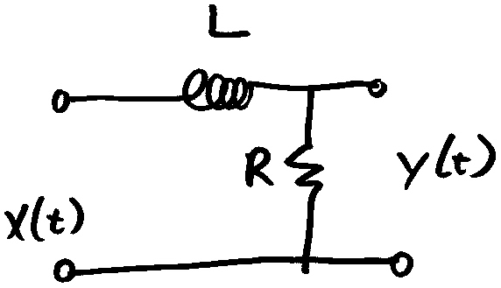
  - 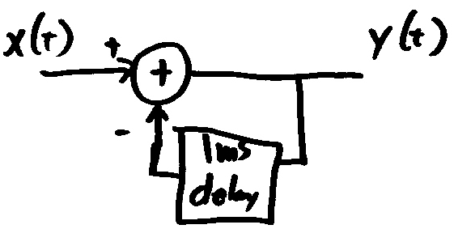
- What is the output of the systems in the above problem if the input is $x(t)=\text{rect}\left(\frac{t}{0\text{.}5\text{ms}}\right)$ (i.e. a 0.5ms wide pulse)?

This problem set is due at the start of class on Tuesday, Oct 1st.

