Chapter 8

The Smith Chart
_____________________________________________________________________________________________________

8.1 - Crank Diagram
The concept of reflection coefficient is a key detail in the understanding and application of transmission lines. The relationship between the reflected and incident voltage and current waves is readily expressed by the reflection coefficient. However, the more useful concept of impedance is a more complicated relationship as the ratio of the total voltage and total current. Early transmission line practitioners spent a great deal of effort trying to represent this relationship in a simple, yet illustrative manner. Since the ratio of the reflected to the incident voltage waves varies with distance from the load as
As an observer move away from the load, the reflection coefficient is “seen” to rotate in a CW manner. This is due to a more negative phase shift experienced by the reflected wave and less negative phase shift by the incident. This phenomenon is illustrated graphically by assuming an incident wave of unity amplitude and zero degrees phase shift, see Figure 8.1a. Since the reflected wave is equal to the product of the unity incident wave and the reflection coefficient, the reflected wave is equal to the reflection coefficient
This is represented by the phasor Γ_{L}e^{-i2βd} that rotates CW as the distance from the load is increased. The tip of the rotating reflection coefficient phasor traces out the dotted circle of radius |Γ_{L}| in Figure 8.1a, completing a revolution every λ/2. The total voltage is given by
where the incident wave is assumed to be unity with zero phase angle. This is represented by the sum of the incident and reflected phasors in Figure 8.1a. Typical phasors are shown for several observation points; the maximum voltage, V(d_{MAX}), occurs where the incident and reflected phasors align; the minimum voltage, V(d_{MIN}), occurs where the reflected phasor is oppositely directed to the incident.

V_{INC}=1∠0°
2βd_{o}
V(d_{MIN})
V(d_{MAX})
V_{L}
V(d_{o})
Γ_{L}
Γ(d_{o})
I_{INC}=1∠0°/Z_{C}
I(d_{MAX})
I(d_{MIN})
I_{L}
I(d_{o})
−Γ_{L}
−Γ(d_{o})
Z_{L}
λ/2
d_{MIN}
d_{o}
d_{MAX}
d

Figure 8.1 – Incident, Reflected, and Total Phasors on a Transmission Line;
a: Voltage, b: Current; c. Location.
For an incident voltage V⁺=1, the incident current is I⁺=1/Z_{C} with reflected and total current as
and
respectively. The current phasors are displayed in Figure 8.1b. Though the incident voltage and current phasors are aligned, the oppositely directed reflected phasors graphically illustrate that voltage maxima and minima are located at the same locations of current minima and maxima, respectively.
The ratio of the voltage to current phasors provides the numeric value of the line impedance as expressed by
Variations in the line impedance with distance are due to the rotation of the voltage and current phasors. The impedance values repeat for a given load repeat every λ/2 as well.
These parameters--the reflection coefficient and the voltage and current phasors--are combined to calculate line impedance in a Crank diagram as shown in Figure 8.2. The reflection coefficient of the load is plotted as a phasor. This phasor is rotated or “cranked” by e^{-j2βd} to represent a line of length d. The incident, reflected, and total phasors are sketched for voltage and current. The ratio of the total voltage to current phasors leads to the line impedance a distance d from the load. The variations of this impedance can be calculated for different values of line
V_{INC},I_{INC}
V(d)
2βd
I_{L}
I(d)
−Γ_{L}
Γ_{L}
V_{L}
2βd

Figure 8.2 - Crank Diagram.
length. This process provides visualization of transmission line behavior. However, it offers little improvement in computational ease. Improvements upon this scheme lead to the Smith chart, the focus of the next section.
Example 8.1: Construct the Crank diagram for a load of Z_{L}=100−j100 Ω on a 100 Ω line of length d=0.2λ. The load reflection coefficient, is plotted in Figure 8.3. The line length corresponds to a CW rotation of
I(0.2λ)
0.2λ
V(0.2λ)
−Γ_{L}
Γ_{L}

Figure 8.3 - Crank Diagram.
2βd=2(2π/λ)(0.2λ)=0.8π=144º so that With an incident voltage of 1∠0º, V⁺(d) =Γ(.2λ) and I⁺(d) =-Γ(.2λ)/Z_{C}. The total voltage is given by
and the total current is given by These are shown on Figure 8.3. The impedance is calculated as
8.2 - The Smith Chart
The behavior of voltage, current, impedance, and reflection coefficient is graphically illustrated by the Crank diagram. In addition, it offers a systematic, albeit limited, calculation procedure. These ideas form the basis for a much more powerful tool—the Smith chart. In 1939 Philip H. Smith, an engineer at Bell Telephone Laboratories, devised a reflection coefficient chart as a calculation aid for transmission line problems. Though Volpert of the Soviet Union and Mizuhashi of Japan proposed essentially the same chart during the same year, Smith received the recognition.
Quite simply, the Smith chart is a reflection coefficient chart where the complex reflection coefficient is plotted on a set of impedance coordinates. At the heart of the Smith chart is the relationship between an impedance and its reflection coefficient
and the inverse relationship
Smith recognized that all reflection coefficients could be shown on the same chart if the impedances are normalized with respect to the characteristic impedance. The normalized impedance is expressed as
so that the reflection coefficient is given as
and the normalized impedance as
.
The last two relations are of the general form of the bilinear transformation,
,
where the complex number z represents impedance or the reflection coefficient and the complex number w represents the other. This defines a unique transformation between the impedance and the reflection coefficient. Actually, the latter transformation is unique only within a range of 0<d<λ/2 due to the half-wavelength repetition of the reflection coefficient. An interesting and useful feature of all bilinear transformations is that circles transform into circles where even a straight line is interpreted as a circle with infinite radius, see Figure 8.4. Furthermore, the angles between circles in one domain are preserved in the other.
Since |Γ|≤1 for passive loads, all reflection coefficients lie on or within a circle of radius 1. Moreover, every point corresponds to a unique normalized impedance z. The nature of the superimposed impedance coordinates appears complicated, but is really quite simple. It consists of two sets of reflection coefficient circles—constant resistance circles and constant reactance circles. To find their equations, the impedance is written in terms of the real and imaginary parts of the reflection coefficient, i.e., Γ=X+jY, as
.

Figure 8.4 - Transformations between Reflection Coefficient and Impedance Planes.
x
x₂
x₁
r
−x₁
−x₂
−r₂
r₁
r₂
−r₁
r₁
r₂
−x₂
−x₁
x₂
x₁
r=0
x=0
This is solved for the normalized resistance, r, as
which is rearranged to
.
This represents circles in the reflection coefficient plane of radius 1/(1+r), centered at X=r/(1+r) and Y=0. All circles of constant resistance are symmetrically located with respect to the horizontal axis of the Smith chart. r=0 defines the circle |Γ|=1; r=1 passes through the origin which corresponds to Γ=0 of a matched load. All values of r<1 lie outside the r=1 circle; all values of r>1 lie inside the r=1 circle. Figure 8.5 shows the loci of Γ for values of r=0, 0.5, 1 and 2, respectively.
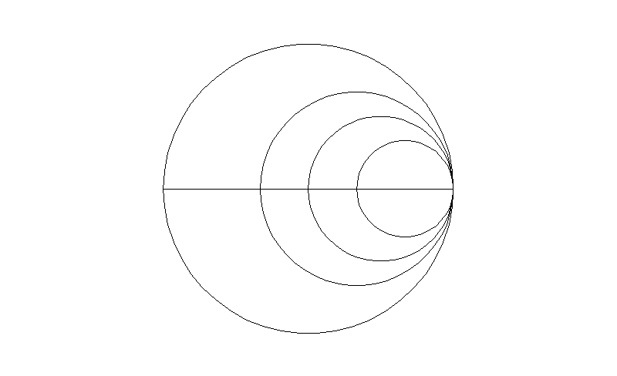
Figure 8.5 - Reflection Coefficient Loci for Constant Resistances.
Similarly the normalized reactance, x, is
which is rearranged as
.
This represents circles in the reflection coefficient plane of radius 1/x, centered at X=1 and Y=1/x. All reactance circles are centered on the vertical line tangent to the RHS of the Smith Chart; they are tangent to the horizontal midline of the Smith chart. The larger the value of reactance, the smaller the circle;
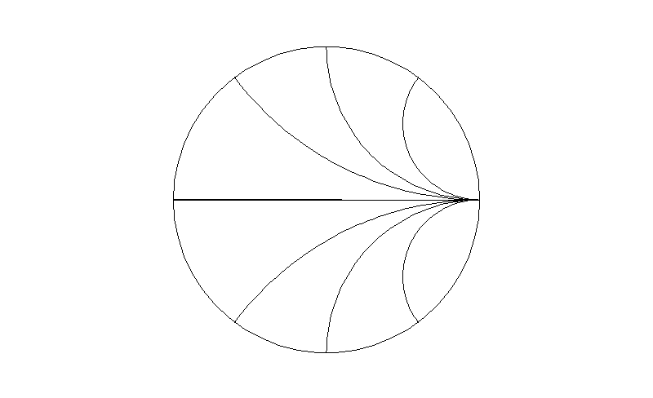
Figure 8.6 - Reflection Coefficient Loci for Constant Reactances.
the smaller the value, the larger the circle. In fact, the horizontal midline of the chart corresponds to x=0. Positive values of reactance lie in the upper half of the chart; negative values in the lower half. Loci of Γ for values of x=0, ± 0.5, ± 1, and ± 2, respectively, are plotted in Figure 8.6.
The reflection coefficient loci of Figures 8.6 and 8.7 are combined for the representation of general impedances, z=r+jx. These combined loci provide the impedance-reflection coefficient transformation at the heart of the Smith chart; they are plotted in Figure 8.8. The center of the chart represents Γ=0, a matched load. The RHS of the horizontal axes represents Γ=+1, an open circuit. The LHS of the horizontal axis represents Γ=−1, a short circuit. The outside edge of the chart where |Γ|=1 represents purely reactive impedances. Regions outside the chart represent negative resistance, possible only with active devices.
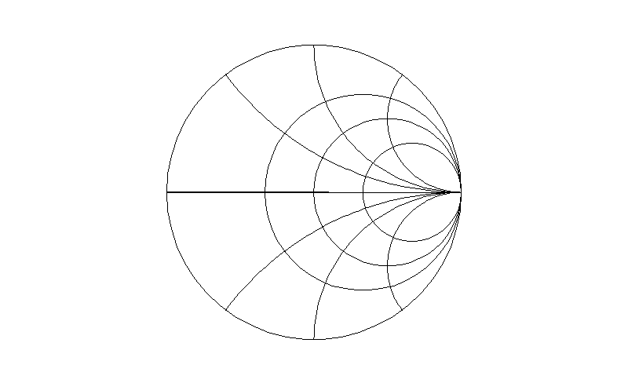
Figure 8.7 - The Smith Chart.
With this foundation, Smith added several useful scales that further enhance the usefulness of the chart. He first added a reflection coefficient magnitude scale. For passive loads, this is just a linear scale for 0<|Γ|<1 as the radius of the chart, usually across the bottom of the chart. In fact, the scale is often extended across the entire width of the chart to include the transmission coefficient as 0<|T|<2 since 1+Γ=T. This scale is most useful when used with a compass. Sometimes there is a closely related scale called return loss, usually calibrated in dB, and defined as
.
Since reflected power is proportional to |Γ|², this is the ratio of the reflected to incident power that is “returned” to the source from the load.
Another closely related scale is the VSWR scale utilizing the relationship VSWR=(1+|Γ|)/(1−|Γ|). Since |Γ| does not change along a lossless line, the locus of points swept out by the reflection coefficient along the line is a constant VSWR circle. The VSWR scale, usually along the bottom of the chart, covers the range 1<VSWR<∞. An interesting feature of a reflection coefficient or VSWR circle is that the value of the normalized resistance where it intersects the positive real axis is equal to the VSWR. No additional scale is needed to compute VSWR.
The real utility of the chart is available with the addition of two, concentric angular scales that encircle the unit outer radius portion of the chart. The first of these is the reflection coefficient phase angle measured in degrees. The angle ranges over a full 360º with the positive direction measured CCW from the RH horizontal axis that represents 0º. With this scale and the reflection coefficient magnitude scale, measured or known reflection coefficients can be entered directly on the chart with the corresponding impedance read from the superimposed circles.
The second angular scale represents electrical length measured in wavelengths. As the line length is increased, the phase angle of the reflection coefficient becomes increasingly more negative. This angular change in the reflection coefficient is calibrated on the outermost scale in terms of the axial change of position in wavelengths. Since transmission line phenomena repeat every λ/2, one revolution of the chart corresponds to λ/2. There are actually two wavelength scales on this portion of the chart. One increases in a CW direction with distance from the load; it actually indicates distance from the load, it is denoted as “toward generator.” The other scale increases in a CCW direction with distance from the source; it is denoted as “toward load.” Both scales begin and end on the LHS of the horizontal scale. In use, the actual numbers on the scale are relatively unimportant, rather the difference between two positions is significant since it corresponds to the line length measured in wavelengths.
In addition to these features, the transform from impedance to reflection coefficient is related to the transform of admittance to reflection coefficient. The reflection coefficient is expressed as
.
This indicates that −Γ corresponds to the normalized reflection coefficient of the load. But, the superimposed coordinates that correspond to −Γ correspond to the normalized admittance of the load. This means that the normalized admittance of a load is diametrically opposite the location of the impedance on the Smith chart. This makes calculation of the admittance of the load a simple, graphical procedure—it is the point directly opposite the impedance point on the chart. Moreover, it suggests that the chart can be used interchangeably for impedance or admittance calculations. Finally, the diametrically opposed location of the admittance on the chart can be interpreted as a rotation of the load impedance by λ/4 which results in an inversion of the impedance. This is a graphical verification of the input impedance of a quarter-wave transformer, Equation 7.123.
These details summarize a number of useful features of the Smith chart. But, they have just laid the groundwork for its real utility—finding input impedances for a load on a length of line.
Example 8.2-1: Determine the load impedance and VSWR associated with Γ=0.5∠π/4 on a 100 Ω line. The reflection coefficient is plotted on the Smith chart and the normalized impedance is read directly as z_{L}=1.38+j1.30 that gives Z_{L}=z_{L}Z_{C}=138+j130 Ω. The constant VSWR circle intersects the positive real axis at r=3, so the VSWR=3.
Example 8.2-2: A load impedance of Z_{L}=30−j50 Ω is attached to a 75 Ω line. Calculate Γ_{L}, VSWR, and Y_{L} via the Smith Chart. The normalized load impedance z_{L}=0.4−j0.667 is plotted on the Smith Chart. The reflection coefficient is measured from this point as Γ_{L}=0.579∠−106º. The constant VSWR circle intersects the positive real axis at r=3.75 which is also the VSWR. Finally, the y_{L} is diametrically opposed to z_{L} and is read off the impedance scales as y_{L}=0.66+j1.1 that gives Y_{L}=y_{L}Y_{C}=y_{L}/Z_{C}=8.8+j14.7 mS.
Example 8.2-3: Calculate the distance from the load of Example 8.2-2 to the voltage minimum nearest the load. Repeat the calculation for the voltage maximum nearest the load. The angular position of the load on the “toward generator” scale is at 0.397λ. The distance from the load to the minimum is d_{MIN}=0.103λ. Since voltage maxima are λ/4 from voltage minima, d_{MAX}=0.353λ.
Example 8.2-4: Calculate the input impedance of a short circuit on a 100 Ω line of 0.2λ length. A short circuit lies on the LHS of the horizontal axis of the Smith Chart. The resulting input impedance will also lie on the outer edge of the chart at a distance of 0.2λ CW from the short circuit. The normalized impedance at this point is z_{IN}=+j3.1 which corresponds to Z_{IN}=j310 Ω.
8.3 - Impedance Transformations with Smith Charts
The reflection coefficient a distance d from a load is expressed as
which corresponds to a CW rotation of the load reflection coefficient. The amount of the rotation is the length of the line d in terms of wavelength. This rotation is accomplished with the aid of the Smith Chart to determine the input reflection coefficient and impedance.
The details of this process are best described with a specific example. Consider a load Z_{L}=35+j75 Ω connected to a 0.35λ length of 50 Ω line for which the input impedance is needed. This problem can be worked directly with the Smith chart. The normalized load impedance is z_{L}=0.7+j1.5 which is located at Γ_{L}=0.67∠59.9º as indicated by the upper-right square on the Smith chart of Figure 8.8. The angular position of the load is at 0.167λ on the outer scale “toward generator.” The amount of rotation of the reflection coefficient corresponding to the length of the line is 0.35λ. The angular position of the input reflection coefficient is at 0.167+0.35=0.517λ. Since the scale extends only to 0.5λ, the actual location corresponds to 0.017λ on the Smith chart. The magnitude of the reflection coefficient doesn’t change with rotation, so the radius is located on the same VSWR circle as the load reflection coefficient. The intersection of the VSWR circle and the angular position of the input, denoted by the left square, is the input reflection coefficient Γ_{IN}=0.67∠168⁰ which corresponds to a normalized load of z_{L}=0.2+j0.1. The input impedance is Z_{IN}=10+j5 Ω.
Figure 8.8 - Input Impedance Calculation with the Smith Chart.
This procedure is reversed when the input impedance is known; the rotation is toward the load (CCW) rather than toward the generator (CW). Otherwise, the procedures are identical.
Each of these problems had one impedance and the line length known with the other impedance to be determined. Sometimes, both impedances are known and the line length is to be determined. For valid problems, both impedances must lie on the same VSWR circle. The line length is calculated as the difference between the angular positions of the load impedance and the input impedance measured toward the generator (CW). Due to repetition of impedance every λ/2, this distance is ambiguous by ±nλ/2.
The Smith Chart makes these calculations this simple! Wow, it’s great as a computational aid. In addition, the Smith Chart provides a visualization of what occurs on a transmission line. The reflection coefficient phasor rotates in a CW manner with distance from the load toward the generator and vice-versa. Moreover, the unique impedance associated with each reflection coefficient is superimposed for easy observation. This is very useful as we design transmission line systems which will optimize power delivered from a source to a load.
Example 8.3-1: Calculate Γ_{L} and VSWR of a 100+j50 Ω load on a 50 Ω line. The load is normalized to a value of z_{L}=Z_{L}/Z_{C}=2+j1. The impedance coordinates for this point are in the upper right portion of the Smith chart of Figure 8.9. The reflection coefficient is represented by the phasor from the center of the Smith chart to this point. It has a length of 0.46 (measured on the Γ scale at the bottom of the chart) and an angle of 27º (measured on the inner most angular scale) so that Γ_{L}=0.46∠27º. The VSWR is found most simply by rotating the reflection coefficient until its constant VSWR circle intersects the positive, real axis of the chart. The normalized resistance at this point is equal to the VSWR=2.6. Alternatively, the VSWR scale at the bottom of the Smith chart can be used.
Figure 8.9 - Several Calculations with the Smith Chart.
Example 8.3-2: Calculate Y_{L} for the load of Example 8.3-1. The admittance of an impedance is diametrically opposite as shown in Figure 8.9. The admittance is Y_{L}=y_{L}Y_{C}=(0.4−j0.2)(0.02)=8−j4 mS.
Example 8.3-3: Calculate the distance from the load to the nearest voltage maximum and the distance to the nearest voltage minimum for Example 8.3-1. To reach the voltage maximum, the reflection coefficient must be rotated down to the positive, real axis or a distance of d_{MAX}=(0.25−0.218)λ=0.032λ. The angular distances are read from the outer-most scale labeled “toward generator.” The distance between maxima and minima is λ/4 so d_{MIN}=(0.25 0+0.032)λ=0.282λ.
Example 8.3-4: Calculate the input impedance for the load of Example 8.3-1 at the end of a λ/8 line. The reflection coefficient must be rotated toward the generator an angular distance of λ/8 to the location (0.2180+0.125)λ=0.343λ as indicated in Figure 8.9. The intersection of this radial line with the constant VSWR circle gives the input impedance as Z_{IN}=(1−j1)50=50−j50 Ω.

8.4 - Lossy transmission Lines
To this point, we have considered only lossless transmission lines. However, truely lossless lines do not exist; all physical transmission lines have some loss. However, most useful transmission lines can be considered low-loss. If the lines are not low-loss, they dissipate so much power as signals propagate through the line that they are not useful as transmission lines. By considering only low-loss lines, we observe that the characteristic impedance remains nearly real as described by
For most transmission lines the loss is due mainly to copper losses so that R must be considered, but G is insignificant. Accordingly, the complex propagation constant is expressed as
Substitution of γ for jβ into Equations ZZZ through SSS leads to an expression for the incident wave of
The form of this wave is similar to a wave on a lossless transmission line, but the e^{−αz} term describes a wave with amplitude that decreases with distance. The wave is attenuated as it propagates along the transmission line due to the extraction of power from the wave by the losses of the transmission line. In a similar fashion, the reflected wave is given by
where the wave amplitude decreases further as it propagates away from the load. This leads to an input reflection coefficient for a line of length d given by
.
The input reflection coefficient is phase shifted from the load as on lossless lines. Additionally, its amplitude is reduced due to the losses of the line. The factor of 2 is due to both down and back reduction in the amplitude as in the phase shift. The effect of a lossy line is to reduce the reflection coefficient; the line appears to be better matched but at the price of power loss. The VSWR varies with position as
.
The input impedance is affected by loss as well according to
.
Historically, the attenuation of has been expressed in nepers/m. However, current usage usually expresses the attenuation in terms of dB/m. This expression is formulated as the ratio of the forward power propagating at z=1 m to the forward power propagating at z=0 m as
A more physical view of the process is obtained by noting that the power transmitted down the line is
so that
The attentuation/m is described as
,
that is the attentuation is one-half the normalized power lost/meter. This definition provides a means of measuring the attenutation constant α.
Lossy lines can be analyzed on the Smith chart in a manner similar to the lossless lines, but with the reduction of the reflection coefficient with distance from the load. Conversely, the input reflection coefficient grows as the distance to the load is decreased. This is summarized on the left hand uppermost scale at the bottom of the Smith chart. Each of the bigger marks (yes, it is hard to see a difference between marks unless you look carefully) represents 1 dB. Moving toward the generator reduces the magnitude of the reflection coefficient by the specified dB; moving toward the load increases the magnitude of the reflection coefficient by the specified dB. Alternatively, the magnitude of the lossless reflection coefficient can be directly multiplied by e^{−2αd} or e^{2αd}, respectively. This effect is that the locus of the reflection coefficient with distance is no longer a circle, but a spiral—inward for distance toward the generator, outward for distance away from the generator. The simplest procedure is to rotate the reflection coefficient the proper distance as if the line were lossless; then apply the appropriate decrease/increase in length of reflection coefficient.
Finally, lossy transmission lines show finite parallel admittance accompanying parallel resonance and non-zero series resistance with series resonance. These values are calculated automatically with Equation .
Example 8:4-1: A lossy line with γ=0.001+j2π and Z_{C}=50 Ω has a length of 50 m. Calculate the reflection coefficient of a 100 Ω on this line as seen at the load and at the input of the line. The reflection coefficient observed at the load is calculated as Γ_{L}=(100−50)/(100+50)=1/3. The reflection coefficient observed at the input is calculated as Γ_{IN}=Γ_{L}e^{−2αd}=(1/3)e^{−2(0.001)100}=(1/3)0.8189=0.273.
Example 8.4-2: A certain transmission line reduces a signal propagating from the input to the load by a factor of 2. Calculate the reflection coefficient and the VSWR at the line input when a short circuit load is attached to the line. Assume that the incident signal is 1 V. When it reaches the load it has an amplitude of 0.5 V. After reflection it has an amplitude of −0.5 V. Finally, it propagates back to the input with a further reduction to –0.25 V. The input reflection coefficient is Γ_{IN}=-0.25 and VSWR_{IN}=(1+0.25)/(1−0.25)=1.67. The lossy line reduces the input reflection coefficient and VSWR.
8.5 - Slotted Line Measurements
The direct measurement of reflection coefficients with a vector voltmeter has become a standard transmission line technique. It is quick and accurate; with the aid of embedded microprocessors it can make swept frequency measurements with automatic calibration and error correction. But, these instruments are expensive! An economical, but more tedious alternative, is the classic slotted line technique with the aid of the Smith chart. The simplicity and elegance of this technique makes it worth our examination.
The heart of this measurement is a section of slotted transmission line to which the load is attached. The voltage within the slotted line is measured at various axial positions to obtain information about the load. The slotted line is precision section of transmission line in which an insulated probe can be inserted to measure the electric fields. Most often the slotted line is composed of a coaxial line mounted in a supporting frame on which a moveable carriage can be slid from end to end. The outer conductor has a narrow, axial slot along its length for access to the fields within the line. The insulated probe, mounted in the carriage, is inserted into the slot in alignment with the electric fields. A voltage is developed between the probe and the outer conductor that is proportional to the electric field and the voltage within the line in the vicinity of the probe. As the carriage is slid along the line, the variations of the voltage within the line can be observed. The design of the slotted line minimizes the effects of the slot on the fields within the line. Moreover, the depth of penetration of the probe into the slot is adjustable to further minimize these effects. Typically the probe should be inserted only as far as necessary to obtain acceptable measurements.
Attached to the probe is a diode detector which is intended to operate in the square law region, i.e., the output voltage is proportional to the square of the voltage on the line. Square law operation is typically limited to power levels at the diode of 10 μw or less so the output signal must be greatly amplified. With this in mind, the RF test signal is usually AM modulated by an audio signal. This allows the use of a stable, AC amplifier tuned to the audio signal instead of a DC amplifier. A diagram of a typical slotted-line measurement system is shown in Figure 8.10.
Short-circuit
Data
Load
Data
λ/2
V_{PROBE}
Slotted Line
d
d_{SCMIN}
DUT
d_{LMIN}
RF
Source

Figure 8.10 - Slotted Line Measurement System.
The measurement procedure follows. With the load attached to the slotted line output, the carriage is moved along the line to locate and measure the magnitude and locations of voltage maxima and minima. The locations of voltage minima, d_{LMIN}, are preferred because the voltage minima are narrower than maxima, particularly for high VSWR, and their position can be more accurately determined. Then the load is replaced by a short circuit and the location of several short circuit minima, d_{SCMIN}, are found. Because of the half-wavelength repetition of voltages on lines, d_{SCMIN} are located an integer number of half wavelengths from the position of the load. From these measurements, the following information has been obtained λ/2, VSWR=V_{MAX}/V_{MIN}, d_{LMIN}, and d_{SCMIN} which is a point nλ/2 from the load at which the impedance of load is replicated. The relationship of these data is shown in Figure 8.11a.
The VSWR circle is drawn on the Smith chart; the load lies on this circle. A voltage minimum lies at the LH midpoint of this circle corresponding to the location of d_{LMIN}. By rotating from the load voltage minimum to the location of the short-circuit minimum, we arrive at an nλ/2 location where the line impedance equals the load impedance. The amount of this rotation is calculated as |d_{LMIN}−d_{SCMIN}|/λ calculated in wavelengths. The direction of rotation can be either toward the generator or toward the load, whichever is more convenient. See Figure 8.11b for the Smith chart construction of this procedure.
For uncalibrated sources, the frequency of the generator can be determined by the half-wavelength separation of short-circuit nulls via f=v_{P}/λ.
The effects of the probe on the fields within the slotted line can be modeled as an admittance in parallel with the impedance of the line. The real part of the admittance represents the power extracted from the
Figure 8.11 - Slotted-line/Smith Chart Method for measuring load Impedance.
line by the probe and transferred to the measurement system. The imaginary part represents the stored energy in the fields around the probe; usually it is capacitive in nature. An inductor placed in parallel with probe can create a parallel tuned circuit with the effective capacitance of the probe, producing a very high impedance. This minimizes the “loading” of the line by the probe and it increases the sensitivity of the probe so that it can be even further withdrawn from the slot (thus further reducing its distortion effects on the fields within the slotted line). Unfortunately, the probe capacitance varies with frequency and probe depth requiring a tunable inductor. But, a variable inductor is easy to fabricate at transmission line frequencies; it is just a short-circuit on a variable length transmission line. As the length is varied, the inductance varies. This tuning scheme greatly improves the performance of a slotted line system.
Finally, the use of voltage minima rather than maxima is preferred for another reason. The effective impedance of the probe tends to disturb the fields within the line less near a voltage minimum than near a maximum. The effects of the shunting probe impedance are less when in parallel with the low impedance at a voltage minimum than when in parallel with the high impedance at a voltage maximum.
There are a number of clever, more sophisticated enhancements of this technique, but the fundamentals discussed so far are sufficient for most measurements. But we will continue our focus on the Smith chart in the next chapter as our main tool in the design of matching circuits.
Example 8.4-1: Determine the measurement frequency and the load impedance for the following slotted line measurements: With an unknown load attached a voltage maximum of 4.3 units is measured; a voltage minimum of 1.6 units exists at 18.3 cm from the load. With the short circuit attached, the first voltage null exists at 25 cm from the load. The slotted line has a characteristic impedance of 50 Ω and is air-filled. The first null of the short circuit must be a half-wavelength from the load which means that λ=0.5 m and f=v_{P}/λ=3x10⁸/(0.5)=600 MHz. The voltage standing wave ratio is VSWR=4.3/1.6≈2.7. The rotation from the load voltage minimum to the short circuit minimum is 6.7 cm=0.134λ toward the generator. The resulting load impedance is Z_{L}=(0.54+j0.61)50 =27.2+j30.4 Ω. See Figure 8.12 for the graphical details of this solution on the Smith chart.
Figure 8.12 - Smith Chart Construction for Impedance from Slotted-line Data.

