Name ______________________________ CM_______________

ECE-320, Quiz #2

1) For the function

the final value as is

a) 0 b) 2 c) 10 d) undefined

Problems 2 -4 refer to the system described by the transfer function:

2) The steady state error for a unit step input for this system is best approximated as

a) 1 b) -1 c) 0 d) 5/6

3) The steady state error for a unit ramp input for this system is best approximated as

a) b) 0 c) 4/6 d) 1

4) The static gain of the system is best approximated as

a) 1 b) 2 c) 3 d) 4

5) The unit ramp response (input = ) of a system is given by

The steady state error for this system is best approximated as

a) 0 b) c) 1 d) 2

Problems 6-8 refer to the step response of a system, shown below

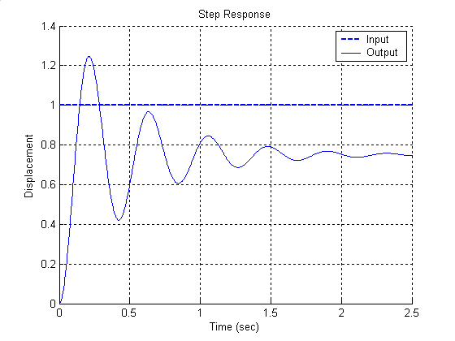

6) The percent overshoot for this system is best approximated as

a) 125% b) 100% c) 66.7% d) 25%

7) The steady state error for this system is best approximated as

a) 0.25 b) -0.25 c) 0.5 d) impossible to determine

8) The steady state error for a unit ramp input for this system is best approximated as

a) b) 0.5 c) 0.0 d) impossible to determine

Problems 9, and 10 refer to the ramp response of a system, shown below

9) The best estimate of the steady state error of this system is

a) -0.3 b) 0.3 c) -0.5 d) 0.5

10) The best estimate of the steady state error for a unit step input for this system is

a) 0 b) 1 c) d) impossible to determine

Problems 11 and 12 refer to the figure below, which shows the unit step response of a real 2nd order system and the unit step response of a second order model we are trying to match to the real system.

11) In order to make the model better match the real system, the damping ratio of the model should be

a) increased b) decreased c) left alone d) impossible to determine

12) In order to make the model better match the real system, the natural frequency of the model should be

a) increased b) decreased c) left alone d) impossible to determine

