ECE331 Lab #1 Spring 2007: CSM12C32 Module, UBUG12 Debug Monitor, Code Warrior IDE, and a Dice Tossing Program
________________________________________________________________________________

Keith Hoover and Jianjian Song
Department of Electrical and Computer Engineering
Rose-Hulman Institute of Technology
Revised August, 2007 (by KEH)

1 Precautions 2
2 Objectives 3
3 Deliverable 3
4 Reference materials 3
4.1 Equipment 3
4.2 Software Installation 3
5 Construction of a circuit with the CSM12C32 module on your breadboard 3
6 First assembly language example: A computer-controlled flashlight 5
6.1 Hardware interface circuit 6
6.2 Use of Metrowerks CodeWarrior IDE to assemble the flashlight program 6
6.2.1 Launch Code Warrior 6
6.2.2 Create New Project 6
6.2.3 Entering the flashlight assembly source program 6
6.2.4 Building the project 10
6.2.5 Motorola S-Record Absolute (ASCII Text) Machine Code File Format 10
6.2.6 Assembly Listing File 11
7 Metrowerks Simulator: program debugging without the CSM12C32 module! 12
8 Using the CodeWarrior in-circuit serial debugger 13
8.1 Preparation before launching the in-circuit serial debugger 13
8.2 Using the Metrowerks IDE in-circuit debug monitor 13
8.3 Debugging with the in-circuit debugger 13
8.4 Stand-alone execution of the user program 14
9 Second assembly language example: Coin-Tossing Program 14
9.1 Specification of Coin-Tossing Program 14
9.2 Charting your course: the program flowchart 14
9.3 Making the project and in-circuit debugging with the UBUG12 serial monitor 17
9.4 Debugging without the CSM12C32 breadboard: using the simulator 18
10 Your first embedded design assignment: Dice Tosser! 19
11 Possible Errors and Solutions 19
11.1 Elf Loader Error 19
11.2 Simulator RAM range error 19
11.3 Error message: L1116: Function main not found 20
11.4 Error in command file .\cmd\monitor_postload.cmd! 20
11.5 Warning on dbg file 20

Precautions
Each student is responsible for buying a CSMS12C32 lab kit at the beginning of the quarter. The CSMS12C32 microcontroller module that costs $25 each is the most vulnerable component. The CSMS12C32 chip has limited current sourcing and sinking capability (on the order of 25 mA). A switching transistor should be used to drive a high current load (such as a motor or solenoid) in excess of 25 mA.
Please exercise reasonable caution in guarding against electrostatic discharge (ESD) damage to your module. This means that you should be careful to touch a grounded object (such as an oscilloscope chassis) to discharge any built up static charges on your body to ground before you touch the breadboard containing the CSMS12C32 module or the module itself.
Take great care to turn the dc power off before adding or modifying any wiring to your board, or before you plug in or unplug your module to/from the breadboard.
In this first laboratory project, you will be wiring an LM7805 voltage regulator circuit and a CSMS12C32 microcontroller module through a pin socket cable on the left side of your breadboard. As you build this circuit, please keep in mind that this circuit must last for the entire quarter, so please wire it VERY neatly and carefully. Please follow the ten rules listed below for a “happy, healthy” CSMS12C32 breadboard. When you are done, your breadboard should look similar to the photograph shown in Fig. 2B.
(1) In order to avoid short circuits between adjacent wires, leave no bare hookup wires exposed. Each wire should be carefully stripped so that only 0.25 inches of the wire is “bare”. If this is done, the wire will plug neatly and completely into the board, with no bare wire left exposed on top of the board.
(2) Cut all component leads as short as possible so no excess component leads are exposed that could provide a path for an inadvertent short circuit.
(3) All hookup wires should be cut reasonably short, and they should be neatly pressed down to the board. Along with your wire stripper, a long nose pliers is a great help in stripping short wires and placing them neatly and securely into your breadboard. Also, to promote easy circuit probing and changing of components, no wires may be allowed to cross over any components.
(4) The dc power supply connector should be situated at the edge of your breadboard at a location that is reasonably clear of other wiring, and well away from the LM7805 regulator IC pins, in order to avoid any chance of the regulator’s 9V “Vin” input pin short-circuiting to its 5V “Vout” output pin, as this could burn out the CSMS12C32 module (see Fif 2B).
(5) As you perform the various interfacing experiments in this course, please take care to ensure that two CSMS12C32 output pins are never allowed to short together. An output pin might be damaged if it is connected to another output pin that happens to be driving a different logic level.
(6) Likewise, please make sure that a CSMS12C32 output pin is never allowed to become directly connected to ground or to the +5V power bus, in order to avoid burning out that pin.
(7) Carrying Rule 6 a bit further, please do not connect any output pin to a load whose impedance is so low that it could draw more than 25 mA during either logic high (+5 V) or logic low (0 V) digital output drive. As a rule, each CSM12C32 microcontroller output pin should not be required to source or sink more than 25 mA instantaneous current. Higher current loads should be driven through some sort of buffering device, which might take the form of an integrated circuit, a BJT, or a MOSFET switching transistor.
(8) Since input pins can sometimes inadvertently be configured as output pins, it is recommended that you place a 10 kΩ protective current-limiting resistor in series with any switches that you interface to the system. Note how the switch is interfaced to the microcontroller in Fig. 2A. We can see from this figure that if the 10 kΩ series current limiting resistor R2 were left out, then the associated I/O pin could be burned out if it were inadvertently configured as an output pin and were asked to put out a high level while the switch was pressed, shorting the output pin directly to ground.
(9) Please check, and then double check, your wiring before turning on the dc power to your system.

Objectives
This introductory first laboratory exercise has the following objectives:
To learn about the Freescale Semiconductor (previously Motorola) CSM12C32 microcontroller.
To learn about simple parallel I/O assembly language programming of the CSM12C32.
To learn how to use the Metrowerks “Code Warrior” integrated development environment (IDE), which consists of an assembler, linker, simulator, and in-circuit serial debugger.
To learn how to debug a program using the simulator and emulator, via the single-stepping (tracing), running to breakpoints, and watching the data in registers and memory locations.
To learn how to load and debug a program using the on-chip UBUG debug monitor.

Deliverable
Demonstrate your lab and submit your code with test results at the beginning of the following week’s lab period.

Reference materials
- CSM12C32 Module User’s Manual and Schematic Diagram. (CSM12C32_UG_B.pdf)
- MC9S12C Family Device User Guide (9S12C128DGV1.pdf)
- HCS12 Microcontrollers CPU Reference Manual (S12CPUV2.pdf)
- HC12 CPU Awareness and True Time Simulator Manual (Manual True Time Simulator HC12.pdf)
- Additional MCCSM12C32 Reference Manuals (CSM12C32_ZIP.zip)

Equipment
The Metrowerks Code Warrior software. The Freescale APS12C32SLK kit. A prototyping breadboard.. An LM7805 5V voltage regulator and other small components.
If your laptop does not have a serial port, you can check out a USB to serial adaptor from the instrument room. There are three different kinds of adaptors and their driver are available from class site on Angel.

Software Installation
Install the CodeWarrior Development Studio for HCS12(X) on the CD from your CSM12C32 kit. Choose the “Complete Installation” option, and download updates after installation is complete. Follow the instructions to request a registration code for your software, as explained in Appendix A of the Code Warrior Quick Start Manual. You need not register your “Academic Special Edition” of CodeWarrior, since the license.dat file is already included with the software, but you do need to have the registration code Emailed to you.

Construction of a circuit with the CSM12C32 module on your breadboard
Carefully plug your CSM12C32 32-pin DIP microcontroller module into your breadboard with. The pin-out of this module and that of LM7805 are given in Fig. 1. The power select Jumper 1 should be closed and Jumper 2 open so that the CSM12C32 module will be powered from the LM7805 on the breadboard.
As shown in Fig. 2, connect the “GND” pin on the CSM12C32 module to the blue 0 V (ground) power distribution bus at the bottom of your breadboard. Carefully connect the “Vx” input pin of the CSM12C32 module to the red 5 V power distribution bus at the top of your breadboard. The ground lead of the 7V – 15V dc power supply module must be connected to the breadboard’s ground bus.
The positive lead of the dc power supply module must be connected to the input terminal of an LM7805 voltage regulator, as shown in Figure 2A. Before connecting the Vout pin of the voltage regulator to the +5V distribution bus (and thus the CSM12C32 module), please power up the regulator and check for +5 V at the Vout pin. It is very important to check this voltage before you apply it to the CSM12C32 module, in order to avoid burning out the module!
Please keep in mind that this +5 V power bus can only supply a few hundred mA of current to the external interface circuitry on your breadboard. Be extremely careful that you do not place a short circuit across the Vcc and ground busses on your breadboard, in order to avoid damage to your CSM12C32 module. (In later experiments, where higher current loads must be driven, a separate external dc power supply will be needed.)
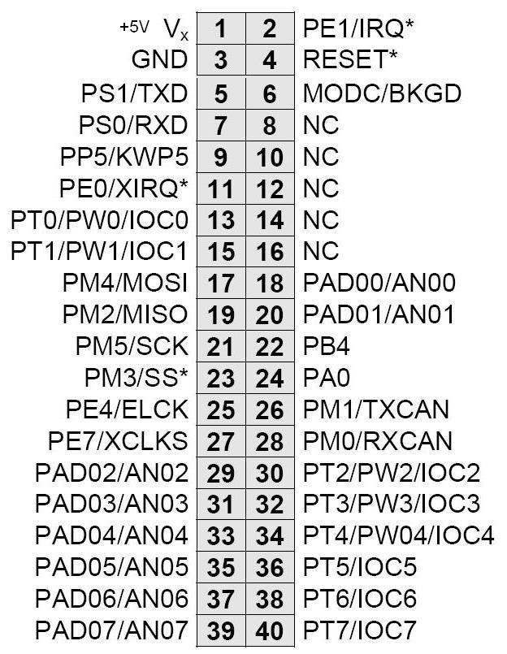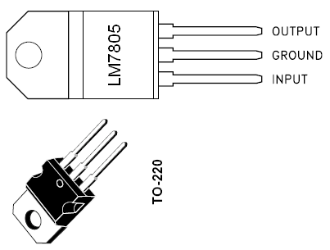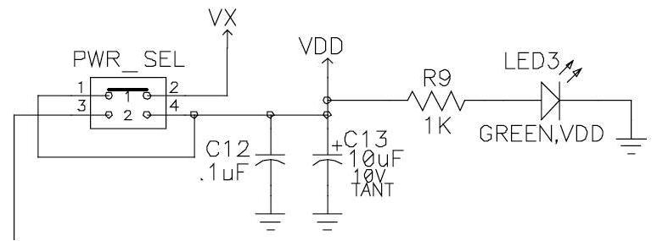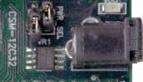
Jumper 1 is closed and Jumper 2 is open so that the on-board voltage regulator is bypassed, and the microcontroller is powered directly from the Vx pin.
Figure 1. Pinout of LM7805, Power Select Jumper connected between Pins 1 and 2, and the 40-pin interface connector J1 on the CSM12C32 Module.
Figure 2A. A schematic showing how the LM7805 5V voltage regulator, Power LED, Reset switch, Data LED, Input Switch, and the dc power connector are connected to the CSM12C32 microcontroller module.

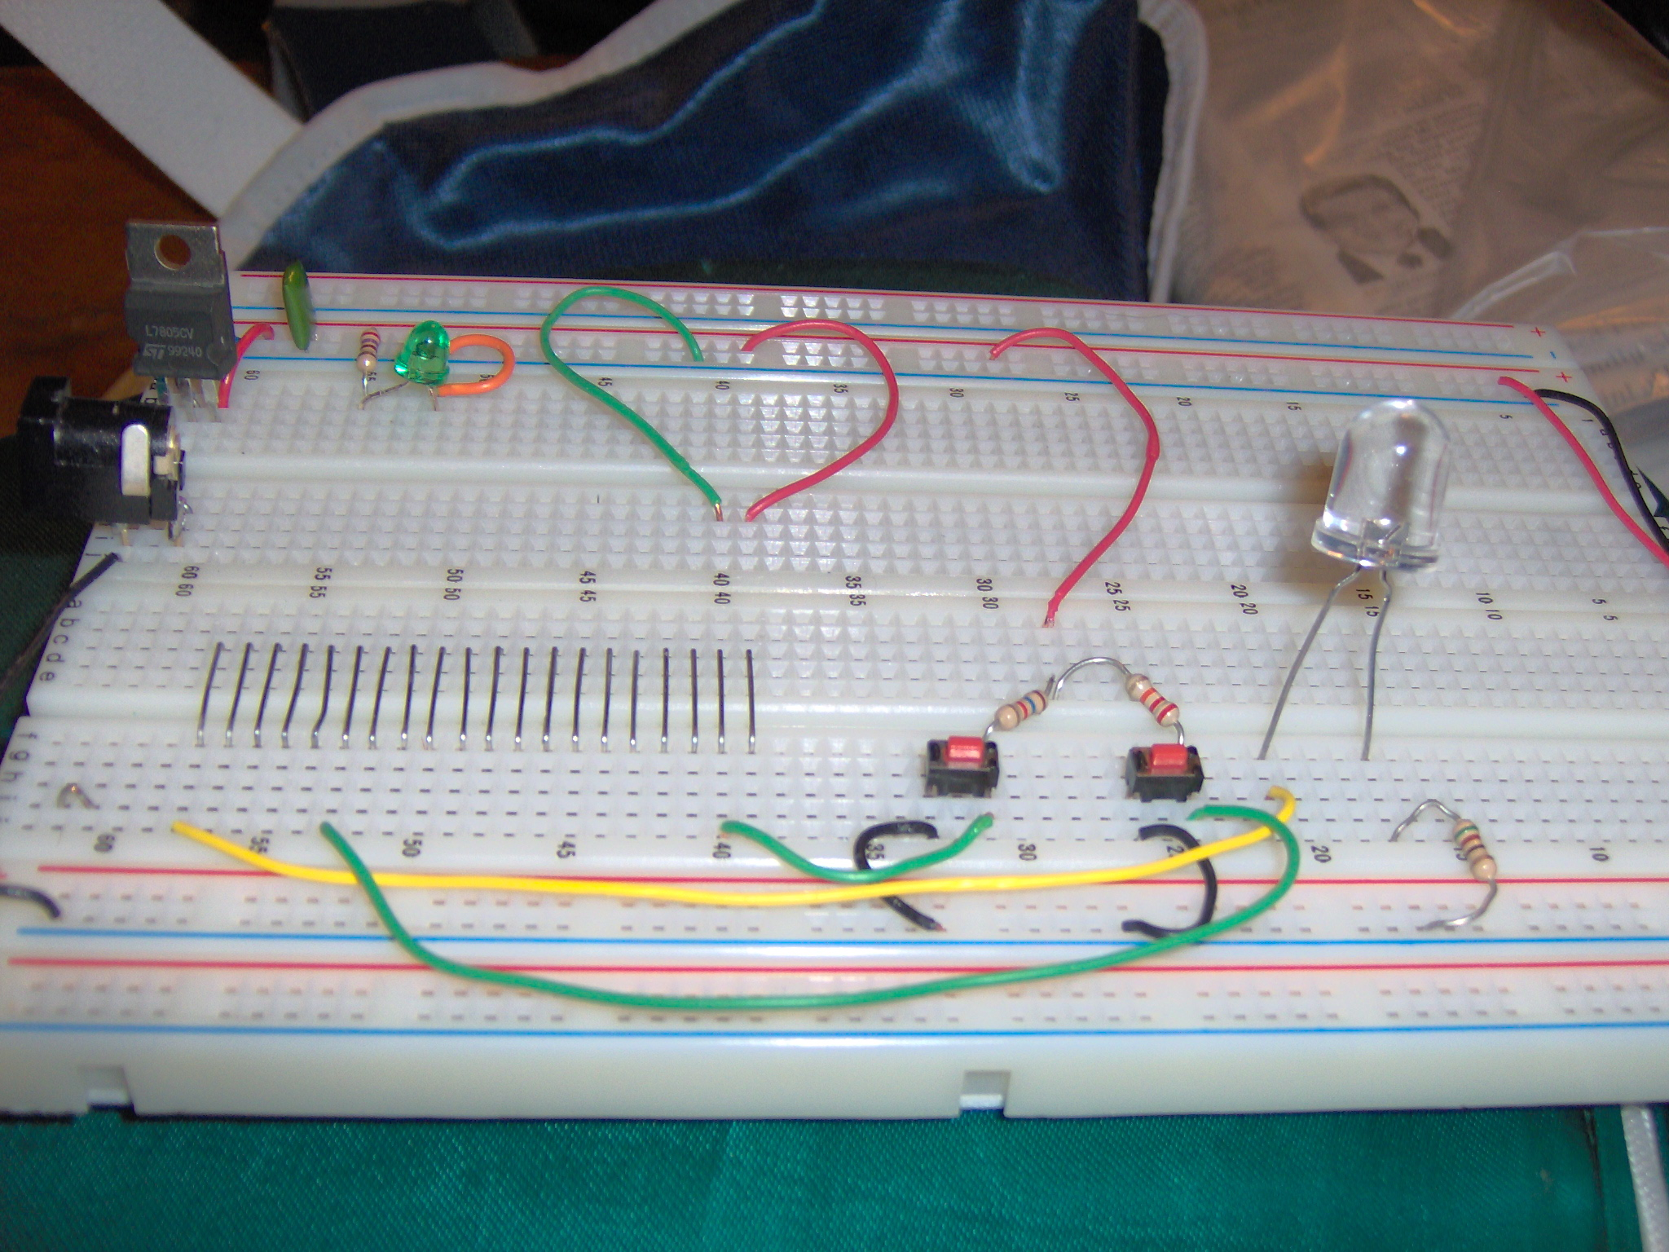
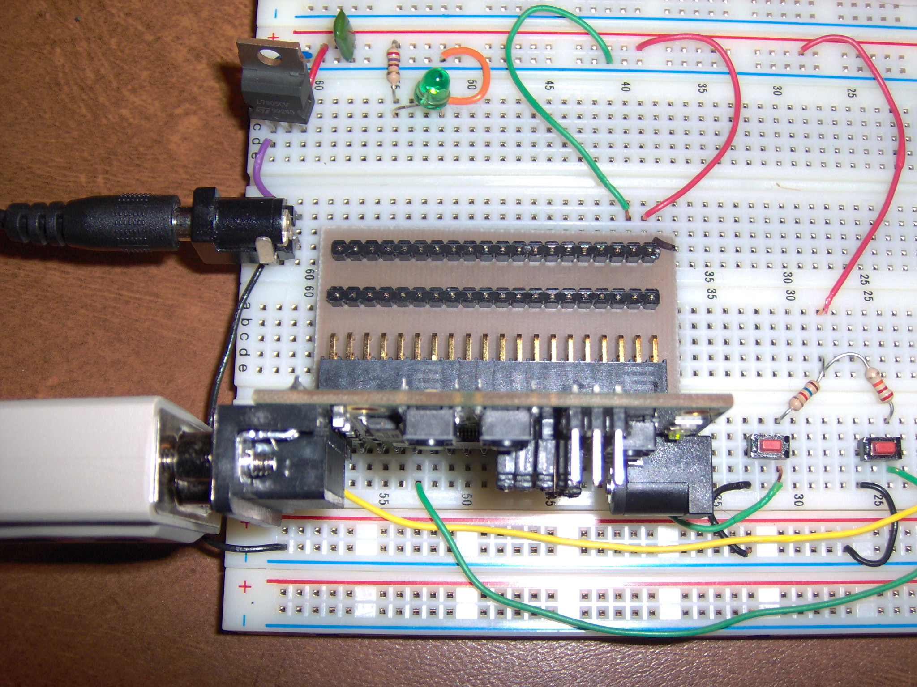
Pin 1
Pin 3
Pin 2
Pin 40

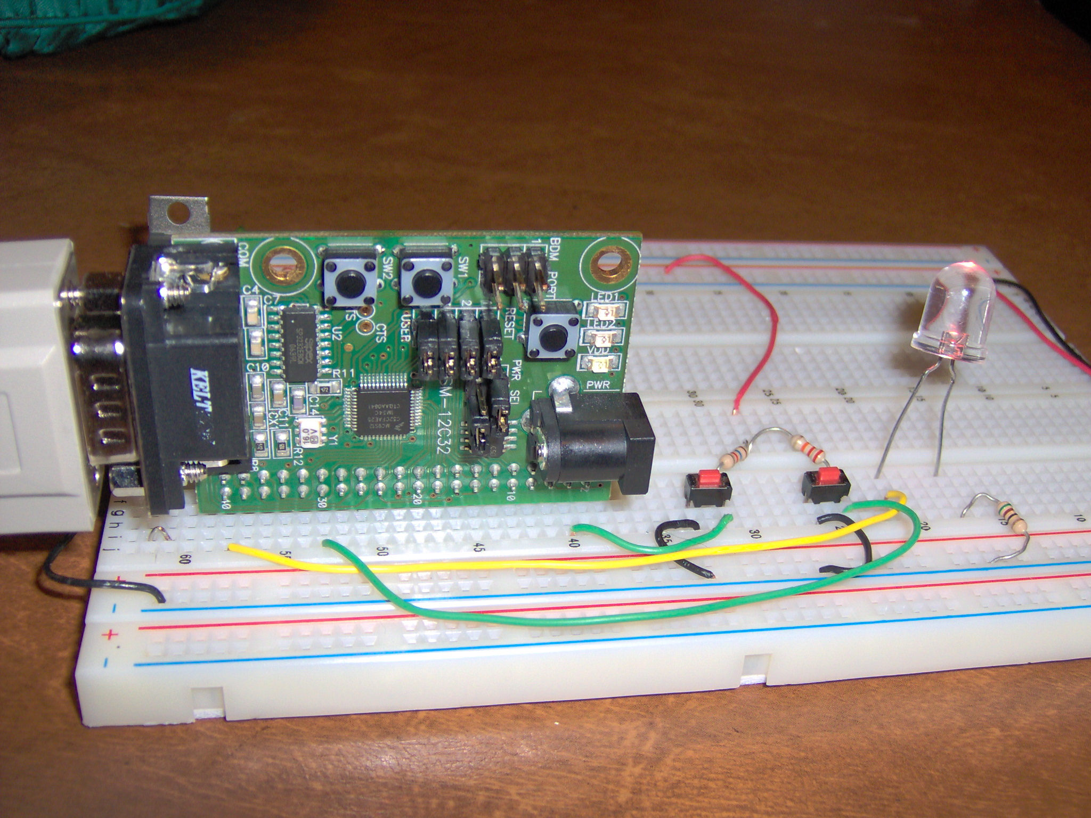
Figure 2B. Pictorial layout of the circuit of Fig. 2A. Note in the top picture how two breadboards have been glued together, and 20 jumper wires have been run. Note in the middle picture how the adaptor connects the CSM12C32 microcontroller module across the junction of the two breadboards, and how the odd-numbered pins (Pins 1 and 3) are accessed from the back side. Note in the bottom picture how wires are attached to the even-numbered pins of the module (Pins 4, 32, and 40)

First assembly language example: A computer-controlled flashlight
The first assembly language program we shall write simply turns on an LED when a switch is closed, and then turns it off when the switch is open. You might think of this important, though somewhat trivial, first embedded design example as a “computer controlled flashlight”!

Hardware interface circuit
Figure 2 shows the required hardware interface circuit. Note that we are using pin PT7 as an output pin to drive the LED. A 510-Ω resistor is used to limit the current through the LED to (5 – 1.2)/510-Ω = 7.5 mA. It is very important that this resistor be included to limit the current through PT1 and thereby protect this pin from being burned out. It is a good idea to limit the current through each CSM12C32 microcontroller output pin to no more than 7.5 mA in order to avoid pin burnout or microcontroller overheating. The pull-up resistor is connected in series with the switch so that the pushbutton switch acts as a short-circuit to ground.
Note that a 10-kΩ resistor (R3) is used to protect the switch input pin in the event that it is accidentally configured as an active high output.

Use of Metrowerks CodeWarrior IDE to assemble the flashlight program
The following sections will list the steps by which Metrowerks CodeWarrior integrated development environment (IDE) can be used to assemble, download, and debug the software that will control this hardware to make it act as a flashlight. Section 7 explains how a program can be debugged using a simulator, without the use of the physical CSM12C32 module. Section 8 explains how the program can be loaded into the flash ROM of a physical CSM12C32 module and debugged on the actual hardware; this is called “in-circuit debugging”. Fortunately, both the simulated and the in-circuit debugging methods will use the Metrowerks debugger commands in the same way.

Launch Code Warrior IDE.
Launch CodeWarrior IDE from Start->All Programs->Freescale CodeWarrior.

Create New Project
Create a new project by clicking on File – New – HC(S)12 New Project Wizard. In the dialog box for Project Name, type LAB1_FLASHLIGHT, click on the Set button to select the desired directory where your project will reside, and then select OK.
A “New Project Wizard – Page 1” window should open, select Next.
A “New Project Wizard – Page 2” window should open Click on MC9S12C32, and select Next.
A “New Project Wizard – Page 3” window should open. Check “Assembly”.
Uncheck the “C” language option. Select Next.
A “New Project Wizard – Page 4” window should open. Check “Absolute Assembly”. Select Next.
A “New Project Wizard – Page 5” window should open. Check “HC12 Serial Monitor” and also “Full
Chip Simulator”. Select Finish.
This completes the creation of the new project. To resume work on this project at a later time, you would click File – Open – LAB1_FLASHLIGHT.mcp. This would reopen this project for further work.

Entering the flashlight assembly source program
Note the project file name appears in the upper left corner of the screen. Just below this is the “project view” that lists the files in the project. Expand the “Sources” category (which contains the source code files) by single-left clicking on the [+}, and then double-left click on the only source code file, “main.asm”. This should open up a source code editing window labelled main.asm. Expand this window so it fills the screen. The initial “main.asm” program serves as a starting template (or “project stationary”, using the Metrowerks terminology) for the creation of a “single-file, absolute assembly” program. The initial source code template file “main.asm” is shown in Figure 3.
The “memory map” of the CSM12C32 processor is presented in Table 1. This memory map for our specific processor must be considered when you are customizing the “main.asm” template. Note that an example program variable “tempbyte” (RAM locations that temporarily store data in a program) is allocated by the “Define Space” ds.b directive at the RAMStart location, $0800. The user’s assembly code begins at symbolic location “Entry”, which is made to start at the beginning of the microcontroller’s flash ROM via the “ORG ROMStart” directive. Note that ROMStart has been set to $4000 using the “EQU” directive, which is indeed correct for our processor.
Table 1: The Monitor Memory Map of the CSM12C32 Module.
0x0000 0x03FF (1K byte) CSM12C32 Register Space.0x3800
(0x0800) 0x3FFF (2 kbytes) CSM12C32 User Application RAM space
(0x0FFF) (0x0800 – 0x0FFF relocated to 0x3800 – 0x3FFF)0x4000 0x7FFF (16 kbytes) User Application Flash Memory 0x8000 0xBFFF (16 kbytes) Fixed Flash Memory (do not use)0xC000 0xF77F (14 kbytes) User Application Flash Memory 0xF780
(0xFF80) 0xF7FF (128 bytes) User Interrupt Vectors
(0xFFFF) (0Xff80 – 0xffff relocated to 0xf780 – 0xf7ff)0xF800 0xFFFF (2 kbytes) Monitor Flash Memory Space (Protected)
The monitor relocates the hardware interrupt vector table from 0xFF8A:0xFFFF to 0X0F8A:0x0FFF. The vectors remain in the same order as the default hardware table.
The microcontroller’s RESET vector consists of the final two bytes of memory space, $FFFE and $FFFF. Upon system reset (upon pressing the RESET button or upon power-up) the processor loads its 16-bit “program counter” with the two bytes found at locations $FFFE and $FFFF, and thus it begins executing the code starting at the address contained in these two locations, where $FFFE contains the high byte of the address, and $FFFE contains the low byte of the address. Normally, these two locations are loaded with the high and low bytes (respectively) of the starting address of the user program, which is symbolically tagged by the symbol “Entry” in the main.asm template. In fact, this is what the main.asm template file has done in the last two lines, via the assembler directive “ORG $FFFE”, which tells the assembler to place what follows into the address starting at $FFFE. The next assembler directive, “dc.w Entry”, which tells the assembler to place the program starting address “Entry” at memory locations $FFFE and $FFFF.

;*****************************************************************
;* This stationery serves as the framework for a *
;* user application (single file, absolute assembly application) *
;* For a more comprehensive program that *
;* demonstrates the more advanced functionality of this *
;* processor, please see the demonstration applications *
;* located in the examples subdirectory of the *
;* Freescale CodeWarrior for the HC12 Program directory *
;*****************************************************************

; export symbols
XDEF Entry ; export 'Entry' symbol
ABSENTRY Entry ; for absolute assembly: mark this as application entry point
; include derivative specific macros
INCLUDE 'mc9s12C32.inc'
ROMStart EQU $4000 ; absolute address to place my code/constant data
; variable/data section
ifdef _HCS12_SERIALMON
ORG $3FFF - (RAMEnd - RAMStart) ; Since we have a 2 kbyte RAM block,
;this = $3800.
else
ORG RAMStart ;RAMStart is defined in the mc9s12C32.inc
;file to = 0x0800.
endif
; Insert here your data definition.
Counter DS.W 1
FiboRes DS.W 1
; code section
ORG ROMStart
Entry:
; remap the RAM & amp; EEPROM here. See EB386.pdf
ifdef _HCS12_SERIALMON
; set registers at $0000
CLR $11 ; INITRG= $0
; set ram to end at $3FFF
LDAB #$39
STAB $10 ; INITRM= $39
; set eeprom to end at $0FFF
LDAA #$9
STAA $12 ; INITEE= $9
LDS #$3FFF+1 ; See EB386.pdf, initialize the stack pointer
else
LDS #RAMEnd+1 ; initialize the stack pointer
endif
CLI ; enable interrupts
mainLoop:
LDX #1 ; X contains counter
couterLoop:
STX Counter ; update global.
BSR CalcFibo
STD FiboRes ; store result
LDX Counter
INX
CPX #24 ; larger values cause overflow.
BNE couterLoop
BRA mainLoop ; restart.
CalcFibo: ; Function to calculate fibonacci numbers. Argument is in X.
LDY #$00 ; second last
LDD #$01 ; last
DBEQ X,FiboDone ; loop once more (if X was 1, were done already)
FiboLoop:
LEAY D,Y ; overwrite second last with new value
EXG D,Y ; exchange them -> order is correct again
DBNE X,FiboLoop
FiboDone:
RTS ; result in D
;**************************************************************
;* Interrupt Vectors *
;**************************************************************
ORG $FFFE
DC.W Entry ; Reset Vector

Figure 3. Initial template file for main.asm generated by CodeWarrior
However, we can see from Figure 4 that on our microcontroller, the UBUG12 serial monitor resides in the upper 2-kBytes of memory space between $F800 and $FFFF, which is protected by the UBUG12 serial monitor, so that the user cannot inadvertently write over this all-important debugging tool. Therefore our user assembly program cannot be expected to allocate any data to the reset vector locations, $FFFE and $FFFF, since these locations lie inside the protected segment, and in fact, they already have the starting address of the UBUG12 monitor program ($F800) burned into them. It would seem like there is no way we can make our user program start up after pressing the RESET button.
The designers of our CSM12C32 module and UBUG12 serial monitor have solved this problem by permanently burning $F8 into $FFFE and $00 into $FFFF. Thus a reset operation always forces the microcontroller to begin execution at $F800, which is the beginning of the protected 2 kbyte on-chip debug monitor program that extends from $F800 up to $FFFF. This monitor routine then branches to the contents of $F7FE and $F7FF, which is not in the protected flash ROM area. Finally, when the flash program ROM is programmed, any writes to $FFFE or $FFFF will actually write the data to the two topmost locations of user-alterable flash ROM, $F7FE and $F7FF.
Thus the last two lines of our assembly language program (“ORG $FFFE” followed by “fdb Flashlight_Entry”) will actually load the starting address “Flashlight_Entry”, which in our case is the same as absolute address STARTRom = $4000, into the top two bytes of user-alterable flash ROM, $F7FE and $F7FF.
To turn the template file into the flashlight program, please modify this main.asm template file so it now looks like Figure 4.

*********************************************************************************
* Flashlight Program For CSM-12C32 module
* PT7 configured as output pin to drive an LED, and PT2 configured as a
* digital input, connected to a pushbutton switch.
* Lines of code that start with an asterisk or a semicolon are comment lines.
**********************************************************************************
; export symbols
XDEF Flashlight_Entry ; export 'Flashlight_Entry' symbol
ABSENTRY Flashlight_Entry ; for absolute assembly: mark this as pgm entry point
;symbolic definitions
RAMStart EQU $0800 ; absolute address to place my variables
ROMStart EQU $4000 ; absolute address to place my code/constant data
DDRT EQU $242 ; Data Direction Reg for PORT T
PTT EQU $240 ; Data Reg for PORT T

; code section
ORG ROMStart ;Start assembling program at location $4000
Flashlight_Entry:
BCLR DDRT,%00000100 ;bit clear will clear bit 2 to make PT2 a switch input
BSET DDRT,%10000000 ;bit set will set bit 7 to make PT7 an output TO drive LED
AGAIN:
LDAA PTT ;load port T value into accumulator A. Pin PT2 is the pushbutton switch
RORA
;rotate accumulator A with carry one bit to right so that Bit 1 of accumulator A holds state of switch.
RORA ;Now Bit 0 of accumulator A holds state of switch
RORA ;Now Carry Bit holds it
RORA ;Now Bit 7 of accumulator A holds state of switch
;Store accumulator A contents out to Port T so that the switch state is shown on LED in PT7
STAA PTT
BRA AGAIN ;Loop back to get new state of switch.

ORG $FFFE ;Assemble next byte into location $FFFE, which is Reset Vector location
FDB Flashlight_Entry ; FDB (or DC.W) directive allocates two bytes
;and store value Flashlight_Entry at Reset Vector
;location as starting address when reset
Figure 4. The Flashlight program source code.

Building the project
Once the main.asm file has been modified according to Figure 4, click on the “Make” icon (6th icon from the right along the top of the Metrowerks CodeWarrior main window. If assembly errors are encountered, you can click on the indicated error message to take you to the erroneous line in the text editor in order to fix it. Eventually the program should assemble without error.
The “Make” process will assemble the main.asm file into an “absolute machine language” file that is assigned an “.abs” file extension. This is a binary file, and therefore it cannot be examined with a text editor. It contains the executable (binary) machine code as well as some additional debug information. In addition, a similar file with an “.abs.s19” file extension is also generated. This (larger) file is holds the same binary machine code data in a printable “ASCII text” “S-record” format that Motorola has long used for downloading code from a host PC to a target microcontroller. A printout of this S-record file appears as follows.
S04F0000433A5C446F63756D656E747320616E642053657474696E67735C6C6F63616C6D67725C4465736B746F705C6C6162315C62696E5C48435331325F53657269616C5F4D6F6E69746F722E61627326
S11740001D0242041C024280B60240464646467A024020F483
S105FFFE4000BD
S9030000FC

Motorola S-Record Absolute (ASCII Text) Machine Code File Format
Each line of text in the S-Record represents a different “S-record”. The first two characters in each line indicate the record type. The first line will always contain an “S0” record, which holds debugging information, followed by one or more “S1” (assembled machine code) record lines, and the last line always contains an “S9” (terminating) record. The next two characters on each line convey the number (in hexadecimal) of the remaining bytes in the record line. Each pair of characters that follows constitutes a pair of ASCII characters that indicates a byte of data expressed in hexadecimal. Therefore, each of these ASCII characters that follow can only take on the ASCII codes for the digits 0 – 9 and the letters A – F. The last pair of characters on each line is an ASCII-encoded hexadecimal checksum byte that is formed by adding the previous characters on the line in a special, prescribed fashion. This “redundant” error checking value can be recalculated by the microcontroller software by adding the received characters as it downloads each line of the S-record file. The calculated checksum value for each line can be compared with the received checksum value, in order to verify the integrity of the data received in each line.
The first line is always an “S0” record, which contains ASCII text information that contains debugging information, but no actual assembled machine code. The S0 record in Fig. 8 indicates that this record is $84 bytes long (remember each byte is a pair of characters). Because the S0 record in this example was quite long, I had to truncate it in Fig. 8. Using an ASCII table, one can determine that the ASCII text that follows the byte count is: “3:\Documents and Settings\Administrator\….”. (Evidently, this S0 record begins with the file directory path to the project folder for this program!)
Following the “S0” record line comes one or more “S1” record lines (in this case there are two) that contain the assembled machine code and initialized data. In the second line of the S-Record we see that the first byte following the “S1” characters is $22. This tells us that this first S1 record is $22 = 34 bytes long. The next two bytes (4 characters) in this record indicate the address ($4000) of the first data byte to be allocated. Next come the machine code bytes. In this case, we see that $10 is to be loaded into address $4000, $EF into address $4001, $18 into address $4002, etc. Note that this makes sense, since the first executable instruction in our source program was “CLI” (clear interrupt mask flag), and its 2-byte OPCODE (according to Appendix A of our textbook) is $10EF. This process continues up to where $11 is loaded into $401E, which is the last byte of code in the program. Recall that the final byte on the line ($15) is NOT a byte of machine code, but rather it is the checksum for that record.
In the third line of the S-Record we find a second S1 record. This one is initializes the reset vector by loading $4000 into locations $FFFE and $FFFF, and it is a result of the last two lines (excluding comment lines) in the assembly source file. The last line is always an “S9” record, which merely indicates the end of the S-record file.

Assembly Listing File
It may be helpful during program debugging to see the assembled machine code, as well as the data allocations, that the assembler made during the assembly process placed beside each corresponding line of assembly code of the source assembly program (main.asm). This is easily done inside the Metrowerks IDE by clicking on Project – Disassemble. A new window displaying the assembly listing file “main.asm.o.lst” will appear, as shown in Figure 5.
Freescale HC12-Assembler
(c) Copyright Freescale 1987-2006

Abs. Rel. Loc Obj. code Source line
---- ---- ------ --------- -----------
1 1 *********************************************************************************
2 2 * Flashlight Program For CSM-12C32 module
3 3 * PT7 configured as output pin to drive an LED, and PT2 configured as a
4 4 * digital input, connected to a pushbutton switch.
5 5 * Lines of code that start with an asterisk or a semicolon are comment lines.
6 6 **********************************************************************************
7 7 ; export symbols
8 8 XDEF Flashlight_Entry ; export 'Flashlight_Entry' symbol
9 9 ABSENTRY Flashlight_Entry ; for absolute assembly: mark this as pgm entry point
10 10 ;symbolic definitions
11 11 0000 0800 RAMStart EQU $0800 ; absolute address to place my variables
12 12 0000 4000 ROMStart EQU $4000 ; absolute address to place my code/constant data
13 13 0000 0242 DDRT EQU $242 ; Data Direction Reg for PORT T
14 14 0000 0240 PTT EQU $240 ; Data Reg for PORT T
15 15 ; code section
16 16 ORG ROMStart;Start assembling program at location $4000
17 17 Flashlight_Entry:
18 18 a004000 1D02 4204 BCLR DDRT,%00000100 ;bit clear will clear bit 2 to make PT2 a switch input
19 19 a004004 1C02 4280 BSET DDRT,%10000000 ;bit set will set bit 7 to make PT7 an output TO drive LED
20 20 AGAIN:
21 21 a004008 B602 40 LDAA PTT;load port T value into accumulator A. Pin PT2 is the pushbutton switch
22 22 a00400B 46 RORA ;rotate accmulator A with carry one bit to right so that Bit 1 of accumulator A holds state of switch.
23 23 a00400C 46 RORA;Now Bit 0 of accumulator A holds state of switch
24 24 a00400D 46 RORA;Now Carry Bit holds it
25 25 a00400E 46 RORA;Now Bit 7 of accumulator A holds state of switch
26 26 a00400F 7A02 40 STAA PTT;Store accumulator A contents out to Port T so that the switch state is shown on LED in PT7
27 27 a004012 20F4 BRA AGAIN;Loop back to get new state of switch.
28 28
29 29 ORG $FFFE;Assemble next byte into loccation $FFFE, which is Reset Vector location
30 30
31 31 a00FFFE 4000 DCW Flashlight_Entry ; DCW directive allocates two bytes and store value Flashlight_Entry
32 32 ; at Reset Vector point location as starting address when reset.
Figure 5. Assembly listing file “main.asm.lst” that shows the assembled machine code for the flashlight program and the data allocations made by the assembler.

Metrowerks Simulator: program debugging without the CSM12C32 module!
The Metrowerks simulator allows you to simulate program execution, and thereby verify proper operation of your program, on your PC, even when the actual CSM12C32 hardware module is not connected to your PC! Such debugging should be limited to non-I/O intensive programs, however, since the simulator does not have access to the actual hardware. The Metrowerks simulator is able to simulate some of the basic
MC9S12C32 parallel I/O functions, but not all of the advanced ones. Further details about the use of this simulator can be found in the “Manual True Time Simulator HC12.pdf” document included in the Lab 1 class folder.
In the upper left Metworwerks IDE selection box that is labeled “lab1_flashlight.mcp”, select the “Full Chip Simulation” option.
Click on the green “Debug” icon. The True Time simulator window appears.
Before beginning the simulation, we shall add a simulated LED to PORT T to simulate the actual LED we have connected to PIN #7 of PORT T. Do this by clicking on Component – Open – IoLED. An “IO_LED” object appears. Note: be sure to choose the IoLED --- not the LED simulation component!
Right click on this object and choose Setup. Set the PORT equal to 240 and the DDR to 242, which are the proper hexadecimal addresses for PORT T.
Click on the “Reset Target” button at the top of the simulator window (first button on the right), or type <Ctrl-R>. The first instruction in the source window (where the source program is displayed) should be highlighted, indicating that the program has been reset to its starting point. At any time in the debugging process you want to start the program back at its beginning, press this button.
Click the “Single Step” button (2nd button from right), or type <F11>. You will see the program take a step. Press the Single Step button several more times, and watch the Register Window, to ascertain that the microcontroller’s registers are changing as expected. Note that the 7th LED from the right becomes green when the PORT T data direction register (DDRT) is loaded. This indicates that Bit #7 of PORT T has been configured as an output, and that output is currently 0. (Green => 0, Red => 1)
click anywhere inside the Memory window and select the Address option. Then change the address of the memory window to 240 to observe the other I/O registers were properly initialized.
Continue single stepping until the program branches back to the top of the loop. Notice that the LED has remained OFF. This is because we have not yet simulated an “input switch” depression. To simulate the input switch going high, step to the “LDAA PTT” instruction; then take one more step. Now double left click on the box corresponding to the contents of accumulator A in the Register window. Its contents (currently “00”) should become highlighted. Type in “04” and then hit the [Enter] key to force accumulator A to a value of 0x04. This step simulates the switch input (on Pin #2 of Port T) going high. Continue single stepping. As you step past the “STAA PTT” instruction, you should see the LED change from green to red. Also, if you are watching memory address 240 in the Memory window, you should also see Bit #7 change to 1 at that time also. (The LED object is merely a nicety, watching memory address 240 tells the story!)
Often single-stepping through a program that contains long loops in order to get down to a point in the code that we want to debug is simply too tedious and time consuming. In such cases, we can run the (simulated) program “at speed” until we hit a previously indicated stopping point, called a “breakpoint”. Once the breakpoint is hit, we can continue single-stepping from there. To see how this is done (even though we do not have any loops in our flashlight program), right click on any desired instruction in the Source window of the debugger, let us choose the “STAA PTT” instruction. Click on “Set Breakpoint”. A red arrow will be displayed to the left of this instruction, indicating that a breakpoint has been set there.
Now click the “Reset Target” button to start the program at its beginning, and next hit the green simulation Run button (7th button from the right). The program will run at speed until the breakpoint is hit, as evidenced by the highlighting of the breakpointed instruction. Once the breakpoint is hit, try single stepping from this point (by hitting the Single-Step button). Also, try experimenting with setting several simultaneous breakpoints in the code, and then running between them by successive depressions of the Run button.
Breakpoints may be removed by right clicking on a line in the Source window where a breakpoint was previously set and selecting the Delete Breakpoint option. With single-stepping and breakpoint setting, along with judicious examination of the Register , Memory , and Data windows, the programmer has no excuse for not being able to debug an assembly language program!

Using the CodeWarrior in-circuit serial debugger
In this section we shall learn how to use the CodeWarrior serial in-circuit debugger to download our program from the PC into the CSM12C32’s flash memory. We shall then learn how to use the debugger (fortunately, it is the same one we learned about in the previous simulator section!), which will allow us to debug and run the code on the actual target hardware.

Preparation before launching the in-circuit serial debugger
Before you start the Metrowerks debugger, first check the following: (1) Make sure that the CSM12C32 module is powered up. (2) Check to make sure that the serial cable is securely connected to the PC. (3) Set your computer’s serial communication (COM) port to 9600 baud, 8 data bits, no parity, one stop bit, no flow control, if it is not already set this way. Do this by right clicking on the “My Computer” icon, then select “Properties – Hardware – Device Manager – Ports – Communications Port (COM1) – Port Settings”. This brings up the “Communication Port Properties” window shown below. Set each parameter as shown below, as needed. (3) While pressing down pushbutton SW1 that is located on the CSM12C32 module, momentarily depress the RESET button on your breadboard (or on the CSM12C32 module) to start the UBUG12 serial debug monitor program running on the CSM12C32 module. (Nothing visible will show up on the CodeWarrior window at this time.)

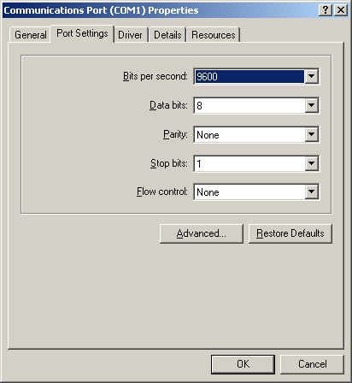

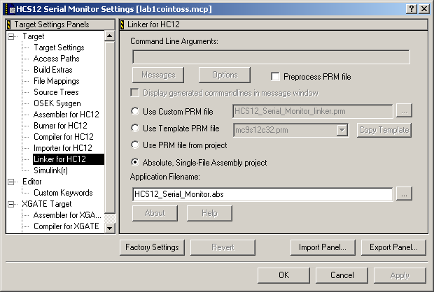

Using the Metrowerks IDE in-circuit debug monitor
If necessary, close the simulator debugger window (which may be open from the last section) by hitting “X” in the upper right corner of this window. Then select the box just under the “lab1_flashlight.mcp” label on the left side of the screen. Change this box from “Full-Chip Simulator” to “HCS12 Serial Monitor”. From the Metrowerks IDE window, make sure the “main.asm” file is highlighted in the left window, click the “Compile” button (7 buttons from the right) and the “Make” icon (6 buttons from the right), to ensure that the project files are up to date. Click on the green Debug icon (4th from the right). You should see some messages scroll by that indicate that the non-volatile program flash memory has been programmed on your CSM12C32 board. Eventually, if all has gone well, the same debugging window will come up as did in the previous simulation section.

Debugging with the in-circuit debugger
Just as you did in the simulator debugging section above (Section 7), you may once again use this debugging window to step through the program using the “Single-Step” icon. The only difference is that now the “LDAA PTT” instruction will load into the accumulator A the actual state of the physical switch that is connected on your breadboard! (Try stepping around the program loop with the switch both pressed and not pressed to verify this is true!) Also, the “STAA PTT” instruction will actually transfer data out to the physical LED on your board. Be sure to also watch the contents of the PTT data port register (at address $240) as you step around the program loop. Note that when the LDAA PTT instruction executes, the LSB of PTT which follows the state of the input switch on your breadboard, is transferred to Accumulator A. When STAA PTT executes, the MSB of the Accumulator A is transferred to the MSB of PTT, which sets the logic state of the LED on your breadboard.
You may also set breakpoints, as before. First you will need to reset the program. If you press the debugger window’s “reset target” button to reset execution, you will get a message that tells you to press the hardware reset button. Momentarily depress the hardware reset button and then click the Retry button. You will have to do this twice before execution is finally reset to the beginning of the program, and you are ready to rerun the program.
Now try setting a breakpoint as you did before at some intermediate instruction. Once you run at speed to the breakpoint, you may single-step from there, or you may press the green run arrow and run at speed until the next breakpoint is encountered. Try experimenting with setting multiple breakpoints in your code.
Now remove all breakpoints and run the program by clicking on the green Run button. Note that the physical LED will turn off whenever the switch is depressed. You need to click Halt and press the RESET button to stop this running mode. You cannot halt and continue.

Stand-alone execution of the user program
Now you can remove the serial cable from the PC. Then hit the RESET button on your breadboard. The flashlight user program should begin executing immediately! The fully-debugged user application is now running independently of the UBUG12 serial monitor!

Second assembly language example: Coin-Tossing Program
Now let us consider a more interesting (and more complex) embedded design assembly language example.

Specification of Coin-Tossing Program
All embedded designs must begin with a functional specification in which the desired product to be designed is described in words.
In this second embedded design example of a coin tosser, the hardware diagram remains as it was in Figure 3, except the pushbutton switch is moved to Pin #0 of Port M (PM0), and the LED is moved to Pin #1 of Port M (PM1). Every “click” of the pushbutton (by “click”, I mean pressing the pushbutton switch down, and then releasing it), will simulate a single toss of a coin, with the LED state coming up in a random state, where LED = ON implies a “Heads” outcome, and LED = OFF implies a “Tails” outcome. The LED stays in this state until the next click. In addition, statistics indicating the outcomes are displayed on the 8-bit I/O ports PORT T and PORT AD. The total number of “Heads” outcomes is accumulated, as an 8-bit binary number, on Port AD; and the total number of “Tails” outcomes is accumulated on Port T. (We will not bother to actually wire 8 LEDs to Port T and 8 LEDs Port AD to display these statistics, as this would be quite tedious; instead we will move a logic probe or scope probe along these 16 pins to observe that the proper number of Heads and Tails outcomes is being displayed as the pushbutton is successively clicked.)

Charting your course: the program flowchart
After the product specification is compete, the programmer must construct a hardware block diagram that shows the hardware that must be controlled, and then construct a program flowchart that indicates, at a high level, what the program must do to properly control the hardware.
A flowchart is a high-level description of the structure of a program. A flowchart consists of just four components: an oval starting block, that indicates the name of the program; rectangular processing blocks, which indicate major processing steps that must be performed in the program; diamond shape decision (conditional branching) boxes, that decide which processing step is to be performed next based upon the data being processed by the program; and the interconnecting flow direction arrow lines.
Just like an outline for a term paper, the flowchart is used to chart the course that the programmer plans to take in order to implement the program. And just like with a term paper outline, the flow chart should be constructed first, not last in the software design process! Once the program flowchart has been constructed, the interesting, creative software design work has been accomplished! All that remains is for the programmer to fill in the low-level details by actually coding the program.
However, human nature often runs counter to the idea of flowcharting (or term paper outlining). We humans tend to be impatient and impulsive. We are anxious to jump in and start programming without doing the requisite high-level planning (flowcharting) first! But consider how a traveller who takes the time to plan and map out their trip before leaving on it usually has a straighter, cleaner journey toward their goal, and does not get lost as often. The flowchart helps the programmer march more directly, efficiently, and cleanly toward the goal!
In an embedded design, the flowchart must be accompanied by a hardware block diagram, or in a simple case, a complete schematic diagram such as that shown in Figure 2, which shows the hardware devices that the program must interact with, and indicates their corresponding signal names that are referred to in the flowchart. In fact, the hardware diagram must be constructed before the flowchart, since you have to know exactly what you are going to program before you can program it!
Besides helping the programmer write a program, flowcharts are a great way to communicate the structure of a program to others. You can often get “lost in the forest for the trees” if you try to understand a large program by looking directly at its code (especially if it is assembly code).
One must decide on the appropriate “complexity level” of the flowchart. A flowchart is at too “low of a level” (too detailed) when basically each processing block and decision diamond in the flow chart represents what is done by just one machine instruction in the program. On the other hand, a flow chart that consists of just three processing blocks labelled: “Get data from input switches”, “Calculate result from input data” and “Output result to LEDs” would be too high a level, since the flowchart does not give enough information about how the result is calculated to be very useful! There has to be a happy medium in a flowchart, where enough of the detail is presented so that the programmer can easily write the program from the flowchart, but at the same time not overwhelm the reader with too much detail.
Figure 6. Flowchart for coin-tossing program (Drafted using the “Flowchart” Auto Shape Symbols in MSWORD found by clicking on Insert – Picture – Autoshapes)
The flowchart of Figure 6 indicates the logical flow and structure of the coin-tosser program of Figure 7. First the data direction registers and the PORTAD digital I/O enable register are set up so that all eight bits of PORTAD and PORTT are configured as digital outputs and PORTM has Bit #0 (PM0) configured as a digital input (for the pushbutton switch) and Bit #1 (PM1) configured as a digital output (for the Head/Tails LED). The nr_heads and nr_tails variables (memory locations), which will accumulate the total number of heads and tails outcomes, are initialized to zero.
*****************************************************************************
;* Coin Tosser Program Example (KEH) 8/5/2004 for CSM12C32 Module
;* Pushbutton SW on PM0, LED on PM1, PTAD holds nr. Heads, PTT holds nr. Tails
;*****************************************************************************
; export symbols
XDEF cointoss ; export 'Entry' symbol
ABSENTRY cointoss ; for absolute assembly: mark this as application entry point
INCLUDE 'mc9s12C32.inc'; This include file has all the MC9S12C32 register EQU's in it!
PushButton: equ PTM
LEDDisplay: equ PTM
ShowNumberOfHeads: equ PTAD
ShowNumberOfTails: equ PTT
; variable/data section
ORG RAMStart
nr_heads: ds.b 1 ;Allocate 1 byte of RAM: Number of head outcomes accumulated here
nr_tails: ds.b 1 ;Allocate 1 byte of RAM: Number of tail outcomes accumulated here
; code section
ORG ROM_4000Start
cointoss:
lds #RAMEnd ; Initialize user stack near top of RAM just below the monitor stack
bset ATDDIEN,$FF; Port AD is to be all digital I/O
bset DDRAD,$FF ; Port AD will be output port to display (as an 8-bit binary nr) the nr of heads.
bset DDRT,$FF ; Port T is will be output port to display (as an 8-bit binary nr) the nr of tails.
bset DDRM,%0000010; PM0 is pushbutton "die toss" switch input, PM1 is "Head/Tail" LED output.
bclr PERM,%00000001 ; Disable internal pull-up resistor on input PM0 (pushbutton SW)
clr nr_heads ; Initialize statistics to 0.
clr nr_tails
clr PTT ; Set all output pins low.
clr PTM
clr PTAD
Top_of_loop:
clrb ; Use B as a 1-bit counter that will be stopped when the switch is depressed... and thereby will contain a ; random outcome: either 0 or 1.
SW_wt_press:
eorb #1 ; Toggle LSB of accumulator B (if high, make it low, and vice versa)
ldaa PushButton ; Load accum A with the SW state (Bit #0)
anda #$01 ; Accum A = $01 if SW not pressed, and $00 if SW pressed
bne SW_wt_press ; Hang in this loop until SW is pressed
jsr delay_rtn ; Wait for pushbutton switch to stop bouncing
SW_wt_release:
ldaa PushButton ; Arrive here when SW is pressed, with random outcome in accum B
anda #$01
beq SW_wt_release ; Hang in this loop until switch is released.
jsr delay_rtn ; Wait for pushbutton switch to stop bouncing by calling delay_rtn subroutine.
slb ; Shift Head/Tail outcome into proper position (from Bit 0 to Bit 1)
stab LEDDisplay ; Send HEAD/TAIL result to LED on Bit 1 of Port M.
cmpb #2 ; If HEAD outcome, B = 2. If TAIL outcome, B = 0.
beq heads_outcome
tails_outcome:
inc nr_tails ; Update nr_tails RAM location
movb nr_tails,ShowNumberOfHeads ; Mirror this value on Port T
bra Top_of_loop
heads_outcome:
inc nr_heads; Update nr_heads RAM location
movb nr_heads,ShowNumberOfTails ; Mirror this on Port AD
bra Top_of_loop
;*********** End of main program*******************
; Here is a short delay subroutine that delays for about
; 20 ms before returning. It is used for pushbutton switch debouncing
delay_rtn: ldy #$ffff
delay_more: dey ;
bne delay_more ;Count y down from $ffff to 0.
rts ;Return addr (pop return addr off stack into PC)
; Here we intialize the RESET vector to point to the
; start of the cointoss program
ORG $FFFE
dcw cointoss ; Intialize Reset Vector with starting address of coin toss program
cmpb #2 ; If HEAD outcome, B = 2. If TAIL outcome, B = 0.
beq ;heads_outcome
tails_outcome:
inc nr_tails ; Update nr_tails RAM location
movb nr_tails,ShowNumberOfHeads ; Mirror this value on Port T
bra Top_of_loop
heads_outcome:
inc nr_heads; Update nr_heads RAM location
movb nr_heads,ShowNumberOfTails ; Mirror this on Port AD
bra Top_of_loop
;*********** End of main program*******************
; Here is a short delay subroutine that delays for about 20 ms before returning. It is used for pushbutton switch debouncing
delay_rtn: ldy #$ffff
delay_more: dey
bne delay_more ;Count y down from $ffff to 0.
rts ;Return addr (pop return addr off stack into PC)
; Here we initialize the RESET vector to point to the start of the cointoss program
ORG $FFFE
dcw cointoss ; Intialize Reset Vector with starting address of coin toss program
Figure 7. The Coin Tossing Program.
The program now enters its infinite processing loop. The first step in this processing loop is a short internal loop (see the lower left of the flowchart) where the least-significant bit (LSB) of accumulator register B, is used to indicate the head/tails outcome. This LSB is toggled (changed) back and forth between 0 and 1 very quickly until the user presses the pushbutton switch, at which time the program execution falls out of this first internal loop. At this point, the LSB of accumulator B contains a random head or tails outcome, since the pushbutton will be pressed at a random time and the LSB is being toggled back and forth very quickly. Next the program waits 20 ms for the switch contact bouncing to die out before the state of the pushbutton switch is again looked at by the program. This is a very important step, since after the contacts of any mechanical switch close, they will bounce (or “chatter”) rapidly between their closed and open states for a few milliseconds before the switch contacts remain reliably closed (until the pushbutton switch is later released). We do not want each of these rapid switch bounces to cause a separate heads/tails outcome to be recorded by our program in the nr_heads and nr_tails locations. This is why the program must delay for 20 ms after the first switch closure is noted.
Program execution then enters a second short internal loop (top right of the flowchart), where we wait for the pushbutton switch to be released. Once again, the switch contacts might once again bounce as the contacts of the switch are opened, so we once again must delay 20 ms. In general, any mechanical switch tends to bounce for a few milliseconds both when the switch is pressed (“make”) and when the switch is released (“break”). Next, the LSB of accumulator B is checked for the outcome and either nr_heads or nr_tails is incremented, the result is displayed in the LED, and program execution returns to the top of the infinite processing loop.
Once the flowchart is complete, an assembly-language program that implements the flowchart is easily written (see Figure 6). Make sure that you understand each instruction in this program and how it implements the flowchart of Figure 6.
Note the use of the “INCLUDE mc9s12c32.inc”. This file consists of a large collection of equate (EQU) statements that symbolically define the microcontroller’s register addresses and the contents of these addresses. Please take the time look over the contents of this file, which can be found at
C:\Program Files\Freescale\Codewarrior for HC12 V4.6\lib\hc12c\include
By including this file at the top of a 9S12C32 assembly program, we can save a lot of typing and avoid hard-to-find address assignment errors!

Making the project and in-circuit debugging with the UBUG12 serial monitor
Make a new project with the Project Wizard. When you get to the step where you are to modify the template main.asm file, copy the “main.asm” file that may be downloaded from the Lab 1 class folder on ANGEL in place of the template main.asm file. This main.asm file contains the “Coin Tossing program shown in Figure 9.
Once the project creation is complete, expand the Libraries category in the “project view” by clicking on the {+} next to it. Then click on the “mcCSM12C32.inc” file to open it up. Note that this file contains a very long series of equate (EQU) statements that associate each of Freescale’s “official” MCCSM12C32 microcontroller register names with their respective addresses, such as “PTM: EQU $250” and “DDRM: EQU $$252”, etc. By including this file, you do not have to define the address each of the symbolic register addresses as you did in the flashlight program. However, this very helpful “include file” must be modified. Change the very first EQU statement in this file from “RAMStart: EQU $800” to “RAMStart: EQU $3800”. Also, on the next line, insert an additional EQU statement: “ROMStart: equ $4000”. Note that this file has been included at the beginning of the main.asm source file. Therefore, the programmer no longer needs to associate the register names with addresses… just so you remember to use the “official” register names assigned by Freescale in your program. If you forget what name to use for a certain register, you can open up the mcCSM12C32.inc file and search through it.
Click on the main.asm program in the “Sources” category to open up an editing window. Then click on the “Make” icon to assemble the source program. After you have successfully assembled this program, you should now try running this program with the in-circuit debugger, following the steps outlined in Section 9. Try setting a breakpoint at the “STAB PTM” instruction. Then, when you run the program, you will not hit this breakpoint until the switch has been “clicked” (pressed down and then released). From this point you can single-step through the program, noting how the correct variable (nr_heads or nr_tails) gets updated. When you remove the breakpoint, you should be able to observe the proper operation of the program, where a random LED state is displayed after each button click, and a logic probe may be used to observe that the correct number of heads is accumulated on PORT T and the correct number of tails is accumulated on PORT AD.

Debugging without the CSM12C32 breadboard: using the simulator
You should also try using the simulator to verify the correct operation of this program, though it is not quite as easy to verify program operation without the actual microcontroller hardware being present. This can be done by following the same steps you followed in Section 8.
After you have brought up the simulator debugger, click on Component – Open – IOLED. Set up this IOLED object with the following addresses: PORT = 250 and DDR = 252. This allows you to monitor the heads/tails outcome indicator LED on Bit #1 of PORT M. Likewise, open up a second IOLED object, and set its addresses to PORT = 270 and DDR = 272 to allow you to monitor the 8-bit “heads count” on PORT AD. Finally, open up a third IOLED object , and set its addresses to PORT = 240 and DDR = 242. This allows you to monitor the 8-bit “tails count” on PORT T.
Now begin single-stepping through the program. Click on the “Step Over” button (5th button from the right), as you single step in this example, so you will step over (not into) the called delay subroutine. If you step into the delay subroutine, it will take to long to step all the way through it!
When you hit either of the two “LDAA PTM” instructions, which are used in the program to read the state of the switch on Bit #0 of PORT M, take one more step to the “ANDA #$01” instruction, and then double left click on Accumulator A in the Register Window to highlight it. Then type in either a “01” (switch UP) or a “00” (switch down) to simulate the switch being read as either high or low. THEN BE SURE TO HIT ENTER BEFORE TAKING ANOTHER STEP, IN ORDER TO ACTUALLY LOAD THIS VALUE INTO REGISTER A of the simulator. You may now resume single-stepping. You should be able to simulate several heads and tails outcomes in this way. You should be able to watch the current head or tail outcome get displayed on the PM1 LED, and also watch the number of heads accumulate on the eight PORT AD LEDs, and the number of tails accumulate on the eight PORT T LEDs.

Your first embedded design assignment: A “fair” dice tosser!
Your first assembly-language programming assignment is, after completing the previous exercises and thoroughly understanding the flashlight and the coin-tosser programs, to modify the coin-tossing assembly language program of Figure 7 to make it into a (reasonably fair!) six-sided “die-tosser”.
Add two more buffered LEDs (on PM2 and PM3) to your breadboard.
Next, using the coin-tossing example of Fig. 7, as a starting point, write a dice-tossing program so that every time the button is clicked (pressed, then released), a random binary number between 1 and 6 is displayed on the three LEDs. The state of the LEDs should remain stable between each click, holding the previous outcome of the die toss. A new outcome should appear after each click.
In a manner similar to that of the coin tosser example, allocate six RAM data bytes using the “define space” (DS.B) directive to keep track of the number of times the die tosser has come up with each possible outcome (1 – 6). However, these statistics cannot be displayed on I/O pins, since we would run out of I/O ports! (We will learn later several methods for expanding the I/O capability of a microcontroller.) Instead, these statistics can be checked by observing the value of each of these variables in the in-circuit debugger’s “Data window” after program execution has been halted.
Test your dice tosser by operating the pushbutton switch for a minimum of 250 times (1000 times would be better!), and record the final contents of these RAM locations in your report. (Hopefully you will be able to show that your dice tosser is “fair”, with approximately equal numbers being accumulated for each of the six possible outcomes.)
Demonstrate your working coin tosser program to the lab instructor, getting his signature on your (well-commented!) assembly source file.
Your lab report should be “memo style”, and it must follow the format described in the first day handout. In particular, this first lab report must consist of a memo that specifically refers to the following four attachments (or appendices):
(1) Schematic diagram of your hardware interface circuit for the die tosser similar to that shown in Figure 4. Your hardware schematic must be drafted using ORCAD. The symbol for the 9S12C32 module (See Figure 1) can be cut and pasted from the ORCAD symbol that appears on the “Technological Arts” M68MOD912C32 CDROM that came with the 9S12C32 microcontroller module. Many other useful ORCAD symbols can be found in the “Digikey” ORCAD parts library. The most recent version of this parts library can be downloaded at:
http://www.orcad.com/downloads/cistarterdb/default.asp.
(2) Flowchart of your die-tossing program.
(3) A well-commented listing of your die-tossing assembly source program and your assembly listing file, showing the work done by the assembler alongside your source code.
(4) (MOST IMPORTANT!) Your test results, consisting of a table that indicates the number of die tossing outcomes (out of 250 tosses) for each side of the die (Be sure to sign and date this section to certify that you and your partner actually recorded this test data).
Each of these attachments must be numbered and labeled appropriately with a meaningful caption. Each attachment must be referred to and also discussed in the text of your memo.

Possible Errors and Solutions

Elf Loader Error
Check the following to fix the error by choosing Monitor-HCS12->Load options
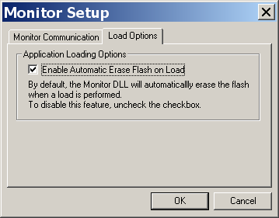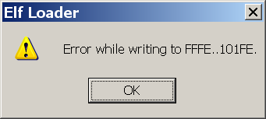

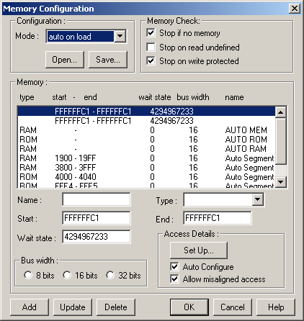
Simulator RAM range error
RAM range in the simulator may not be set correctly. For example, The initial RAM range might be from 0x3800 to 0x3800. It should be changed to 0x3800 to 0x3FFF as follows under Simulator->HCS12FCS>Configure….. This error may cause stack not to work correctly. For example, a subroutine may not be able to return to its caller.

Error message: L1116: Function main not found
This message will occur when the project does not have a function named “main”. It seems that one function must be named main, which is the starting point of the object code for a project.

Error in command file .\cmd\monitor_postload.cmd!
The following error occurs if Findproc command had a process name that did not exist in any source file. Findproc command is in file Debugger Cmd Files->Monitor->Monitor_PostLoad.cmd

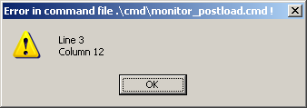
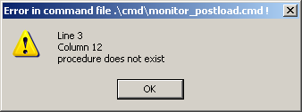

The process should be the label to start the main program. Use this in general: Findproc main. Declare main as your reset vector. The following example declares maximum as the starting address of the code.
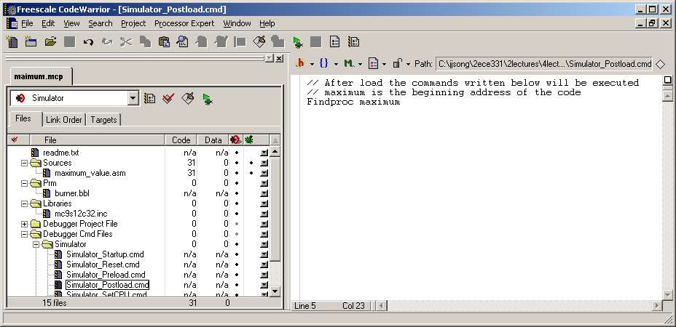

Warning on dbg file
How to fix this??
