Circuit Drawing and Simulation using Cadence Orcad Lite V. 9.2
Prepared by Keith Hoover for Operation Catapult 2002
Dept. of Electrical and Computer Engineering
Rose-Hulman Institute of Technology
Terre Haute, Indiana 47803

1. Introduction to SPICE and PSPICE
SPICE is an electronic circuit simulation tool that was developed at the University of California at Berkeley in the mid 1970’s. SPICE is an acronym that stands for “Simulation Program with Integrated Circuit Emphasis”. It was developed specifically for use in verifying the proper operation of new integrated circuit designs before they are ever committed to silicon. Therefore, SPICE had to yield very accurate predictions of circuit performance, since many dollars are at stake when committing a new IC design to silicon!

SPICE soon became a very popular industrial and academic general circuit simulation tool, because it was developed under U.S. government funding and was therefore distributed free of charge to any U.S. citizens. Early versions of SPICE were confined to run on large computer mainframes that used the UNIX operating system, but soon SPICE programs capable of analyzing relatively small circuits were migrated to run on the IBM PC platform in the early 1980’s, as the IBM PC came into widespread use

The original SPICE program required a “net list” description of the circuit to be entered. (The net list was also called a “simulation SPICE deck” in the old days of computer punched cards.) In the net list, each circuit component must be entered on a line that contained a label that denoted the component type, the component value, and the node numbers across which the device is connected. Making a net list required drawing the schematic and then numbering the nodes. (The ground node must be numbered “0”, but the rest of the node numbering is arbitrary).

PSPICE is an enhanced commercial version of SPICE. PSPICE was first marketed by MicroSim. Then MicroSim was bought by OrCad, which was in turn recently acquired by Cadence. Orcad PSPICE has a very useful “schematic capture” front end “pre-processing” program called “CIS Capture”, that allows the circuit schematic to be drawn on the computer screen, and then PSPICE automatically numbers the nodes and generates the net list. PSPICE also has a very nice graphical plotting “back end” program called “PROBE”. Using the PROBE graphical post-processor, the PSPICE output can be plotted. Multi-trace plots are easily generated. A set of X-Y cursors can be employed to read and display precise values at any desired point on any selected waveform.

Orcad Lite Version 9.2 PSPICE is a “crippled” freeware demonstration version of the commercial industrial-strength version of Cadence’s Orcad SPICE that can run on a wide variety of computer platforms, including the inexpensive IBM-compatible PC’s. By “crippled”, I mean that a number of restrictions have been intentionally built into the freeware version, which seldom hamper the student who desires to simulate and study simple basic electronic circuits containing only a few components, but would make it impossible to simulate most of the more complex practical industrial circuits. This clever so-called “crippleware” scheme has made MicroSim Demo PSPICE, and now Orcad Lite PSPICE, by far the most popular educational circuit simulation tool. The overwhelming academic acceptance of PSPICE “crippled freeware” has contributed to the success of the commercial version of this product, as students trained to use the PSPICE freeware have graduated and entered industry. PSPICE has become the defacto standard academic circuit simulation software, and it is covered in depth in dozens of recent electronics textbooks.

Some of the more notable limitations of the Orcad Lite crippleware Version 9.2 PSPICE are listed below:
Orcad Lite V. 9.2 PSPICE Freeware Limitations
- Schematic drawings limited to a maximum of 60 instances of the same part.
- Simulations limited to a maximum of 64 nodes.
- Simulations limited to a maximum of 10 transistors. (Each OP AMP model contains 2 transistors.)
- Simulations limited to 10,000 digital logic level transitions.
- Simulations limited to a maximum of 10 transmission lines.
- Only a subset of the component PSPICE simulation libraries are made available, though more can be downloaded from the internet using the Capture CIS (component information systems) program.

2. Types of Analog PSPICE Simulations
There are several distinct types of analog PSPICE simulations: DC quiescent operating bias point calculation, transient analysis, sinusoidal steady-state “AC sweep” (frequency response) analysis, and “DC sweep” (voltage transfer curve) analysis.

DC quiescent operating “bias point” calculations are performed automatically, since the DC operating point must be known in any electronic circuit containing diodes or transistors before the AC behavior of the circuit can be determined.

Transient analysis simulations are probably the most popular type of PSPICE analysis, where one or more time-varying response waveform(s) are calculated based upon one or more specified time-varying input source waveform(s). Various types of input source waveforms are available for transient analysis. The most popular transient simulation sources are the sinusoidal voltage source (VSIN), voltage pulse train (VPULSE), exponential voltage source (VEXP), or piecewise-linear voltage source (VPWL), where any piece-wise linear waveform may be ascribed to the source. In addition, VPULSE has the following special cases: square wave (Vsq), triangle wave (Vtri), saw-tooth voltage source (Vramp), and TTL-level (0 – 5V) square wave with adjustable frequency and duty cycle (V_ttl)

AC Sweep analysis simulations calculate the amplitude and phase of the AC (small-signal) part of the response signal as a sinusoidal steady-state source (usually the AC sinusoidal steady-state source is called “VAC”) is varied over a specified range of frequencies. Such simulations yield standard frequency response curves, or “Bode plots” of the indicated sinusoidal steady-state output node voltage (either magnitude or phase) vs. source frequency. It is essential to keep in mind that while AC sweep analyses yield very useful gain and phase frequency response information, they give no indication of the dc offset (which is calculated separately by the DC quiescent operating point calculation). In addition, AC sweep analyses do not indicate signal saturation levels, as they are based purely on “small-signal” analysis theory. Thus in an AC sweep analysis, the AC input source can be assigned unrealistically high voltage amplitudes, say 1 V, even when a high gain amplifier circuit is being simulated, whose output would actually saturates with a 1 V input. The level of saturation must be investigated via a separate transient simulation.

DC Sweep analysis simulations yield voltage transfer curves, where a dc source voltage (usually the dc source is called “VDC”) is varied over a prescribed range of values. Then the indicated output node voltage is plotted versus the swept source voltage.

Examples of all three of these simulations will be presented later in this document.

3. PSPICE Element Names
PSPICE circuit elements are given distinctive part names whose first letter corresponds to the element type, and after this first letter, the name may consist of up to seven letters and digits. This concept will help you locate the proper part when you are drawing your schematic diagram. For example. PSPICE component names are case-insensitive.

C = capacitor, D = diode, E = voltage-controlled voltage source, F = current-controlled controlled current source, G = voltage-controlled current source, H = current-controlled voltage source, I = independent current source, J = JFET, K = mutual inductance, L = inductor,
M = MOSFET, Q = BJT, R = resistor, S = voltage-controlled switch, T = transmission line,
V = independent voltage source, W = current-controlled switch, X = user-defined sub-circuit.

4. PSPICE Scale Multipliers
Component values consist of a number that may (or may not) have one of the following scale-multiplying suffixes appended (no embedded blanks allowed): These scale multiplying suffixes may be either upper or lower case; that is, they are case-insensitive.

F = femto (10⁻¹⁵), P = pico (10⁻¹²), N = nano (10⁻⁹), U = micro (10⁻⁶), M = milli (10⁻³),
K = kilo (10³), MEG = mega (10⁶), G = giga (10⁹), T = tera (10¹²)

Note from this table that the most common mistake made by almost all PSPICE beginners is to confuse M with MEG! 12.3M = 0.0123, while 12.3MEG = 12,300,000.

Though PSPICE itself makes no use of specified units, common (case-insensitive) units such as HZ, OHM, V, A, H, F, DEG, S may be appended after the scale multiplier, with no embedded blanks, to remind the user of the units that are assumed on various component values. For example, a resistor value might be expressed as 1.5Ohm = 1.5 Ω, 1.5kOhm = 1500 Ω, 1.5MOhm = 0.0015 Ω, and 1.5MegOhm = 1,500,000 Ω. Note once again that no embedded spaces are allowed between the numeric value and the suffix; for example, a capacitor must be assigned a value of 150UF, not 150 UF.

5. Orcad Lite V. 9.2 Installation Instructions
To install Orcad Lite V. 9.2 on your laptop, please follow the steps below. (About 140 MB of space is required on your hard drive for the Capture CIS and the PSPICE A/D programs).
- Disable any anti-virus detection program that may be running, as this will often prevent new programs from being properly installed.
- Put the Orcad Lite V. 9.2 Installation CDROM, available from the instrument checkout room, into your computer’s CDROM drive and click on Start – Run – D:\Setup.exe (Where D: is the letter of your CDROM drive.)
- Select the Capture CIS and the PSPICE products only. The letters “CIS” stand for “component information system”, and it allows additional device models to be acquired easily over the Internet.
- Click Next button several times to accept default directory and folder names.
- Cadence Product File Transfer Window should appear, and files will be transferred to your PC’s hard drive from the Orcad Installation CDROM.(wait few minutes).
- Click Finish button.

6. Transient Analysis Example #1: From Schematic to PROBE Plot!
The detailed steps listed below will guide you through the entire transient analysis of a full-wave rectifier dc power supply circuit with capacitor filter. Everyone should work through this example in detail, in order to become familiar with the Orcad 9.2 schematic entry, PSPICE simulation, and PROBE analysis procedure. Later examples will not be so detailed.

- Install the Orcad Lite V. 9.2 CDROM in your computer. Click on Start – Programs – Orcad Family Release 9.2 Lite Edition – Capture CIS Lite
- Once the Orcad Capture - Lite Edition window appears, you must create a new project for your simulation. Do this by clicking on File – New – Project. A “New Project” window should appear.
- Click on the Browse button in the lower right-hand corner of the New Project window. Then browse to the desired folder in which you want to save your PSPICE simulation project. If an appropriate folder has not yet been created, you may use the Create Directory button to create a new folder for your project.
- Check the “Analog or Mixed A/D” radio button.
- Enter the desired project name, say “Full-Wave Rectifier Example”, and hit the OK button.
- The “Create PSPICE Project” window appears. Check the “Create Blank Project” radio button, and hit OK.
- A Schematic 1:Page 1 schematic diagram “sheet” window appears. Click the tiny square in the upper right of this schematic drawing window to expand it to fill the monitor screen.
- To place a part on the schematic sheet, click on Place – Part, or simply hit the letter “P” on your keyboard, or single left click the component selection icon to the right of the schematic sheet. (It is the second icon from the top that is shaped like an AND logic gate). A “Place Part” window should appear.
- Click on “Add Library”. A list of the PSPICE simulation device model libraries should appear. (The commercial version of Orcad PSPICE has a much more extensive list of PSPICE device models.) Hold down the Ctrl key and while it is down, click on each library that is displayed. Hit the Open button. This will place all of the parts that are available in the selected Orcad Lite PSPICE simulation libraries into the Parts List window.
- Start by placing the sinusoidal voltage source on the schematic sheet. For a transient simulation, you must use the VSIN sinusoidal voltage source. In the “Part” blank, enter VSIN, and click OK. Alternatively, the VSIN source may be selected from the Parts List by double left clicking on the VSIN entry). As you begin to type the part name into the Part blank, note how the Parts List scrolls. Thus, if you are looking for a part such as a BJT transistor, but you do not know its part number, you can begin by typing Q (since we know from Section 3 that all BJT parts must start with the letter Q) in the Part blank, and then looking down the Parts List to see what is available.
- As you drag the mouse cursor around the schematic sheet, the VSIN symbol outline (not yet distinct) should follow. Somewhere near the middle left of the sheet, deposit (instantiate) the part by single left clicking the mouse. Note that you could place multiple instantiations of the part by dragging the part with the mouse to new locations, and left clicking; but in this case we do not want to place any further instances of this part, so single right click the mouse, and choose the “End Mode” menu item from the list that appears, in order to terminate the entry of this component.
- If you accidentally deposit extra instances of a part do not despair. After you have terminated component entry (by left clicking and then selecting End Mode), simply place the mouse over the unwanted part and single left click to highlight it (a pink dotted box will appear around the part), and then hit the Delete key.
- If you decide to move a part that has already been placed, simply move the mouse button over the part to be moved, and hold the left mouse button down, as you drag the part to the new desired location. Then release the mouse button to deposit the part at its new location.
- If you want to rotate the part symbol by 90 degrees before it has been instantiated, hit the “R” key on your keyboard. The device outline will rotate by 90 degrees and when you instantiate it, that is, the part symbol will be oriented horizontally, instead of vertically. Likewise, you can use the “H” and “V” keys to mirror the part horizontally or vertically. Rotating and mirroring can be done after the part is instantiated as well, simply by selecting the part (by left clicking on it so that the pink highlighting box appears around it) and then right clicking on the selected part, and choosing “rotate” or “mirror” from the menu that appears.
- Now that one instance of VSIN has been placed on the schematic, you will want to assign its parameters. For transient simulation, VSIN has three parameters that must be set: FREQ (frequency of the sine wave), VAMPL (amplitude of the sine wave), and VOFF (dc offset). To set these parameters, double left click on the VSIN part. The Orcad Lite Property Editor window will appear. Click in the cross-hatched FREQ box to enter the frequency (60HZ). Recall that PSPICE does not care about the HZ (Hertz) units; it is happy to have the frequency entered as 60, but the units (HZ) may be helpful to remind the user of what units have been assumed in the simulation. Then use the scroll bar at the bottom to scroll to the end of the entry line, and enter VAMPL as 20V and VOFF as 0V. Hit the “X” in the upper right corner of the Property Editor window to exit.
- Now hit “P” to bring up the Place Part window again. This time, type “D” in the Part blank, in order to display the region of the parts list that contains the diode models, and choose the D1N4002 (1 A, 50 PIV power diode) part. Instantiate (place) this part 4 times on the schematic, and rotate the diodes into the standard bridge configuration (see Figure 1).
- In similar fashion, place the resistor (R) and capacitor (C) as shown in Figure 1. Both of these components must have their component values entered (let R = 4KOhm and C = 10UF), since the default values shown are not the desired values. Double left click on these symbols, and enter the desired component values in the Property Editor; or double left click directly on the default value of each component, and enter the desired component value in the more compact “Display Properties” window. (This latter method is somewhat more convenient than the former. In fact, you could have entered the three VSIN parameters this way as well!)
- To wire the parts together, click on Place – Wire, or simply hit the “W” key on the keyboard, or click on the Place Wire button icon (the third one from the top at the right of the screen). The mouse cursor changes from an arrow to a cross. Place the cross over a device terminal, then single click the left mouse button to connect a wire to this terminal, drag the wire to the terminal to which it is to be connected, and then single left click to connect the wire to this terminal. You may then repeat the procedure as many times as necessary, until all of the component terminals have been connected. A wire may be routed in a specific way by left clicking at intermediate points where you desire the wire to bend 90 degrees, thereby anchoring the wire to those intermediate points on the schematic grid. Notice that wires may cross without being connected to each other, just so you do not left click at the point where the wires cross!
- To terminate wire entry, you may either right click and choose End Mode, or you may left click on the Selection (arrow) button icon, which is the topmost icon to the right of the schematic sheet. The cursor should change back from the cross to the selection arrow. The selection arrow may now be used to delete any misplaced wires, just as it was used above to delete or move schematic part symbols.
- Before the schematic is complete, a ground reference symbol must be placed on one of the circuit nodes. Though many ground symbols are provided for drawing purposes, you must choose the one ground symbol whose name starts with the number “0”in order for the PSPICE simulation to work properly --- the “0” in the part name tells PSPICE that this is the ground node (Node 0). To bring up the ground symbols, hit the “G” key, or else click the GND icon button that appears to the right of the schematic sheet. In the Place Part Window that appears, the “0” ground may not initially be present. If it is not, click on the “Add Library” browse (if necessary) to the PSPICE directory, and select the “source” library. The “0” ground part should now be displayed.
- Place the “0” ground symbol as shown in Fig. 1, and wire it to the indicated ground node. Of course, multiple “0” ground symbols may be used to avoid having to tie all of the grounded nodes together with a wire.
- We must tell PSPICE what output nodes are to be displayed in the PROBE plot. In this case, we are interested in plotting the voltage across the load resistor. Since one side of this resistor is grounded, we may use a “single-ended” probe (in much the same way that we would use a single-ended oscilloscope probe to view this voltage in the lab). Click on the single-ended voltage probe marker (circle V) icon at the top of the schematic sheet and deposit this probe to the top of the load resistor, as shown in Fig. 1.
- Also of interest is the voltage across the VSIN source. Because neither side of this source is connected to the ground node, we must use a differential probe, just as we would have to use a pair of oscilloscope probes, to view the voltage across this source in the laboratory. Click on the differential voltage marker icon (circle + and circle -). Then deposit the (+) marker by single left clicking on the top terminal of the VSIN voltage source, and deposit the (–) marker by single left clicking a second time on the bottom terminal of the VSIN voltage source.
- Labels may added to the schematic by clicking the ASCII entry icon labeled “A” (the bottom-most icon located to the right of the schematic sheet.)
- Next we must tell Orcad how we want the transient PSPICE simulation to be carried out. This is done by creating a Simulation Profile by clicking on PSPICE – Create New Simulation Profile, or by clicking on the like-named icon at the top of the schematic sheet. Enter a name for this simulation profile (such as FW Rect), and hit the Enter key. A Simulation Settings window will appear. Select the “Time Domain (transient)” simulation type, and check the General Settings option. Change the Run To Time box to indicate how far in time we desire to run the transient analysis. Since in this simulation, our source is 60 Hz, and a 60 Hz sine wave repeats every 1/60 = 16.66 ms, we shall run our transient analysis out beyond 2 cycles = 34 ms. So enter 34MS into the Run To Time box, enter 0 into the “Start Saving Data After” box, and enter 50US into the Maximum Step Size box. (In general, the maximum step size should be about 1/1000 of the transient simulation run time.) Leave the Skip Initial Transient Bias Point Calculation box unchecked. Click OK.
- Now run the PSPICE simulation by clicking on PSPICE – Run, or by clicking on the Run PSPICE icon (blue arrow) above the schematic sheet. The PROBE plot should appear showing both input and output waveforms, as depicted in Figure 2.

Figure 1. Full-Wave Rectifier With C Filter – Drawn Using Orcad Lite

- Now click on the “Toggle Cursor” icon button above the schematic sheet, and select the desired output waveform (trace) that you want your X-Y crosshair cursors to track by clicking on the desired trace symbol appearing at the lower left of the PROBE plot, which si a small dot, circle, or square that is located just to the left of the output waveform name. The probe cursor coordinates appear in the Probe Cursor window. The cursor coordinates are indicated in the top line labeled “A1”(the horizontal time position is followed by the vertical voltage value). Note that these coordinates are continuously updated as you move the mouse horizontally, dragging the cursor cross-hairs along the waveform. Right clicking will save these coordinates on the second line (A2), and line A1 will continue to track the new mouse position, with the third line, labeled “dif”, registering the difference between the current cursor position A1 and the saved cursor position A2. The “dif” line permits easy measurement of output waveform slopes.
- At any desired position of the cursor, you may permanently display the precise cursor coordinates right on the PROBE plot by clicking on the Mark Label button icon (located along the top, on the far right). Once the cursor crosshairs have been toggled off (by hitting the Toggle Cursor button a second time), you may use the mouse to drag the coordinate labels, and also the coordinate marking arrow, to a more readable position on the plot. Other cursor control icon buttons are available for automatically locating waveforms peaks and waveform troughs and positions of maximum slope --- these come in handy if we want to measure the ripple voltage amplitude of our full-wave rectifier circuit. In the PROBE plot of Fig. 2, I have used the appropriate buttons to automatically find the maximum (peak) and minimum (trough) output voltage excursions, and then I have used the Mark Label button to permanently label the coordinates of the peak and trough. These coordinates can be used to measure the simulated peak-to-peak ripple voltage amplitude of 18.66 – 15.85 = 2.81 V.
- To print the schematic, first “select” the entire schematic, using your mouse to drag a rectangular selection box around the entire schematic diagram (highlighting it in violet-pink). To do this, position the mouse cursor in the upper left corner of the diagram, and then hold down the left mouse button as you drag the cursor to the lower right corner of the schematic. Then release the left mouse button. Then select the “Scale to Paper Size” button, and click on File- Print - OK.
- To print the PROBE plot, select the PROBE window and click on File – Print – OK.

7. Transient Analysis Example #2: Schmitt Comparator
A diagram of an inverting Schmitt comparator circuit using a UA741 OP AMP is shown in Fig. 3. Note that like real OP AMPs, the UA741 SPICE model must be powered with two dc supply voltages, one positive with respect to the ground node and one negative. This Schmitt comparator circuit is driven with a 1-Hz, 10 V peak “VSIN” sinusoidal source. This time, the transient PSPICE simulation is set up to run up to 2 seconds, so that the response to two sinusoidal input cycles are displayed. A PROBE plot containing the sinusoidal input voltage (Vin) and the rectangular output voltage waveform (Vout) is shown in Fig. 4. The observed rising and falling input trigger thresholds, VT+ = 4.612 V and VT- = 2.349 V, are apparent on this plot, and they have been marked on Fig. 4 using the “Mark Label” icon, which appears after the “Toggle Cursor” icon has been used to turn on the cursor cross-hairs.

Figure 2. PSPICE Simulation of Full-Wave Rectifier Circuit of Fig. 1

Figure 3. Schematic of Inverting Schmitt Comparator

Figure 4. Probe Plot Resulting from Inverting Schmitt Comparator Schematic

8. Transient Analysis Example #3: OP AMP High-Current Voltage Follower
This third transient analysis example shown in Fig. 5 contains an OP AMP along with a Q2N3904 NPN BJT and Q2N3906 PNP BJT connected in “complementary symmetry” fashion, to form a high-current, unity voltage gain, voltage follower circuit capable of driving high currents through a relatively low-resistance (30 Ohm) load resistor (R1). At its peak value, the load current is 3V / 30 Ohms = 100 mA, which is well beyond what the LM741 OP AMP could deliver alone, since this OP AMP is current-limited to about 20 mA. During positive output voltage swings, transistor Q1 is off, while the NPN BJT Q2 is on and functioning as a (unity-gain) emitter follower. During negative output voltage swings, transistor Q2 is off, while the PNP BJT Q1 is on and functioning as an emitter follower. Note that the feedback path for the unity-gain voltage follower includes the BJT output stage. This overcomes crossover distortion (the dead zone near the output voltage zero-crossings, where both Q1 and Q2 are OFF) as well as the 0.7 V output voltage drop associated with BJT emitter follower stages. Fig. 6 shows the results of this simulation. Note that the output follows the input perfectly, so only one waveform can be seen.

To investigate what would happen if the negative feedback connection had been connected from Pin 6 of the OP AMP to Pin 2, without including the BJT output stage in the feedback path, the PSPICE simulation was repeated with the feedback path re-routed directly around the OP AMP, not including the BJT complementary-symmetry output stage, and the resulting PROBE plot is shown in Figure 7. Cross-over distortion, and also the 0.7 V drop, is now quite apparent. The output no longer perfectly follows the input.

Figure 5. Voltage Follower with Boosted Output Drive Current Capability

Figure 6. Probe Plot for High Current Voltage Follower Circuit of Fig. 5
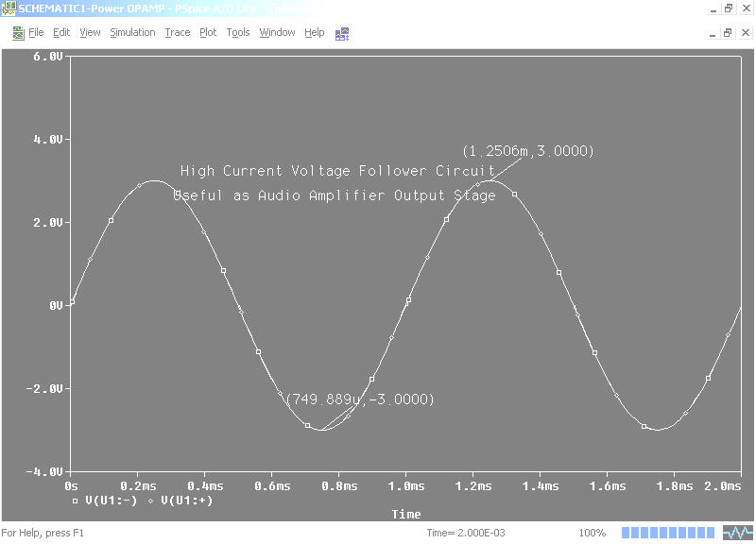

Figure 7. Voltage Follower with OP AMP output fed directly back to (-) Input
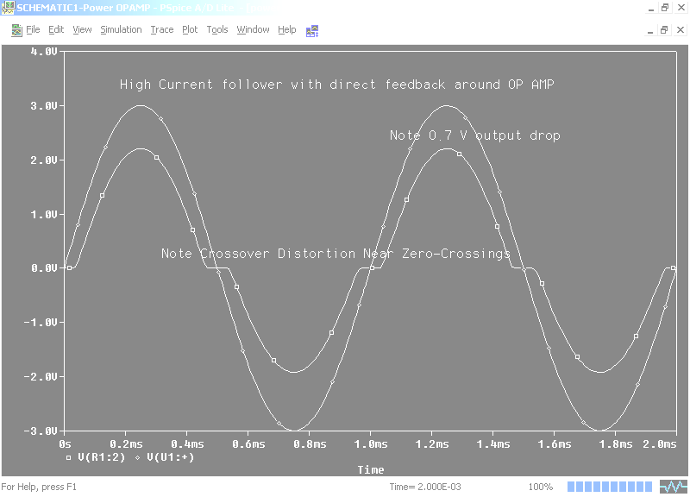

- AC Frequency Sweep Simulation Example

A 6th-order Butterworth (maximally flat passband) and Bessel (linear phase) 1 kHz active low pass filter (LPF) is designed by cascading three 2nd-order Sallen-Key active filter circuits. The component value calculations based upon the active filter design table distributed in class are presented in Figure 8.

Note that this circuit diagram was constructed using “dc power nodes” to connect DC power to the three UA741 OP AMPs, without having to use actual wires, which would have unnecessarily cluttered the schematic drawing. In this example, the dc power bus was connected by left clicking on the PWR icon button to the right of the schematic sheet. Then a “distinctive power node” shape was arbitrarily chosen (VCC_arrow) to represent the Vcc = +15V dc power node, and a different power node shape (VCC_bar) was arbitrarily chosen to represent the Vee = -15V dc power distribution bus. These two dc power node symbols are merely node connection symbols, not power sources in their own right, so besides connecting the VCC_arrow power node to the three Vcc dc power terminals of the OP AMPs, the VCC_arrow power node also had to be connected to an actual dc power (VDC) source that was set to a value of +15 V, and the other side of this source had to be connected to ground through a “0” ground symbol. The –15 V Vee power bus, indicated by VCC-bar, was handled in similar fashion.
When it came time to set up the Simulation Profile, the time the analysis type had to be changed from transient to “AC Sweep/Noise”. The AC Sweep Type was set for a Start Frequency = 10Hz, End Frequency = 10KHz, and Points/Decade = 30.

In order to make the resulting PROBE plot resemble a Bode frequency response plot (a plot of dB Gain vs. Log Freq), the Logarithmic radio button was checked, with Decade markings, as opposed to octave markings, selected. Since this is an AC simulation, the circuit was driven with a sinusoidal AC steady-state voltage source, VAC of 1V amplitude. It is common practice to specify a 1 V amplitude in AC Sweep PSPICE simulations, even if the gain of the circuit would cause an actual 1 V input level to drive the circuit into saturation. This bit of fiction is permissible, since in SPICE AC Sweep analyses, only small-signal sinusoidal steady-state theory is applied, which does not consider the possibility of saturation, and by using a 1 V peak sinusoidal input, the output voltage waveform may be interpreted as the AC voltage gain magnitude. Note that the frequency of this VAC source need not be specified, as it will be swept from 10 Hz to 10 kHz, as dictated by the information we entered into the Simulation Profile.

Please keep in mind that the AC Sweep type of PSPICE simulation gives important information about the small-signal sinusoidal steady-state frequency response of the system, but it does not give any information about how high the input signal can swing before the output becomes distorted. To determine such information about saturation levels, a separate PSPICE Transient simulation would have to be run at a fixed sinusoidal frequency, where the VAC sinusoidal voltage source would have to be replaced with a VSIN source. Don’t forget to place a voltage probe at the output of the right-most OP AMP.

Figure 8. Butterworth and Bessel 6th-Order, 1 kHz LPF Design Calculations

Figure 9. 6th-order, 1 kHz Butterworth Active LPF Orcad Schematic Diagram
The plot of output voltage magnitude (or since we made the input source magnitude = 1, this is also a plot of voltage gain magnitude) that results from running the simulation is still not quite in standard Bode plot form, since the vertical output voltage gain axis is calibrated linearly, not in decibels (dB). To convert it to dB, simply double-left click on the trace legend appearing in red, such as “V(C1:2)”, at the bottom left of the PROBE plot. A “Modify Trace” window appears. Note all of the different waveform modification functions that appear in the window to the right, and also note all of the other internal circuit node voltages and currents that may be displayed (without rerunning the simulation) on the left. To convert to decibels, simply use the DB( ) function to modify the entry in the Trace Expression blank at the bottom of the Modify Trace window, creating “DB(V(C1:2)). Hit OK, and the PROBE plot should become a Bode Plot (DB Gain vs. logarithmically-spaced frequency), as shown in Fig. 10. The vertical axis can be labeled clicking on Plot – Axis Settings – Y Axis, and filling in the Axis Title box. A plot title can be added by clicking on Plot – Title, and filling in the title box. A plot of the phase shift through the LPF filter vs. frequency can be obtained by going back to the PROBE plot, clicking on the red waveform name at the bottom left, and applying the PHASE function, P( ), instead of the DB( ) function. This plots the phase shift through the LPF filter in degrees vs. frequency, as shown in Fig. 11.

Note from Fig. 10 and Fig. 11 that the 6th-order Butterworth design exhibits a perfectly flat passband, but has a nonlinear phase shift in the passband, meaning that delay distortion will be present (different passband frequencies arrive at the output of the filter at different times). On the other hand, the 6th-order Bessel LPF exhibits a poorer (less sharp) gain transition region beyond the 1 kHz cutoff frequency, but a more linear phase shift in the passband, which implies less delay distortion.

Fig. 10. Plot of Voltage Gain of 6th-order, 1 kHz Butterworth LPF
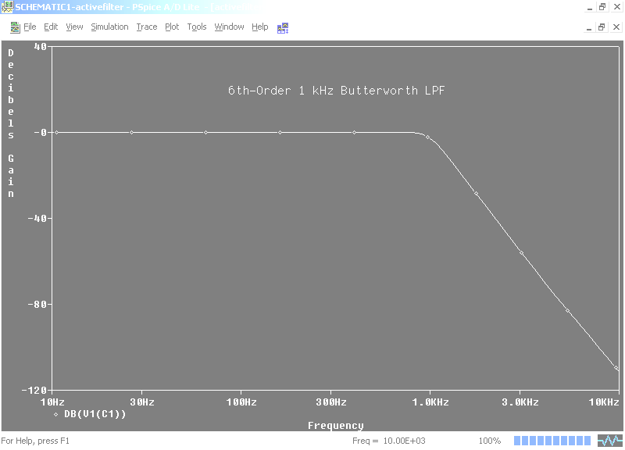

Fig. 11. Plot of Phase Shift through 6th-order, 1 kHz Butterworth LPF
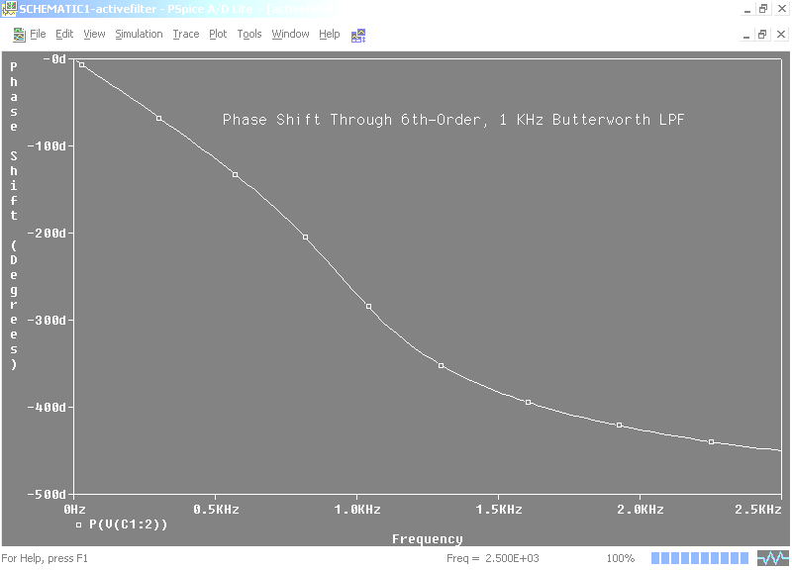

The circuit of Fig. 9 then had the capacitor values changed to correspond to those of the Bessel filter, as designed in Fig. 8. The resulting magnitude and phase shift Bode Plots appear in Fig. 12 and Fig. 13.

Fig. 12. Plot of dB Voltage Gain for 6th-Order, 1 kHz Bessel LPF
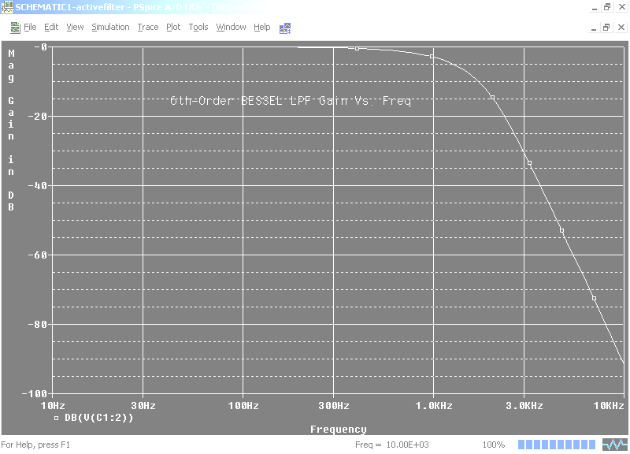

Fig. 13. Plot of Phase Shift through 6th-order, 1 kHz Bessel LPF
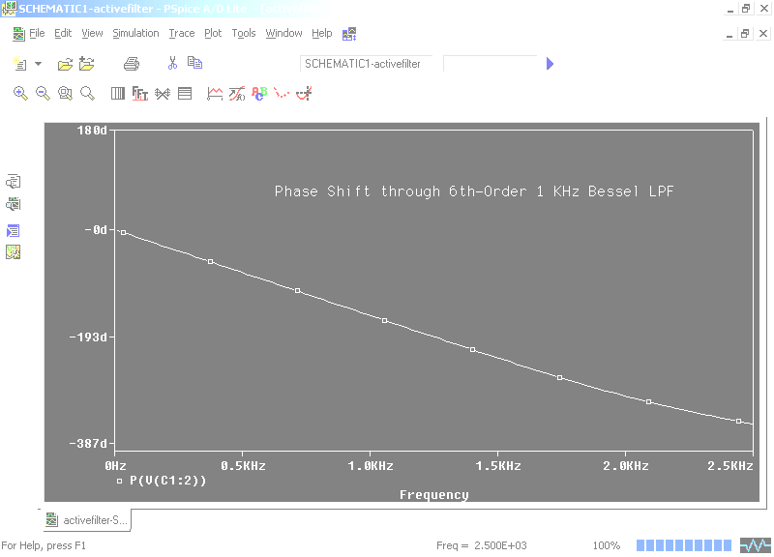
10. Swept DC PSPICE Simulation Example
We often desire to obtain a dc voltage transfer curve (VTC) that relates a DC output voltage (Vout) to the swept DC input voltage (V1). Fig. 14 shows the Orcad circuit of an asymmetrical diode voltage clipper circuit. To obtain the VTC of this circuit, place a voltage probe at the output voltage node.

Figure 14. Diode Clipper Circuit
Now you must set up the Simulation Profile. In the Simulation Settings window’s Analysis Type box, choose the DC Sweep analysis type. Next, in the “Sweep Variable” section of the Simulation Settings window, you must identify one of the DC sources (in this example, V1) as the “Sweep Variable”. Even though V1 has been assigned a nominal voltage value (1 V), check the Voltage Source radio button, and in the Name box, enter the name of the desired DC source to be swept (V1). Then in the “Sweep Type” section of the Simulation Settings window, check the Linear radio button, and, supposing that we desire to sweep V1 from –30V to +30V, enter Start Value = -30V, End Value = +30V, and Increment = 0.1V. Then hit OK. Figure 15 shows the resulting VTC, we see that this circuit clips negative input voltage excursions at about –10.7 V, and positive input voltage excursions at about 20.7 V, as is easily predicted using elementary circuit theory.

Figure 15. Swept DC (VTC) Simulation of Diode Clipper Circuit
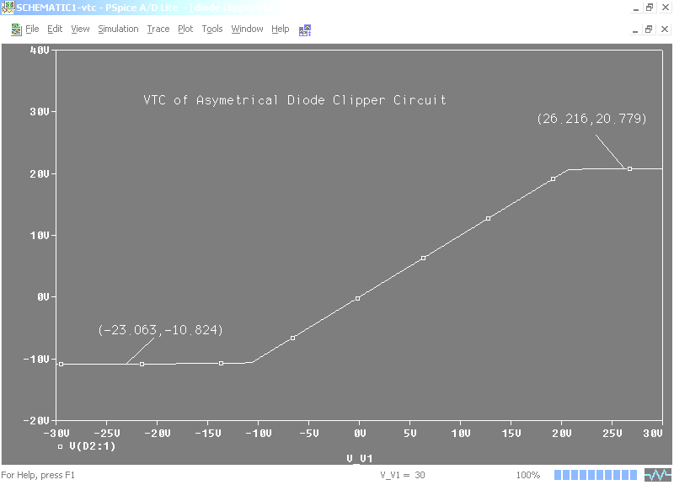
11. DC Bias Point / Transient Analysis of BJT Common Emitter Amplifier
A common-emitter audio BJT amplifier circuit is shown in Fig. 16. Both the DC bias point (the dc current and voltages associated with each node) and the circuit’s transient response to a relatively large input sine wave are of interest. After either a Swept AC, Transient, or DC Bias Point type of SPICE analysis has been run, you may press the “V” button that lies at the above the schematic sheet to see the dc bias voltage associated with each circuit node. (The DC Bias Point analysis calculates only the DC bias point, while the Swept AC and Transient analyses first calculate the DC bias point, then use that information to perform the AC or transient analysis). Likewise, you may press the “I” and/or the “W” button to see the branch currents and branch powers. Fig. 16 has both the V and the I buttons pressed. Fig. 17 shows the Transient Probe plot, where the Simulation Profile has been set up to do a Time Domain (Transient) analysis from 0 up to 3ms with a step size of 0.01ms. Note that this amplifier exhibits a 6 V p-p max symmetrical output swing with a voltage gain of about 3V / 30mV = 100.

Fig. 16. BJT Amp with DC Bias Values Displayed (I and V buttons pressed)

Fig. 17. Transient Simulation of BJT Amplifier – Output Near Saturation
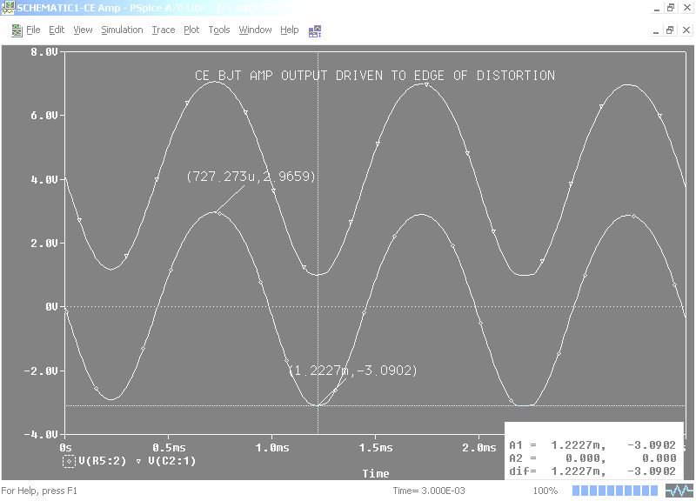

12. Using Orcad Lite to draw electronic schematic diagrams
The Orcad Lite CIS Capture tool is an excellent schematic diagram drawing tool, even if PSPICE simulation is not necessary. The Orcad Lite V. 9.2 freeware program comes with an extensive library of commonly used electronic component symbols which are in use today by the electronics industry, though those parts that can be used for PSPICE simulation are much more limited. To access the much wider of components that are useful for schematic drawing purposes only, bring up a schematic and click on Place – Part (or just hit the “P” key). The Place Part window should appear. Click on the Add Library button. If you are browsing in the PSPICE parts directory folder, click the “up arrow” button that backs you up into the Library folder. You will now see many different categories of parts that you may browse through. Select all of these part libraries. Now your parts list has become gargantuan. Try typing PIC16F84/MICROCONTROLLER into the parts list search box. You will bring up the schematic for the PIC microcontroller we are using!

