ECE331 Class Quiz #5 3 points maximum (Lecture 11 Microcontroller Interfacing)
Name: __________________________________________________ CM ___________

- A power NPN BJT with beta = 80 is used to switch a 10 ohm, 20 V resistive load using the upper left circuit of Slide #55. What is the maximum permissible value of Rb? How much current must the open-collector driving gate be able to sink? (Assume Vcesat = 0 V.)

- Explain the purpose of the “back emf” suppressor diode in the reed relay circuit of the lower left circuit of slide #55. (Hint: use v_{L}(t) = Ldi_{L}/dt. The Zener diode arc suppressor is needed if the load being switched is ____________________.
- How long does it take to turn ON the reed relay if the reed relay coil has an inductance of 50 mH, a resistance of 200 ohms, and a pull-in current of 20 mA?
- How long does it take to turn OFF the reed relay if its break-out current is 10 mA, assuming the back emf suppressor diode has negligible on resistance. How might we speed up this turn off time?

- Consider the practical optocoupled H bridge circuit for bidirectional motor control shown below. Complete the chart below that shows the signal values that must be supplied by the microcontroller for each operating mode. Note that the TIP107 BJTs are PNP (They act as current sourcing switches) and the TIP102 BTs are NPN (they act as current sinking switches)..
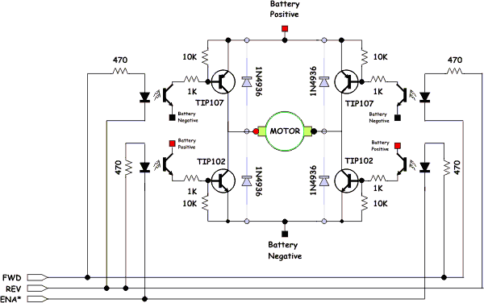

FWD | REV | ENA* | Description
1 | 0 | 0 | Turn on upper left source and lower right sink. (go forward)
 |  |  | Disable lower right sink. When ENA* is fed a PWM signal the bridge modulates the "forward" current through the motor.
 |  |  | Turn on both lower left sink and lower right sink, shorting the motor. This causes a rotating motor to stop rotating so this mode is called "Braking."
 |  |  | Disable both lower sinks. When fed a ENA* is fed a PWM signal the bridge modulates the "braking" of the motor.
 |  |  | Turn on the upper right source and lower left sink. (go backward)
 |  |  | Disable lower left sink. When ENA* is fed a PWM signal the bridge modulates the "reverse" current through the motor.
0 | 0 | x | Turn off all sources and sinks. Motor coasts without any braking.
- For the permanent magnet (PM) stepping motor of Slide #66 – 67, we found that a 3-magnet rotor would rotate 30 degrees per step in the CCW direction, which implies 360/30 = 12 steps per revolution (Slide #67). Draw a similar figure for a 5-magnet rotor, and determine the number of degrees per step, rotation direction, and steps per revolution.
S
S
S
S
S

