Handout for EC331 Lab #6:

-- Interrupts in C, Linking Separately Compiled C and Relocatable ASM Modules, using the Hitachi Style LCD Panel Display

Jianjian Song and Keith Hoover

Department of Electrical and Computer Engineering
Rose-Hulman Institute of Technology

October 2009

Table of Contents

1. Objectives 2
2. Deliverables 2
3. Equipment 2
4. LCD Panel Interface Routines 2
5. Modifying the LCD routines, so they are callable from a C program 3
6. Digital 24-hour clock with LCD readout 3

Objectives
- Learn how to write relocatable assembly modules and then link them together into a single executable program.
- To learn how to mix C and Assembly modules that are separately compiled/assembled and then linked together into a single executable program.
- To learn how to write interrupt service routines in C
- To learn how to interface to Hitachi HD44780 LCD Panels
- To gain more practice working with Output Compare Timer interrupts.

Deliverables
You have one week to complete this lab assignment, which is due at the very beginning of the next week’s lab. Your lab report must consist of: (1) schematic diagrams (drafted using ORCAD) of all interfacing hardware, (2) commented source code, (3) description of testing procedures and test results.

Equipment
You will need your CSMB9S12C128 microcontroller module, an LCD display panel using the popular Hitachi HD44780 microcontroller (included in your lab kit.) Pre-written source code for the LCD panel may be downloaded from the ECE331 Lab 5 AFS folder.

LCD Panel Interface Routines
Review the “Relocatable Assembly” lecture and the “LCD Demo” example program. Then connect the LCD panel to your microcontroller as indicated below. Download the “LCD Demo” project folder and run this demo, which consists of two relocatable assembly files: one that contains a main program that calls the LCD panel display routines, and the other that contains these LCD display routines.
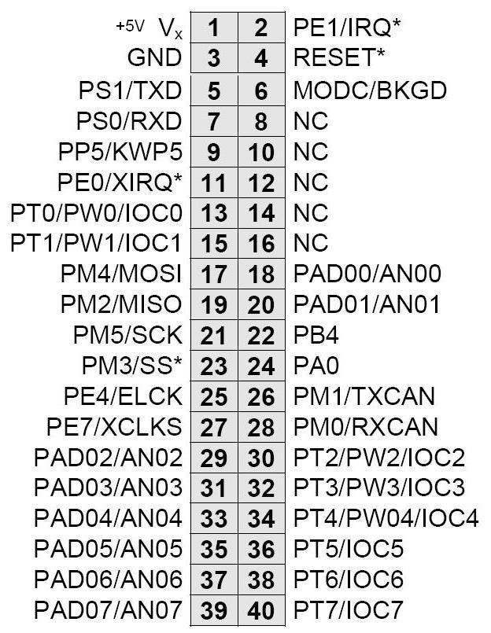
LCD Panel Connections to CSM9S12C32 Module
LCD Pin Signal Name CSM9S12C32 Pin

1 Vss (0V – DC Power) None
2 Vcc (5V – DC Power) None
3 Vee (0V–max contrast) None
4 RS PT2
5 R/W (0V-always write) None
6 E clock PT3
11 DB4 PT4
12 DB5 PT5
13 DB6 PT6
14 DB7 PT7

Run this program and verify that it displays messages on both lines of the display.

Modifying the LCD routines, so they are callable from a C program
Now review the “C to ASM” lecture, and study the associated demo program. Then modify each of the LCD driver subroutines in the LCD_subroutines.asm file so they are callable from a C program.
Hint: You should discover that only one of these assembly routines needs to be changed very slightly!
Each routine should be called as shown below:

void LCD_INIT(void); //Initialize LCD panel upon power-up.
void LCD_DTA(ASCIIchar); //ASCIIchar = 8-bit ASCII character to be displayed.
void LCD_ADDRESS(POSNchar); //POSNchar = LCD Panel Display RAM address
// For our 2 – line by 24 character LCD panel
// address 0x00 is beginning of first line
// address 0x40 is beginning of second line
void LCD_MESSAGE(STRINGchar *, POSNchar);
//STRINGchar * = Address of first element of
// ASCII string to be displayed.
//POSNchar = LCD Panel Display RAM address
void LCD_CMD(CMDchar); //CMDchar = 8-bit LCD Panel Command
//Example: LCD_CMD(1) will clear entire
// LCD display panel.
Now write a short C program that calls several of your modified C routines so that it displays your favourite poem, joke, or wise saying (or one that you have written), two lines at a time (each line must be no longer than 24 characters long, since the LCD panel display we are using is 24 x 2). The document you are displaying must contain at least 10 lines. The program must pause for several seconds in between displaying pairs of lines, in order to allow time for the lines to be read.
Hint: here is how a null-terminated ASCII string may be declared and initialized in C in the flash ROM area of memory:
char *msg1 = "Hello World" ;

Digital 24-hour clock with LCD readout
Now review the “Interrupts in C” lecture and study the associated demo program. Write an interrupt routine in the C language that updates the time in global variables that are labelled Hours, Minutes, Seconds, and Centiseconds at 10 ms (1 centisecond) intervals. Set up a Timer Channel 0 output compare interrupt that is triggered every 10 ms (or as close to 10 ms as you can come!). You must also write a main program that initializes timer ticks and then falls into a loop that continuously displays the time in “HH:MM:SS” format on the LCD panel, using 24-hour (military) time. This main program must call the modified LCD panel driver routines that you produced in Part 5 of this lab.

