Lab Report Memo Guidelines and an Example Lab Report

Begin each lab report with a simple, informative memo-style header.

To: Prof. Keith Hoover
From: Your Name
Regarding: ECE331 Lab #X— Lab Title (Put Course Number, lab number, then title)
Date: September 10, 2009 (the date the lab was performed, not the due date)
Summary:
Start your memo with a summary. The summary is intended to be a complete description of the lab experiment, but written succinctly for a knowledgeable reader. Choose your words carefully and engineer your summary to be brief, but effective.
Memo Body:
- Describe what you did.
- Include any requested calculations, relevant circuit diagrams, flowcharts, and record any requested experimental measurements.
- Answer any questions that were asked in the lab writeup. Use complete sentences, and include enough information so that the memo report is self-documenting without referring back to the lab procedure.
- If several measurements were taken, present your results in a table. Be sure to number and caption that table, and be sure to refer to that table by number in the text of your memo.
- Embed the figures and tables that you create into the memo text, close to where they are referred to, or if they are lengthy, put them at the end of the memo as an “Attachment” or “Appendix”. You can embed figures in the text in Microsoft Word by creating a text box (Insert->Text Box) and then placing the figure into the text box (Insert->Picture->From File). You can also format the text box so that text flows to the side (Click on text box and then Format->Text Box->Layout->Square), but in any case make sure that the figure is legible!
• All figures, tables, and appendices (attachments) must have captions underneath or above them that describe what it is. As a general rule, all figures and tables should be self-contained: you should be able to understand what is going on in the figure by just looking at the figure and reading the caption. For example, note how the example figure presented in Fig. 1 is numbered and also captioned. Also note how the example table shown in Table 3 is numbered and also captioned.

 | H2O Baseline for higher I
A | Vo | V1 | V2 | Vo-(V1+V2)
0.1 | 1.19 | 0.597 | 0.355 | 0.238
0.2 | 2.5 | 1.4 | 1.07 | 0.03
0.3 | 3.6 | 2 | 1.55 | 0.05
0.37 | 4.18 | 2.13 | 1.92 | 0.13
0.4 | 4.52 | 2.55 | 2.05 | -0.08
0.5 | 5.25 | 2.57 | 2.51 | 0.17
Table 3. Baseline Test for H₂O: Large Currents
• Place well-commented code, diagrams, and other requested items at the end of the memo as an “Attachment” or “Appendix”. (Each Appendix or Attachment must be numbered and captioned just like a figure or a table.) Be sure to refer to each attachment by its number in the text of your memo.

Concluding Section:
Entitle it simply Conclusion, or Recommendations for Further Work,
Summary Comments, or any other title that tells what the boss is going to see when reading the conclusion. Remember, the goal of any written or oral presentation is to communicate effectively.

Example of a (Very Simple) Memo-Style Lab Report

To: Prof. Keith Hoover
From: Bolivar Shagnasty
Regarding: ECE497 Lab #5— Computer Controlled Flashlight
Date: September 10, 2009
Summary: In this laboratory experiment a computer-controlled flashlight was designed, built, and tested. By doing this experiment, I learned how to use the CodeWarrior IDE, how to interface hardware to the FreeScale 9S12C128 microcontroller, and how to write and debug an 9S12C family assembly language program.

Body: I set the jumpers on the Axiom CSMB12C128 microcontroller module, and I connected this module to the FreeScale PBMCUSLK project board as shown in the photograph of Fig. 1 and the schematic diagram of Fig. 2.

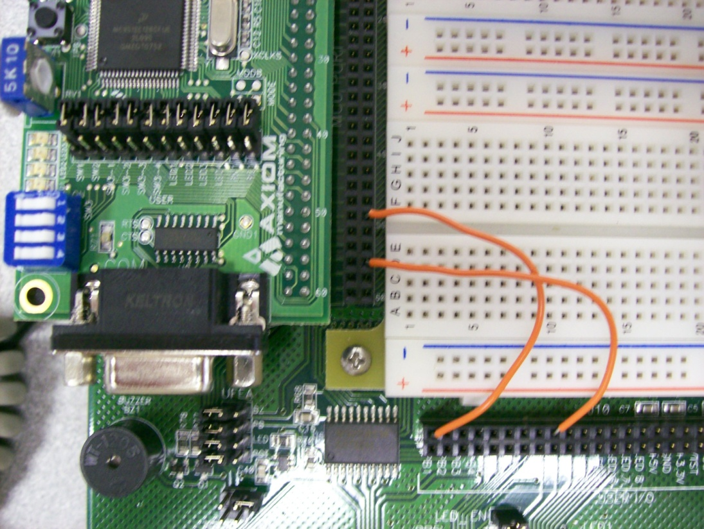

Figure 1. Photograph of the Computer Controlled Flashlight hardware, showing how the CSMB12C128 module is connected to the LED and SWITCH on the PBMCUSLK project board.

Figure 2. Schematic diagram of the hardware interface for the computer controlled flashlight.

Next, I installed the HCS12 CodeWarrior software on my laptop. I began by writing a flowchart of our program, as shown in Fig. 3.
Figure 3. Software flowchart for the computer controlled flashlight.
Next an assembly program was written from this flowchart, as shown in Attachment 1. The project was tested by operating the switch 1000 times, and each time the LED turned on and off as expected. No failures were observed even after leaving the program run for 24 hours.

Summary Comments: I have gained familiarity with the CodeWarrior development tools and I have found that my computer controlled flashlight design to be quite reliable. I did find that CodeWarrior would not run properly until I removed the “Windows 2000 compatibility” check box from the IDE.exe program that was found in the BIN folder of CodeWarrior. After this extra step (that was not mentioned in the original lab write up) was followed, CodeWarrior ran very dependably.

Attachment 1. FreeScale 9S12C128 assembly language program for the computer controlled flashlight

;*****************************************************************************
;* Coin Tosser Program Example (KEH) 8/5/2008 for the CSMB12C128 Module
;* Pushbutton SW on PB1, LED on PB0, PTAD holds nr. Heads, PTT holds nr. Tails
;*****************************************************************************
; export symbols
XDEF cointoss ; export 'Entry' symbol
ABSENTRY cointoss ; for absolute assembly: mark this as application entry point
nolist
INCLUDE 'mc9s12c128.inc' ; This include file has all the 9S12C128 register EQU's in it!
list
PushButton: equ PORTB
LEDDisplay: equ PORTB
ShowNumberOfHeads: equ PTAD
ShowNumberOfTails: equ PTT
; variable/data section
ORG RAMStart
nr_heads: ds.b 1 ;Allocate 1 byte of RAM: Number of head outcomes accumulated here
nr_tails: ds.b 1 ;Allocate 1 byte of RAM: Number of tail outcomes accumulated here
; code section
ORG ROM_4000Start ;This is the symbol for the ROM start address in the 'mc9s12c128.inc' file.
cointoss:
lds #RAMEnd ; Initialize stack pointer to top of RAM
bset ATDDIEN,$FF ; Port AD is to be all digital I/O
bset DDRAD,$FF ; Port AD will be output port to display (as an 8-bit binary nr) the nr of heads.
bset DDRT,$FF ; Port T is will be output port to display (as an 8-bit binary nr) the nr of tails.
bset DDRB,%00000001 ; PB0 is "Head/Tail" LED output.
bclr DDRB,%00000010 ; PB1 is pushbutton "die toss" switch input.
clr nr_heads ; Initialize statistics to 0.
clr nr_tails
clr ShowNumberOfTails ; Zero the number of tails displayed on Port T
clr LEDDisplay ; Turn off the heads/tails LED
clr ShowNumberOfHeads ; Zero the number of heads displayed on Port AD
Top_of_loop:
clrb ; Use B as a 1-bit counter that will be stopped when the switch is depressed and
;thereby will contain a random outcome: either 0 or 1.
SW_wt_press:
eorb #1 ; Toggle LSB of accumulator B (if high, make it low, and vice versa)
ldaa PushButton ; Load accum A with the SW state (Bit #0)
anda #$02 ; Accum A = $01 if SW not pressed, and $00 if SW pressed
bne SW_wt_press ; Hang in this loop until SW is pressed
jsr delay_rtn ; Wait for pushbutton switch to stop bouncing
SW_wt_release:
ldaa PushButton ; Arrive here when SW is pressed, with random outcome in Accum B
anda #$02
beq SW_wt_release ; Hang in this loop until switch is released.
jsr delay_rtn ; Wait for pushbutton switch to stop bouncing by calling delay_rtn subroutine.
stab LEDDisplay ; Send HEAD/TAIL result to LED on Bit 0 of PORTB.
cmpb #1 ; If HEAD outcome, B = 1. If TAIL outcome, B = 0.
beq heads_outcome
tails_outcome:
inc nr_tails ; Update nr_tails RAM location
movb nr_tails,ShowNumberOfTails ; Mirror this value on Port T
bra Top_of_loop
heads_outcome:
inc nr_heads ; Update nr_heads RAM location
movb nr_heads,ShowNumberOfHeads ; Mirror this on Port AD
bra Top_of_loop
;*********** End of main program*******************
; Here is a short delay subroutine that delays for about
; 20 ms before returning. It is used for pushbutton switch debouncing
delay_rtn:
ldy #$ffff
delay_more:
dey ;
bne delay_more ;Count y down from $ffff to 0.
rts ;Return addr (pop return addr off stack into PC)
; Here we intialize the RESET vector to point to the
; start of the cointoss program
ORG $FFFE

