ECE342 Lab #9 Conducted Emission 15 Feb 2006

Objectives
- To observe and understand the LISN.
- To observe and understand a switching power supply.
- To observe and understand shielding effectiveness for conducted emissions with common-mode choke or ferrite bead.

Introduction
The regulatory limits specify the maximum EUT emission energy, usually in dBμV, detected by the LISN. Two types of detectors are defined: Quasi-Peak and Average, meaning that there are two limit lines. Conducted emissions measured by each detector must be below the corresponding limit. The test range for these measurements is typically 150 kHz to 30 MHz, though some limits may start as low as 9 kHz, depending on the regulation. Since metallic surfaces near the EUT will produce variable coupling mechanisms, the regulations also specify the physical layout of the test setup including separation distance of the test items, non-metallic table, and vertical conductive surface behind the EUT setup. A typical layout for desktop devices is shown below.
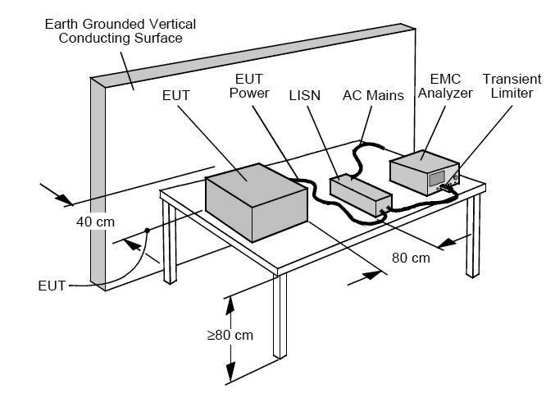
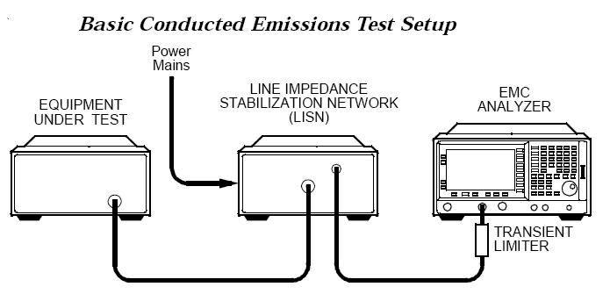
The LISN performs several important functions. It helps filter incoming power from the ac mains and prevents any noise on the lines from reaching the EUT. It routes conducted emissions from the EUT to the receiver. It presents a defined 50 ohm impedance to the receiver, allowing calibrated measurements.
During conducted emissions testing, a transient limiter can protect the EMC analyzer input from damage caused by high-level transients from line impedance stabilization networks (LISNs) or current clamps. The E7400A-Series EMC Analyzers have limiter diodes placed before the first converter and the preamp to help protect both elements.

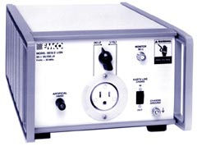
LISN
The LISN is EMCO MODEL 3810/2 from ETS-Ling rent.
Here is a schematic of the line impedance stabilization network (LISN). A transient limiter, which is a separate device, is connected between the LISN and a spectrum analyzer to protect the analyzer.

Ferrite beads
Ferrite beads or cores are nonconductive ceramic magnetic materials. A ferrite bead can be modelled as a serial connection of a resistor and an inductor for frequency range of operation. Its total impedance is therefore Z=R+jL.
When a current passes along the wire that goes through a ferrite bead, both resistance and inductance of the ferrite bead will resist time-varying flux change and therefore either store or burn the magnetic field energy in the wire.
The following example is the frequency response of a ferrite bead (core) 28A2736-0A2 from Steward. As can be seen, its frequency response arranges from 10Ω at 1MHz to 500Ω at 400MHz. From the filter effectiveness point of view, the high the impedance the better.
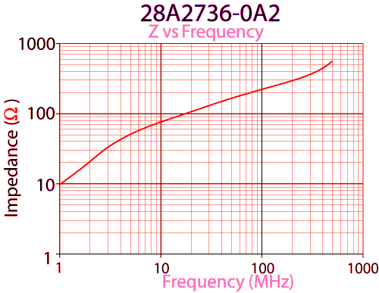

Common-mode choke
For common-mode currents, the self inductance and mutual inductance of the choke reinforce each other so that more energy will be stored in the choke.
For differential-mode currents, the two inductances will cancel each other and therefore less energy will be stored in the choke.
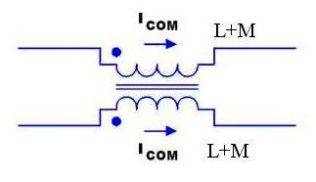

Switching Power Supply
Here is a switching power supply that converts a 5V DC power supply to 25V DC power supply. The power supply uses 900kHz oscillator so that the transformer can be pretty small. A common-mode choke can be used to filter out conducted emission.

Conducted Emission of the Power Supply

Measurement

Frequency (MHz)
E field (dBμV)

Measurement with common-mode choke
Frequency (MHz)
E field (dBμV)

Measurement with a ferrite bead
Frequency (MHz)
E field (dBμV)

