Name:___________________________________ CM#___________
Part I: Antennas
1. Introduction

Near field vs. far field
- λ, f, and v_{p} are related by$λf=v_{p}$, in a vacuum or in air.
- $λ=\frac{3×{\text{10}}^{8}m/s}{f \text{in} \text{Hz}}=\frac{\text{300} m/{μs}}{f \text{in} \text{MHz}}$ Note vp = 300 m/μs = 11811”/μs.
- Far Field > Whichever is larger:$3λ$ or$\frac{2D^{2}}{λ}$, where D is the largest dimension of the antenna

Circuit quantities: radiation resistance, radiated power

Space quantities: radiated field pattern, radiated power pattern

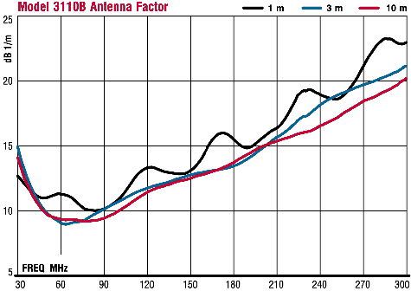
Antenna factor $\frac{\left|E_{\text{inc}}\right|}{\left|V_{\text{rec}}\right|}$
Example: at 80 MHz, we see that AFdB = 9 dB. Therefore, E_{dBuV} = AF_{dB} + CL_{dB} + VA_{dBuV}. Assuming 30 ft of coaxial cable, with 4.5 dB/100 ft loss, we have E_{dBuV/m} = 9 dB + 4.5/3 dB + VA_{dBuV}

Interfering sources
- Normalize the background noise spectrum to reduce error

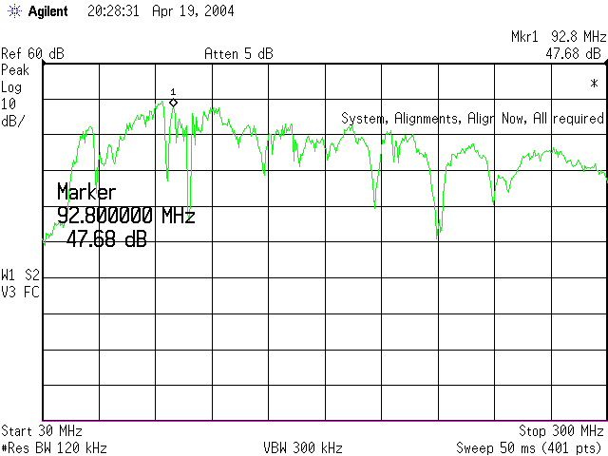
Dipoles and Monopoles

A dipole antenna
We shall use a standard 30 MHz – 300 MHz biconical broadband receiving antenna. The axis of our biconical antenna will be oriented horizontally, so it responds best to horizontal E field. Here is an example of the background frequency spectrum. We often desire to NORMALIZE our spectral measurements using this background spectrum in order to remove the effects of interfering RF noise sources. Or better yet, place the antenna in a shielded room, where there is no background frequency spectrum to interfere with our measurements.

Configuration | Length (m) | Electrical  Length (in wavelengths) | Maximum E field (dBμV/m) | Frequency (MHz)
Closed, shortest, horizontal |  |  |  | 80
Open, shortest, horizontal |  |  |  | 80
Open, shortest and vertical |  |  |  | 80
Open, mid-length and horizontal |  |  |  | 80
Open, mid-length and vertical |  |  |  | 80
Open, longest and horizontal |  |  |  | 80
Open, longest and vertical |  |  |  | 80
1.875 m dipole, horizontal |  |  |  | 80
1.875 m dipole, vertical |  |  |  | 80

A monopole
Configuration | Length (m) | Electrical  length | Maximum E field (dBμV/m) | Frequency (MHz)
End Fire |  |  |  | 80
Broadside Horizontal |  |  |  | 80
Broadside Vertical |  |  |  | 80

Twin lead terminated in a resistor
- Does it make any different when it is folded?
- Is it a dipole or monopole?

Configuration | Length (m) | Electrical  Length | Maximum E field (dBμV/m) | Frequency (MHz)
End Fire |  |  |  | 80
Broadside Vertical |  |  |  | 80
Broadside Horizontal |  |  |  | 80
Folded in half, Horizontal |  |  |  | 80

Loop Antenna
- How can you make radiation large or small? (Directivity, loop area)
- Fold and Hold it with one hand, both hands, closed to my chest. See any difference? What are circuit models for these cases?
- Shield it with aluminum foil

Configuration | diameter (meters) | Maximum E field (dBμV/m) | Frequency (MHz)
Plane of Loop Vertical |  |  | 80
Plane of Loop Horizontal |  |  | 80
Two Turns, plane Horizontal |  |  | 80
Four Turns, plane Horizontal |  |  | 80

F-2000 Clamp-on Current Probe from Fischer Custom Communications
The F-2000 is usable from 10 MHz to 3000 MHz and has a reasonably constant transfer impedance of$Z_{T}=\frac{V_{\text{output}}}{I_{\text{wire}}}$ of about 20 dB above 1 ohm => Z_{T} = 10^{20/20} = 10 Ω from 30 MHz to 3000 MHz. It can operate without saturation from 50 amps peak pulse and 10 amps CW. The F-2000 is the first clamp-on probe capable of making current measurements beyond 1200 MHz. It is hand-made, and costs over $1000.00!
Note $Z_{\text{TdB}}=\text{20}\text{log}(\frac{V_{\text{output}}}{I_{\text{wire}}})=\text{20}\text{log}(V_{\text{output}})−\text{20}\text{log}(I_{\text{wire}})=V_{{\text{output}}_{\text{dB}}}−I_{{\text{wire}}_{\text{dB}}}$
Thus $I_{{\text{wire}}_{\text{dB}}μV}=V_{{\text{output}}_{\text{dB}}μV}−Z_{\text{TdB}}=V_{{\text{output}}_{\text{dB}}μV}−\text{20}\text{log}({Z_{T}}/1Ω)$
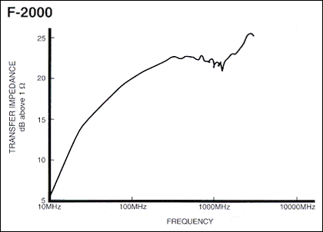

Common-mode currents on an electrically short “twisted pair” transmission line
Configuration | Length (m) | Frequency (MHz) | Vsa  (dBμV) | Peak Current (dBμV)
Half-Wave Dipole antenna current distribution |  | 80
a twisted pair (open-circuit terminated) |  | 80
a twisted pair (terminated in a resistance) |  | 80
a twisted pair with ferrite bead |  | 80
a twisted pair with 4-turns of common-mode choke |  | 80

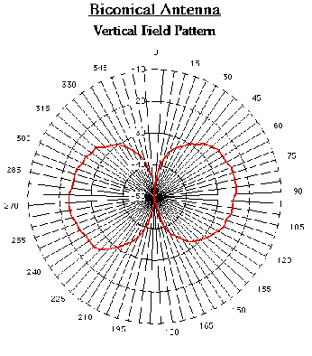
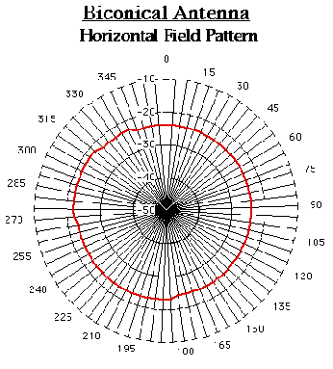
Appendix: Biconical Antenna Pattern

Part II: Conducted Emission Testing

Objectives
- To observe and understand the LISN.
- To observe and understand a switching power supply.
- To observe and understand the use of a common-mode choke or ferrite bead.

Introduction
The regulatory limits specify the maximum conducted RF noise emissions between inadvertently present on the 60 Hz, 120 VAC power cable of a product, or “Equipment Under Test” (EUT). This conducted emissions test is made in a carefully defined way over a RF frequency range that is often between 150 kHz to 30 MHz, though some limits may start as low as 9 kHz, depending on the regulation. The conducted emission measurement is an RF voltage measurement made over the specified range of frequencies (using a spectrum analyzer). The readings are taken in dBμV across a standard 50 ohm load that must be provided by a specialized piece of EMC measuring equipment called a “Line Impedance Stabilization Network” (LISN). Two types of detectors are allowed inside the spectrum analyzer, meaning that there are two limit lines specified in the conducted emission standard.: Quasi-Peak (which is a quasi-instantaneous reading where the signal intensity is sampled at each frequency a specified number of times over a specified time period, and the peak reading is taken, this measurement is allowed to be larger in the conducted emission standards) and Average (where the signal intensity is sampled at each frequency a number of tims over a fixed time interval, but this time the average intensity is computed, this measurement is more forgiving, and is thus specified as a smaller limit in the conducted emission standards) Conducted emissions measured by each detector must be below the corresponding limit. The test range for these measurements is typically 3 m or 10 m. Since metallic surfaces near the EUT will produce variable coupling mechanisms, the regulations also specify the physical layout of the test setup including separation distance of the test items, non-metallic table, and vertical conductive surface behind the EUT setup. A typical layout for desktop devices is shown below.
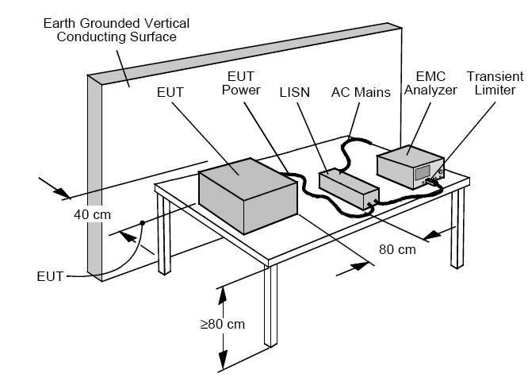
The LISN performs several important functions. It helps filter incoming power from the ac mains and prevents any noise on the lines from reaching the EUT. It routes conducted emissions from the EUT to the receiver. It presents (at RF frequencies) a well-defined 50-ohm impedance on the power line, across which the EMC spectrum analyzer can take meaningful voltage measurements of the RF noise currents produced by the EUT, allowing calibrated measurements that can be repeated accurately at any test site around the world.

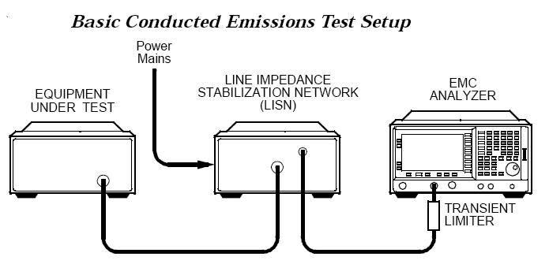

During conducted emissions testing, a transient limiter is often used to protect the EMC analyzer input from damage caused by high-level power line transients that occasionally occur on the 60 Hz power line. In addition, the E7400A-Series EMC Analyzer has built-in limiter diodes placed before the first converter and the preamp to help protect both elements.

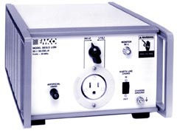
LISN
The schematic of the EMCO MODEL 3810/2 LISN is shown below. POWER OUT connects to the EUT,and the POWER IN connects to the standard 60 Hz power line, where “E” is the ground prong (green wire), “L1” is the “hot” phase, and “N” is the neutral (typically grounded phase).
At 60 Hz, the LISN is “invisible”, and it simply passes the 60 Hz power on to the EUT from “POWER IN” to “POWER OUT”. This is because at 60 Hz, all of the LISN capacitors exhibit very high impedances, and also each of the LISN’s inductors exhibits a very low impedance.
But at the RF frequencies of interest (from 150 kHz to 30 MHz), the capacitors have relatively low impedance, and they act like short circuits. Note how RF emissions already present on both “L1” and “N” phases of the external ac power line severely filtered out by the low-pass filter formed by the 50 μH inductors and the 1 μF capacitors, note the break frequency of this LPF is at 1/(2π*sqrt(50 μH*1 μF) = 22.5 kHz, which is well above 60 Hz but well below 150 kHz. This external RF line filtering is very important in conducted emission testing, because when performing conducted emission testing on a EUT, we do not want to be measuring externally produced conducted emissions from nearby offending devices that are also plugged into the 60 Hz power line.
From the EUT side of the line, the unwanted conducted RF current emissions caused by the EUT will “see” a precise 50 ohm load between the L1 phase and ground (E) and also between the N phase and ground (E). Therefore, a given RF noise current level will develop the same RF noise voltage level that can be measured by an EMC analyzer, no matter what kind of power line it is plugged into, at any EMC test site anywhere in the world! Without the use of the LISN, the RF impedance load presented by the power line to the EUT would vary widely from location to location, depending on the line length, layout, what nearby devices were plugged into the line, etc, and so there could be no published national standard for conducted emission!
A transient limiter, which is a separate device, uses a resistive 4 dB, 50 ohm attenuator to provide a constant, precise 50 ohm load across the power line, regardless of variations in the input resistance of the EMC analyzer that is connected to its output terminals, and also has transient limiting diodes, is connected between the LISN and a spectrum analyzer to protect the analyzer.
Schematic Diagram of the LISN

Ferrite beads
Ferrite beads or cores are nonconductive ceramic magnetic materials. A ferrite bead can be modelled as a serial connection of a resistor and an inductor for frequency range of operation. Its total impedance is therefore Z=R+jL.
When a current passes along the wire that goes through a ferrite bead, both resistance and inductance of the ferrite bead will resist time-varying flux change and therefore either store or burn the magnetic field energy in the wire.
The following example is the frequency response of a ferrite bead (core) 28A2736-0A2 from Steward. As can be seen, its frequency response arranges from 10Ω at 1MHz to 500Ω at 400MHz. From the filter effectiveness point of view, the high the impedance the better.
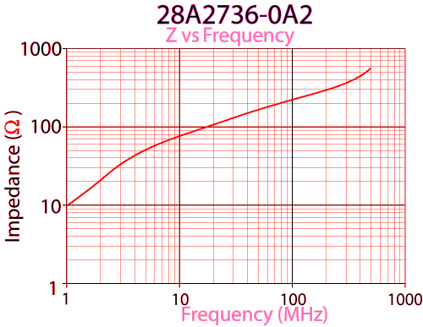

Common-mode choke
For common-mode currents, the self inductance and mutual inductance of the choke reinforce each other so that more energy will be stored in the choke.
For differential-mode currents, the two inductances will cancel each other and therefore less energy will be stored in the choke.
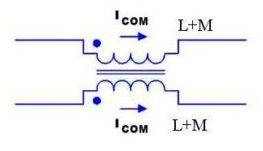

Switching Power Supply
Here is a switching power supply that converts a 5V DC power supply into a 25V DC power supply. The power supply shown below uses a 900 kHz oscillator, so that the primary and secondary windings can be made with a relatively small number of turns, while still presenting an impedance at the switching frequency that is high enough to avoid severely loading down the pulse generator that drives the primary coil. But at the same time, this choice of high switching frequency presents a problem from the EMC point of view. Common-mode RF currents couple onto the 2-wire 5 V power supply cable and are radiated, as indicated by the voltage output measured at several “worst-case” frequencies using a current probe that has been clamped around the power cable (both wires) spectrum received by the spectrum analyzer. A common-mode choke (or ferrite bead, which is a 1-turn common-mode choke) can be used to attenuate common-mode conducted emissions on the dc power line.

Conducted Emissions on Power Supply Cable

Measurement

Frequency (MHz)
Ic (dBμA)

Measurement with common-mode choke
Frequency (MHz)
Ic (dBμA)

Measurement with a ferrite bead
Frequency (MHz)
Ic (dBμA)

