Name ___________________________ CM _____ Due date: Monday, September 14
ECE342 EMC Homework #1 Fall 2009_10
(Decibel, Power Gain, and EMC regulations)

Determine the following measurements in dBμV assuming a 50-ohm load.

1000 V.

25 μV.

-10 dBm.

10 dBm
Scrambled answers: 117, 97, 180, 28 dB/µV

Determine the following measurements in dBm (= dBmW) assuming a 50-ohm load.

100 Watts.

25 mW.

96.99 dBμV.

1000 dBmV
Scrambled answers: -10, 14, 50, 953 dBm (dBmW)

Convert the following quantities into units of volts, assuming a 50-ohm load.

–100 dBμV.

100 dBmV.

20 dBm.

–20 dBm.
Scrambled answers: 2.24V, 10pV, 100V, 0.0224V

A 50-Ω source is connected to a 50-Ω receiver using 400 feet of a coaxial cable that exhibits a 3.5 dB/100 feet loss at 200 MHz. If the received voltage at the receiver terminals is 100 dBμV at 200 MHz, what is the internal “open-circuit” (Thevenin-equivalent) source voltage in μV? (Answer: 10⁶ µV)

Indicate which of the following products are regulated by Part 15 SubPart B of the FCC Rules and Regulations. If the device is regulated, specify whether it is an FCC Class A or Class B device. If a device is not regulated by part B, indicate why. (Assume that each of the devices below employs digital circuits which are clocked at 10 kHz or above.)

Sun Workstation. (used in an industrial setting).

A home DVD playe

A programmable “picker and placer” robot for use in manufacturing

5(d) A laptop computer intended for home use.

The following frequency spectrum was obtained from the output of a square wave generator. Note that the point labeled “1” corresponds to a level of 56.49 dBµV, as indicated in the upper right corner of the display. Find (to within reasonable graphical accuracy) the following:

The fundamental frequency of this signal. (Ans: ≈10 MHz)

The amplitude of the signal at the fundamental frequency in μV. (Ans: ≈42100 µV)

The amplitude of the tenth harmonic in μV. (Ans: ≈133 µV)

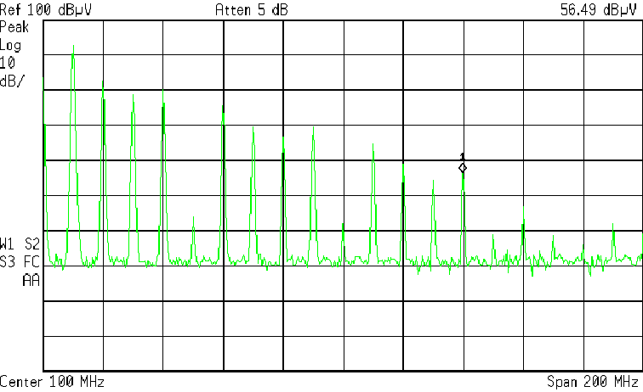
- Find (to within reasonable graphical accuracy) an equivalent circuit that represents the impedance of a two-terminal device that has the following frequency response as read on our Agilent laboratory spectrum analyzer / tracking generator setup. Note the spectrum analyzer has been set to display a logarithmic frequency scale in this plot.

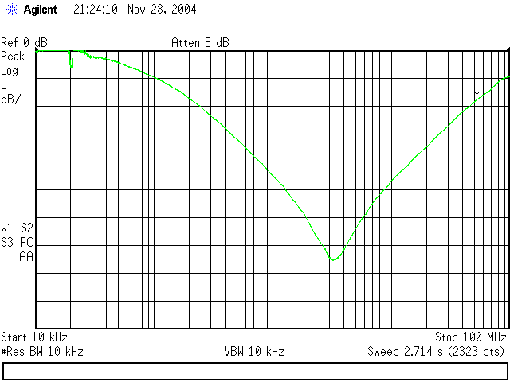

Answer: Let us all work the problem assuming ArelativedB = 20 dB at f = 800 kHz and fres = 3.10 MHz. Does this look approximately correct from the graph above? Then from this data, you should be able to show that this unknown capacitor may be modeled as a capacitance C = 79.2 nF in series with an inductance L = 33.3 nH.
- Problem 2.1.7 on p. 87 of 2nd edition. (Answers: 38.35 dBuV/m, fails by 1.01 dB.
- The radiated emissions from a product are measured at 50 MHz at 15 m away and are found to be 21 µV/m. Does the product comply with the FCC Class B limit? By how much does the product pass or fail? (Answer: fails by 0.424 dB.)

