ES 203 Electrical Systems
Homework 4

Due Date: Wednesday, 2 April (both sections 01 and 02)

Problems
- Determine the voltage, current, and power for each circuit element using formal analysis as follows:
(a) Redraw the circuit to clearly show your voltage and current assignments for each element,
(b) Write the system of equations,
(c) Solve the system of equations (attach your Maple worksheet),
(d) Create a table of the requested values for each element, and
(e) Show that the total power delivered is equal to the total power absorbed.
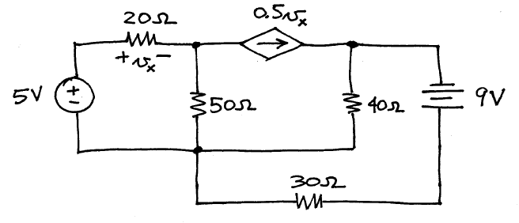
(The power absorbed by the 50-ohm resistor is 548 mW.)
- Determine the current i_{C}(t) and the voltage v_{L}(t) using formal analysis and phasor analysis as follows:
(a) Redraw the circuit to clearly show your voltage and current assignments for the phasor-domain circuit,
(b) Write the system of equations,
(c) Solve the system of equations (attach your Maple worksheet),
(d) Create a table of the phasor voltage and current, in polar format, for each element,
(e) Write i_{C}(t) and v_{L}(t) as sinusoids, and
(f) Plot i_{C}(t) and i_{g}(t) on the same graph.
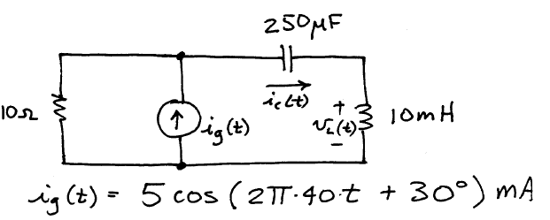
(I_{C} is 0.349 + j2.97 mA)
- Chapter 2, problem 14 (The equivalent resistance is somewhere between 1.5K and 2.0K)
- Chapter 5, problem 29 (The equivalent reactance is -570 ohms)
- Consider the circuit of Chapter 5, problem 30.
(a) Derive the equation for the magnitude of the equivalent impedance as a function of angular frequency ω and the circuit component values left as variables, e.g., use R, L, and C rather than the numerical values. You must work this part by hand!
(b) Repeat part (a) but derive the equation for the angle of the equivalent impedance.
(c) Plot the magnitude of the equivalent impedance over the frequency range ω = 9 krad/s to 11 krad/s, and use the component values specified on the schematic diagram.
(d) Repeat part (c), but plot the angle (in degrees) of the equivalent impedance.
(c) Study your two plots, and offer two distinct observations about the behavior of the impedance as a function of frequency (remember, “impedance” means both the magnitude and phase).
- Chapter 2, problem 19, but with i(t) defined as the current through the 1.5K resistor, and with the current reference arrow pointing from top to bottom.
- Chapter 5, problem 32, but using instructions as follows:
(a) Find the phasor current I_{L} using repeated source transformations and series/parallel impedance combinations; express I_{L} in both rectangular form and in polar form (Hint: first convert everything to the left of the j200-ohm impedance to an equivalent voltage source in series with an equivalent impedance).
(b) Write the time-domain form of I_{L} , i.e., write i_{L}(t), using a frequency of 2 kHz.
(c) Compare I_{L} to the current source. Comment on the plausibility of your result for I_{L}.
(The phase angle of I_{L} is 118° )

