Design of the SN74LS85 Magnitude Comparator with Verilog on Xilinx Foundation Series 2.1i

Jianjian Song

ECE333 Digital System, Fall 2000

Table of Content
1 Choose File->New project to create a new project 1
2 Create or load a Verilog source file 2
3 Synthesize the Design 2
3.1 Select parameters 2
3.2 Run Synthesizer 3
4 Simulate the Design 3
4.1 Create a simulation script file 4
5 Implement the Design 6
5.1 Create a User Constraint File (UCF) 6
5.2 Implement the design 6
6 Pin assignment in the Pad Report 7
7 Down the bit steam file to the XS40 board 8
8 Error messages and possible solutions 8
8.1 Error: Cannot find a valid license for Synopsys synthesis 8
8.2 Error: The specified part XC4010XL-09-PC84 is either invalid or not supported 8
8.3 Error: Cannot get chip information from Synopsys. Specified target is invalid or cannot get the target. 8
8.4 Error: Cannot create chip in Synopsys project. Specified file does not exist. 8
8.5 Error: Cannot find a valid license for Synopsys Constraint Editor. Constraint Editor/Viewer will not be available. 8
9 Hints 8
9.1 Simulation Step 8
9.2 Implementation Step 8
9.3 A panic button 9
10 Appendices 9
10.1 The Verilog Code for the SN74LS85 4-Bit Magnitude Comparator 9

The objective of this exercise is to design a 4-bit magnitude comparator that performs the exact functionality as the SN74LS85 4-Bit Magnitude Comparator as specified by Motorola. But the design is in Verilog and the implementation is on a Xilinx FPGA.

Choose File->New project to create a new project
Enter a project for the new project. Select HDL and click OK.
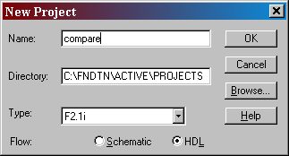

Create or load a Verilog source file
Click HDL design entry option in the Design Entry block of the design flow chart to open the HDL Editor. A window will appear to ask if the HDL Design Wizard is desired. You can click Existing document to open an existing file or and choose Use HDL Design Wizard to create a new file. Click OK after selecting the right option.
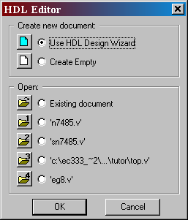
Use Design Wizard to create ports. Click Finish when done.
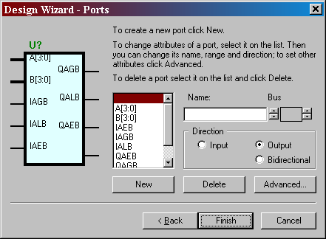
Type the Verilog source code in the HDL Editor. The source code is appended to this note.

Synthesize the Design

Select parameters
Click Synthesis block in the design flow. A window will appear for you to choose a target device if it is the first time the design is to be synthesized. If it is an existing design, use Project -> Create Version to change device. Click Run after choosing a device. We want to choose the XC4000XL family, Device 4010XLPC84 with speed of –3.
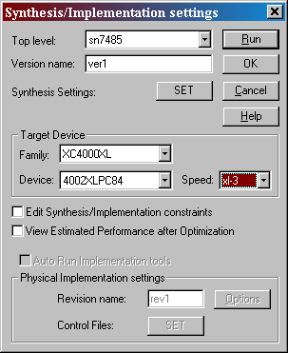

Run Synthesizer
Click Run in the menu above to start synthesis process. Three folders are generated: Compare, simprims, xc4000x after the design is synthesized.
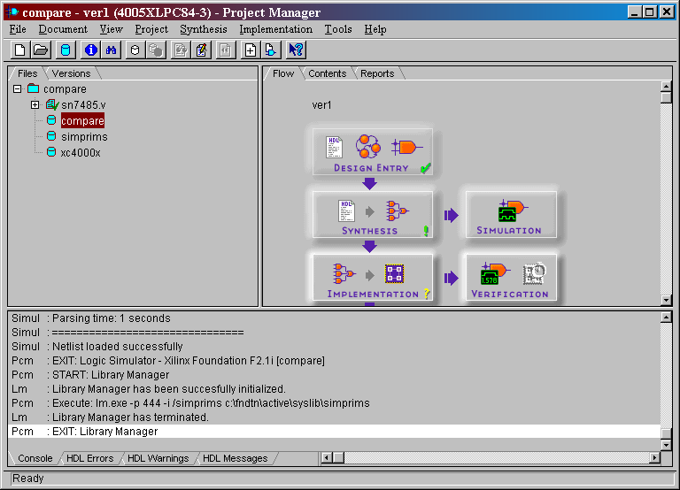

Simulate the Design
Click Simulation block in the design flow chart to start Logic Simulator as shown below.
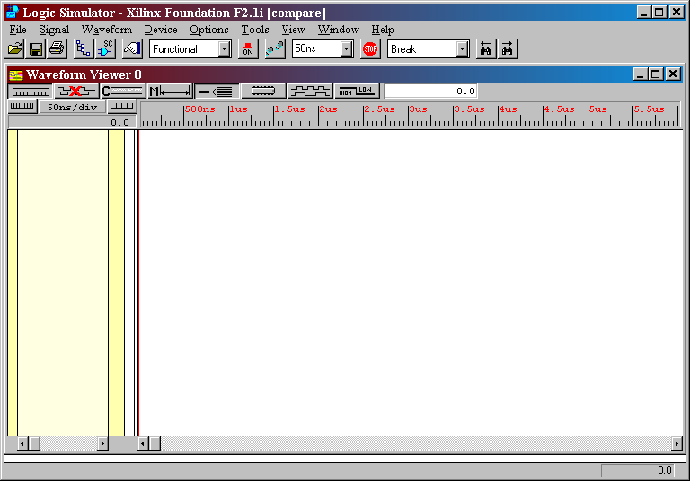

Create a simulation script file
In Logic Simulator, select Tools->Script Editor to start the Script Editor. Click OK to use the Script Wizard.

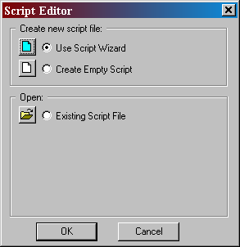

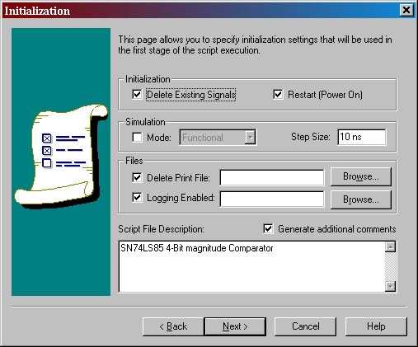
Define vectors
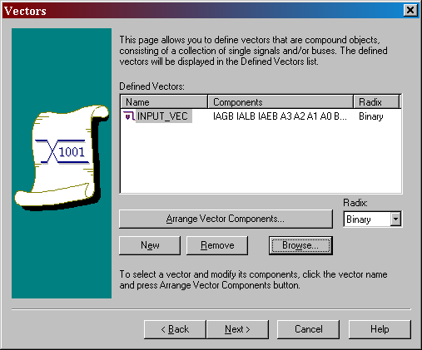

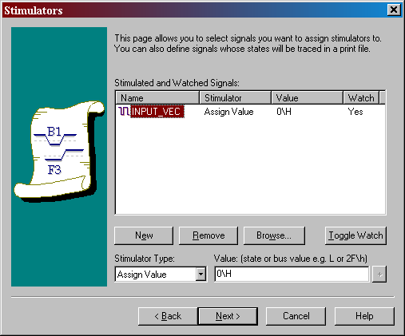
Skip “Set Break Points”.
A template file will be generated. Add additional commands to this file.
To display output waveform, add lines “watch QAGB”, “watch QALB”, “watch QAEB” one command per line.
To simulate input vectors, add “cycle” after each assignment. The simulation will advance one clock cycle each time command cycle is executed. A truth table can be produced this way.
assign INPUT_VEC 085\H
cycle
The actual simulation script file should exercise all the possible input combinations.

Implement the Design

Create a User Constraint File (UCF)
A User Constraint File specifies pin assignment among other constraints. A file compare.ucf should have been created automatically. Use HDL Editor in Tool->Design Entry to open that file and add the following pin assignment. Notice that a component of an array is specified as A<3> for example. Save this file.

# File name: compare.ucf --UCF for module sn7485 #
############################################################
# Pin and CLB location locking constraints #
############################################################
# -----------------------
NET A<3> LOC=P6;
NET A<2> LOC=P7;
NET A<1> LOC=P8;
NET A<0> LOC=P9;
NET B<3> LOC=P38;
NET B<2> LOC=P39;
NET B<1> LOC=P40;
NET B<0> LOC=P41;
NET IAGB LOC=P27;
NET IALB LOC=P37;
NET IAEB LOC=P29;
NET QAGB LOC=P14;
NET QALB LOC=P10;
NET QAEB LOC=P28;

Implement the design
To implement the design with a FPGA, click Implementation block in the design flow chart. The following window will appear so that some parameters can be chosen.
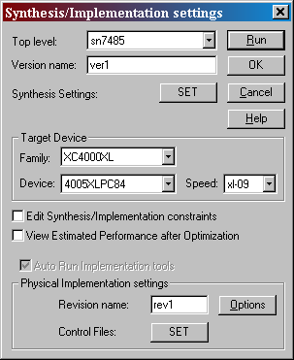
Click SET to open a window to specify implementation control files. The files are Constraints file, Guide file, and Floorplan files.
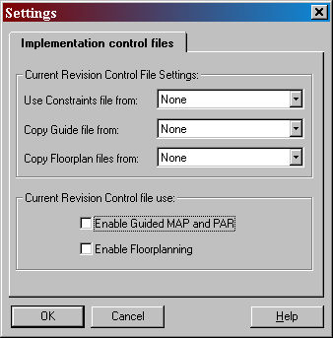
Choose custom and a file name compare.ucf will appear. Click OK to start implmentation.
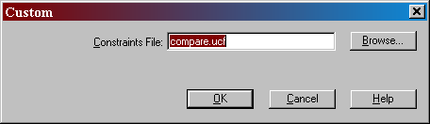
A number of steps will be executed to geneate a bit stream file as shown below. A file called compare.bit should be created after this implementation step.
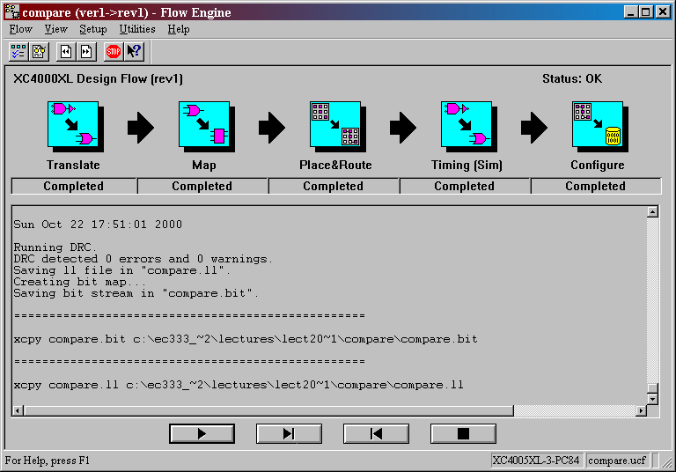

Pin assignment in the Pad Report
The pin assignment can be found in the Pad Report that is located in Reports->Implementation Report File folder. The part number is indicated at the beginning of this file. Make sure it is Part xc4010xl with Package pc84.

Down the bit steam file to the XS40 board
Run GXSLOAD and pick the compare.bit file from the project folder and drop it into GXSLOAD window. The file will be downloaded into the FPGA on the XS40 board. After the downloading is over, the circuit is ready for testing.
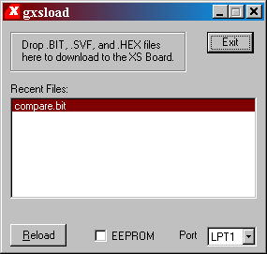
To istall gxsload, obtain the executable xstooset from the class folder. Choose to install tools for the older versions. A number of tools will be installed: gxsload, gxstest, gxsport, and gxssetclock. gxstest is used to test the board.

Error messages and possible solutions

Error: Cannot find a valid license for Synopsys synthesis
Solution: Create a folder C:\Flexlm and place a copy of your license file license.dat in it. Edit your autoexec.bat file to include LM_LICENSE_FILE=C:\FLEXLM\license.dat.

Error: The specified part XC4010XL-09-PC84 is either invalid or not supported
Solution: install the device library for XC4000XL from the Xilinx Foundation CD ROM.

Error: Cannot get chip information from Synopsys. Specified target is invalid or cannot get the target.
Solution: Update Version file to specify the target device with Project->Create Version. You may want to delete the old version with Project -> Delete Version.

Error: Cannot create chip in Synopsys project. Specified file does not exist.
Solution: Update Version file to specify the target device with Project->Create Version. You may want to delete the old version with Project -> Delete Version.

Error: Cannot find a valid license for Synopsys Constraint Editor. Constraint Editor/Viewer will not be available.
Solution: ignore the error since the Constraint Editor is not part of the Starter Kit.

Hints

Simulation Step
- Are the Part Number and Package Number correct? (Check and edit them by opening Project->Create Version.)

Implementation Step
- Have you changed the UCF file? If yes, you need to start Synthesis again.
- Have you set the User Constraint File? IF no, click Set in Synthesis/Implementation Setting Window)
- Are the part number, package number and pin assignment correct? (Check them by opening Pad Report in Reports->Implementation Report Files)
To edit the UCF file, start Design Entry->HDL Editor and look for file with *.ucf.

A panic button
Click Project->Clear Implementation Data to start a fresh implementation version if you don’t want to continue with the current version.

Appendices

The Verilog Code for the SN74LS85 4-Bit Magnitude Comparator

module sn7485 (A, B, IAGB, IALB, IAEB, QAGB, QALB, QAEB) ;
// Jianjian Song, EC333 October 2000
input [3:0] A ;
input [3:0] B ;
input IAGB ;
input IALB ;
input IAEB ;
output QAGB ;
output QALB ;
output QAEB ;

// add your declarations here
//reg QAGB;
//reg QALB;
//reg QAEB;

assign QAGB = (A>B) || (A==B)&&IAGB || (A==B)&&!(IAGB||IALB||IAEB);
assign QALB = (A<B) || (A==B)&&IALB || (A==B)&&!(IAGB||IALB||IAEB);
assign QAEB = (A==B)&&IAEB;

//always @ (A or B or IAGB or IALB or IAEB)
// begin
// QAGB <= (A>B) || (A==B)&&IAGB || (A==B)&&!(IAGB||IALB||IAEB);
// QALB <= (A<B) || (A==B)&&IALB || (A==B)&&!(IAGB||IALB||IAEB);
// QAEB <= (A==B)&&IAEB;
// end
endmodule

