Name:______________________________________ CM: _______ Grade:_____/10
- (a) Give a unique application of surveillance not mentioned by the instructor.

(b) In this application, what specifically are you trying to detect?

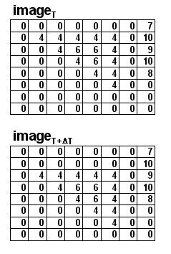
- (a) (2 pts) Subtract the following ideal pair of frames
(image _{T+ΔT} – image_{T}). The triangle moved
downward 1 pixel

(b) What further processing would you need to do to detect the triangle?

- (2 pts) Sketch (qualitatively) the motion field for a camera that’s zooming out while panning to the left:

- For a single pixel in my image, I have $\frac{∂f}{∂x}=\text{10},\frac{∂f}{∂y}=\text{24},\frac{∂f}{∂t}=5\text{.}$I use consecutive frames.

- (2 pts) Please write the simplest formula you can relating Δx and Δy. Hint: use the Taylor series expansion and plug in all known values.

Δy
Δx

- Sketch the line defined by your answer to (a) →
(Next class we’ll see its significance)

- (0) Tell your instructor about anything from today's session (or from the course so far) that you found confusing or still have a question about. If none, please write “None”.

