Name:___________________________________________________ Grade:_____/10
- What is the general structure of a convolutional neural network?

- What features does the first layer of a CNN typically learn?

- What makes a CNN tolerate variations in location of objects?

- Perform 2x2 max-pooling on the following matrix. What are the switch variables? Use the switch variables to undo the max-pooling and reconstruct the initial matrix.

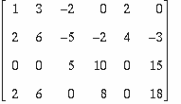

- What is gradient descent?

- What features does the first layer of the shape classifying network learn?

- (0) Tell your instructor about anything from today's session (or from the course so far) that you found confusing or still have a question about. If none, please write “None”.

