CSSE 290 Web Programming
Homework Assignment 7: Kevin Bacon
.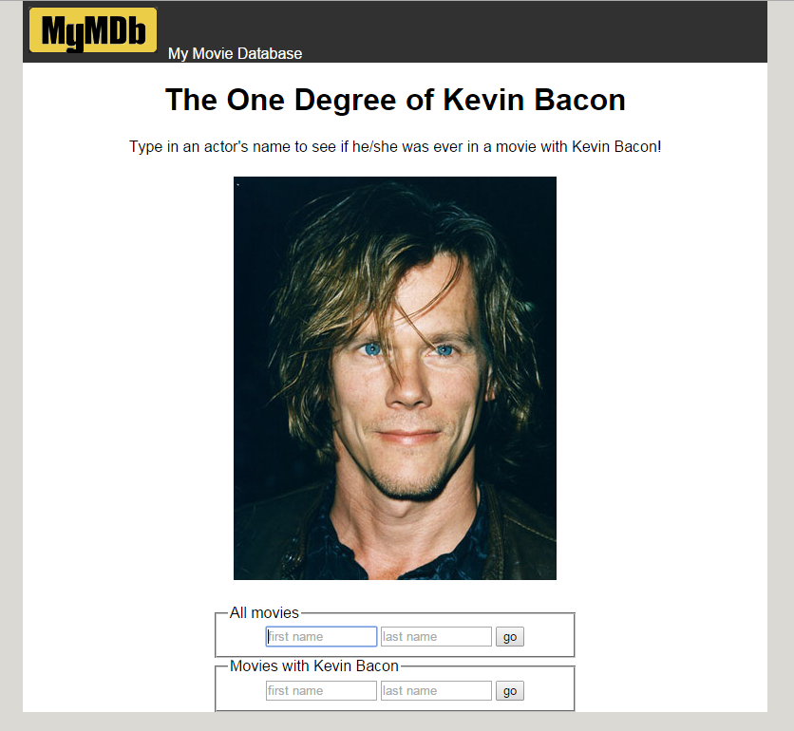

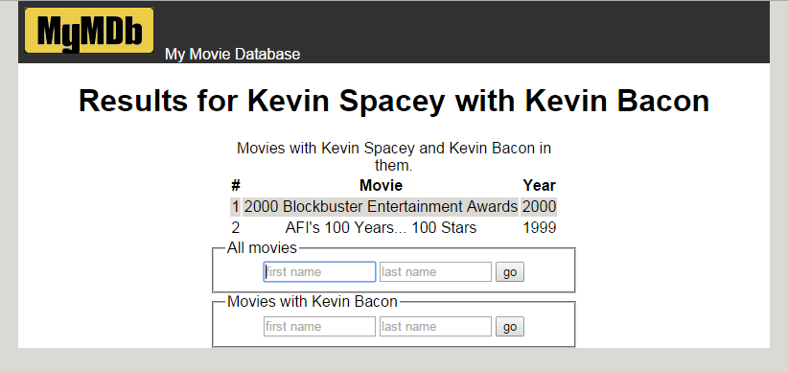

Background Information:
The Six Degrees of Kevin Bacon is a game based upon the theory that every actor can be connected to actor Kevin Bacon by a chain of movies no more than 6 in length. Most, but not all, can reach him in 6 steps. 12% of all actors in the IMDB cannot reach him at all.
Your task for this assignment is to write the HTML/CSS and PHP code for a web site called MyMDb that mimics part of the popular IMDb movie database site. Your site will show the movies in which another actor has appeared with Kevin Bacon. The site will also show a list of all movies in which the other actor has appeared.
(If you prefer, you may use another actor rather than Kevin Bacon as the center point, so long as that actor is in our database and has a large number of connections to other actors.)
The following provided files are on the course web site to get started:
- top.html, some common HTML that should appear at the beginning of every page
- bottom.html, some common HTML that should appear at the end of every page
- mymdb.php, the initial front page that welcomes the user to the site
The front search page mymdb.php contains two forms in which the user can type an actor's name. The user can search for every film the actor has appeared in (which submits to search-all.php), or every film where both the actor and Kevin Bacon have appeared (which submits to search-kevin.php).
Files that you must write and submit:
- search-all.php, the page showing search results for all films by a given actor
- search-kevin.php, the page showing search results for all films with the given actor and Kevin Bacon
- common.php, any common code that is shared between pages
- bacon.css, the CSS styles shared by all pages
- bacon.js (optional), any part of this that you prefer to do in JavaScript
- search-degree2.php, (and perhaps a corresponding additional JavaScript file) if you do the extra-credit part

Front Page, mymdb.php:
The initial page, mymdb.php, allows the user to search for actors. You may modify it in any way you like, or you may leave it as-is. The forms on the page contain two text boxes that allow the user to search for an actor by first/last name.
- firstname for the actor's first name
- lastname for the actor's last name

Movie Search Pages, search-all.php and search-kevin.php:
The two search pages perform queries on the imdb database to show a given actor's movies. Query the IMDB database using PHP's PDO library as taught in class. (Use imdb_small on your own computer for testing and debugging)
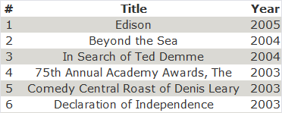
The data in both tables should be sorted by year descending, breaking ties by movie title ascending. The tables have three columns: A number starting at 1; the title; and the year. The columns must have styled headings, such as bold. The rows must have alternating background colors, called "zebra striping." (Note that this can be done entirely with CSS, but you are allowed to use JavaScript if you prefer).

Database and Queries:
The database has the following relevant tables. (The roles table connects actors to movies.)
table | columns
actors | id, first_name, last_name, gender
movies | id, name, year
roles | actor_id, movie_id, role
Your search pages perform the following queries. For some queries, you must use a join on multiple database tables.
1. search-all.php - List of all the actor's movies: A query to find a complete list of movies in which the actor has performed, showing the results in an HTML table. If the actor doesn't exist in the database, don't show a table, and instead show a message such as, "Actor Cary Laxer not found." If the actor is found in the database, you may assume that actor has been in at least one movie.
Hint: To find the proper query, you will need to join all three of actors, movies, and roles. Retain only the rows where the relevant IDs from the tables match each other, and also retain only the rows that pertain to your particular actor. One possible solution joins 3 tables in the FROM clause and has one test in its WHERE clause.

2. search-kevin.php - List of movies with this actor and Kevin Bacon: A query to find all movies in which the actor performed with Kevin Bacon. These movies should be displayed as a second HTML table, with the same styling as the first. This is the harder query and should be done last. If the actor doesn't exist in the database, don't show a table, and instead show a message such as, "Actor Sriram Mohan not found." If the actor has not been in any movies with Kevin Bacon, don't show a table, and instead show a message such as, "Sriram Mohan wasn't in any films with Kevin Bacon."
This query is bigger and tougher because you must locate a pair of performances, one by the submitted actor and one by Kevin Bacon, that both occurred in the same film.
Hint: You must join a pair of actors (yours and Bacon), roles that match those actors, and a movie that matches those roles.

3. both pages - Find the ID for a given actor's name: One thing that makes this program more complicated is the fact that some actors share the same name. The imdb data resolves this by giving them slightly different first names, such as "Will (I) Smith" vs. "Will (II) Smith". The user presumably doesn't know or understand this, so they will just type "Will Smith" and expect the program to do the right thing. But if your code naively searches for "Will Smith" in the database, it will not find any match.
To resolve this, you need a third query that searches for the best match for the actor's name that was typed by the user. This query finds and returns the ID of the actor whose last name exactly matches what was typed by the user, and whose first name starts with the text typed by the user. If more than one such actor exists, you use the actor who has appeared in the most movies, breaking ties by choosing the actor with the lower-numbered ID.
You could figure out how many movies an actor has appeared in using a series of joins between tables, but this can be hard to get right and can be slow. To help, we have created a column in the actors table named film_count that contains the total number of roles played in all films by the actor. You can use this column to help write your query.
For example, if you have written this query correctly and searched the larger imdb database for "Will Smith", you would produce the actor ID 444807. For "David Cohen" you would produce the ID of 90749. For "Elizabeth Taylor" you'd produce 809516. On the imdb_small data set, for "Chris Miller" you would produce 321300.
Hint: You don't need any JOINs here because all information comes from the actors table. If you don't want to write this query right away, you could temporarily hard-code an actor's ID or just write a query to return the first actor with a given first/last name, which is what the correct query would do anyway when there are no conflicts.
The behavior of the page can be whatever you wish if the actor being searched for is Kevin Bacon himself.

Appearance Constraints (all pages):
Your three PHP pages must match certain appearance criteria listed below. Beyond these, any other aspects of the page are up to you, so long as it does not conflict with what is required. The intention is to give you some flexibility to be creative with the appearance of your page, while also expecting you to practice some non-trivial CSS styling. We'll mention our sample page's styles (as shown on the first page of this document), but you don't have to exactly match those as long as you follow these rules.
- All pages must begin with the content from top.html and end with the content from bottom.html, including the "favicon", MyMDb logo, and the two forms to search for movies. It is especially important not to modify the names of the query parameters in the provided forms, such as first_name. The images are collected in the images folder, so you may need to make a few changes to HTML and PHP code that loads images
- The main section of content must be a centered area that is narrower than the overall page body. This main section should have a different background color than the overall body behind it, to make it stand out. (Sample page uses a width of 90% and a white background, atop a body with a background of #dad9d4.)
- Every page should have a descriptive level-1 heading explaining the contents of the page. (Sample pages have headings such as, "Results for Kevin Spacey" or "The One Degree of Kevin Bacon".)
- The top and bottom banner areas containing the MyMDb logo and W3C images should have a common color scheme and/or background image that make them stand out from other content on the page. (Samples use a background image of banner-background.png and white text.)
- The site should have a consistent color and font scheme used throughout. Your CSS should be structured such that it is easy to change the color/font scheme by modifying colors and fonts in a single place in the file. (Samples use Verdana / sans-serif for text, black-on-white for the main area, and #dad9d4 for gray shaded backgrounds.)
- All content should have reasonable sizing, padding, and margins such that content does not awkwardly bump into other content on the page. Content should also be aligned in reasonable ways for easy viewing. (Sample centers the various elements; their forms are 24em in width; many elements have 1em of padding or margin for separation.)
- Any query results should be shown in tables with captions describing the tables, and headings describing each column. The rows of the table should alternate in background color, also called "zebra striping." Borders should be collapsed. (Sample page has every other row use a background of #dad9d4, starting with the 2nd row.)

Development Strategy:
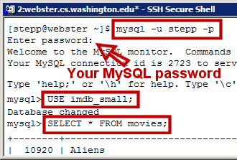
Because the imdb database is large and shared by all students on wwwuser, a bad query can hurt performance for everyone. For debugging purposes, we have a smaller database imdb_small with fewer records. While testing, please use that database and not the full imdb. When you think your code works and you are ready for final testing, switch your PHP code to refer to imdb.
Use phpMyAdmin or the command-line mysql interface to develop your queries before writing PHP SQL code. Example test actor IDs are 376249 (Brad Pitt) or 770247 (Julia Roberts). If your command-line query takes too long, press Ctrl-C to abort it.
Enable exceptions on your PDO object to spot mistakes, as shown in the textbook and slides. Print your SQL queries while debugging to see the actual query being made. Many PHP SQL bugs come from improper SQL query syntax, such as missing quotes, improperly inserted variables, etc.
You do not need to secure your page against HTML/SQL injection attacks to get full credit, but you may if you like.

Implementation and Grading:
Minimize the use of global variables, and use descriptive variable names. Place descriptive comments at the top of each file, each function, and on complex code. Also place a comment near every SQL query to explain what that query is searching for. Use parameters and return values properly. Use proper separation of content, presentation, and behavior between HTML, CSS, (JavaScript) and PHP code.
With so much in common between the two search pages, it is important to find ways to avoid redundancy.
You should use the PHP include function to include shared common content that is on multiple pages. Also use functions where appropriate.
For full credit, do not directly write any actor's ID number anywhere in your PHP code, not even Kevin Bacon's. For example, don't write a line like:
$bacon_id = 22591; # Kevin Bacon's actor id (BAD, don't do this)
It is not acceptable to perform query filtering in PHP. Your SQL queries must filter the data down to only the relevant rows and columns. For example, a bad algorithm would be to write a query to fetch all of the actor's movies, then another query to fetch all of Bacon's movies, then use PHP to loop over the two looking for matches.
Format your code. Properly use whitespace and indentation. Use good variable and function names. Avoid lines of code more than 100 characters wide.
Where to Submit: You should use SFTP to copy your entire HW7 folder to your webProgramming folder on wwwuser.csse.rose-hulman.edu . If you wish, you can leave out the spec.doc and spec.pdf files to save server space and transfer time. Test your program after you upload it!
Extra Credit – up to 15 points (the assignment is worth 100 points) Add a third form (or modify the second form) so there is an option of looking up 2nd-degree separations. I.e., the given actor appeared in a film A with actor B, and B appeared in film C with Kevin Bacon. For each such combination, you should display A, B, and C in a reasonable way. If there are a lot of results, only display the first 100 of them, the ordering determined first by B’s last name (ascending order), then by year of film A (descending order).

Copyright © Marty Stepp / Jessica Miller, licensed under Creative Commons Attribution 2.5 License. All rights reserved.
Modified (with permission) by Claude Anderson foe CSSE 290/280 at Rose-Hulman

