CSSE 290 - Web Programming
Homework Assignment 3: Movie Review Part Deux
For this assignment you will write PHP code that produces movie review pages much like your TMNT page from HW2. Your PHP code will allow you to generate reviews for a variety of movies using the same code. You must create files:
- movie.php, the PHP code to produce review pages for movies
- movie.css, the style sheet for movie.php (probably does not need to be modified from HW2 version)
We do not expect you to produce pixel-perfect pages that exactly match our images. But your page should follow the styles specified in this document and match the look, layout, and behavior shown here as closely as possible.
The overall page looks mostly the same as in the previous assignment. The difference is that the page can show reviews and information for a film other than TMNT. For example, the following output shows The Princess Bride:
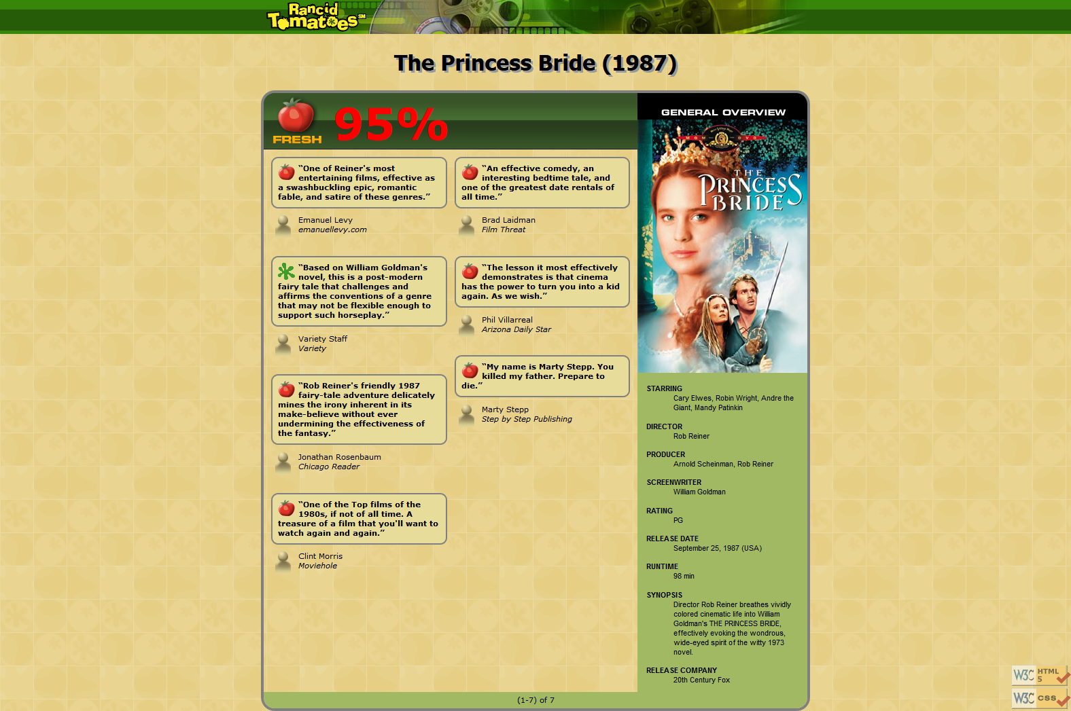
To make things simpler, the page's title can now always be just "Rancid Tomatoes".
From the course web site you will download a .ZIP archive of input files for a few movies, described on the next page. Unzip this file into the same directory as your HW3 files, so that the files will be located in relative paths such as tmnt2/info.txt and princessbride/overview.png. Your code should assume these are the relative paths to use.
(Don't put them in a moviefiles/ folder. Put each film's folder, such as tmnt2/ or mortalkombat/, directly in your hw3 folder.)

The page uses the same images as HW2, with two minor changes. The tmnt.html page showed rottenbig.png next to its 33% rating. But now some films have high overall ratings. Any film whose rating is 60% or above should show freshbig.png, shown at right. Also overview.png has moved, since each movie has its own overview image. The overview images are the one exception; since these now come from the support ZIP file and reside in the folder with the movie's information, link to these using a relative path such as "tmnt2/overview.png".
All style elements not described here should be as specified in HW2 or subject to the preference of the web browser. The screenshots in this document were taken on Windows in Firefox, which may differ slightly from your browser.

Appearance Details:
Your movie.php page will show reviews of different movies based upon a query parameter named film that is passed from the browser to the page in its URL. The value of this variable should be a string representing the movie to display. The browser will request your page with a URL such as the following:
movie.php?film=princessbride
Your PHP code can store this parameter into a variable using code such as the following:
$movie = $_GET["film"];
All of your PHP code should use this parameter's value, and you should never hard-code particular movie names. Your code may assume that the browser has properly supplied this parameter and has given it a valid value. You may assume that the movie exists and has a corresponding folder of valid input data and images. You do not have to handle the case of a missing or empty film parameter, a value that contains bad characters, a value of a movie that is not found, etc.
Based upon the parameter’s value, display a review of that film. Each film is stored in a directory named the same as your query parameter. For example, the film princessbride stores its files in a folder named princessbride/ . The files associated with each movie are the following. You may assume that the files exist and are valid for all films.
- info.txt, a file with three lines of information about the film: its title, year, and overall rating percentage. The information is used as the page heading and overall red movie rating number. Here's an example file:
The Princess Bride
1987
95
- overview.txt, a file with information to be placed in the General Overview section of your page. Each pair of neighboring lines contains the title and value for one item of information, to be displayed as a definition list term (dt) and its description (dd). The number of lines in the file varies from movie to movie. Example:
STARRING:Cary Elwes, Robin Wright, Andre the Giant, Mandy Patinkin
DIRECTOR:Rob Reiner
PRODUCER:Arnold Scheinman, Rob Reiner
SCREENWRITER:William Goldman
...
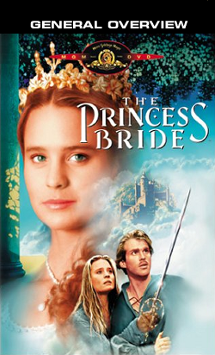
- overview.png, an image to display at the top of the General Overview section. This is the movie poster for the film, such as the one shown at right.
- review1.txt, review2.txt, ..., files containing information for each review of the film. Each review file contains exactly four lines: The review, a fresh/rotten rating, the reviewer's name, and the publication. For example, review1.txt might store the following:
One of Reiner's most entertaining films, effective as a ...
FRESH
Emanuel Levy
emanuellevy.com
  - Different movies have different numbers of reviews. Show the first half of the reviews in the left column, and the rest on the right. If a movie has an odd number of reviews, the left column receives the extra review. For example, Princess Bride has 7 reviews, so the first four go on the left and the last three on the right. If a movie has only a single review, it goes in the left column. Do not worry about the possibility that the overview and reviews sections will be wildly different in height. (You may assume that the film has at least 1 review, but it might have 10 or more; you should display them all.) The green bar along the bottom of the page also should now display "(1 - N) of N" where N is the number of reviews for the current movie.
If a review has ten or more reviews (such as tmnt2), the names will be e.g. review01.txt, .... Don't hard-code file names like "review1.txt"; look for all files that begin with "review" and end with ".txt".
  - The image to show for each review is affected by the second line of the review's text file. If the critic gave the film a FRESH rating, display fresh.gif. If it's ROTTEN, display rotten.gif.
For example, if your variable stores "princessbride", open princessbride/info.txt to read the film's title/year/etc. and display that on the page. Display the contents of princessbride/overview.txt in the General Overview section on the right side. Then look for all review files in princessbride/ and display each in the reviews area.

Creative Aspect: Your Own Movie
As part of your turnin, create your own set of movie input data to be fed into your movie.php page. Write an info.txt, overview.txt, and at least 4 review text files for your movie. Also find a suitable image to use as overview.png of size 250x412px. You can resize an image using the free GIMP editor or a program of your choice. The name of the folder that contains the files for your review should be mymovie.

Development Strategy and Hints:
PHP code is difficult to debug if you have errors. Write the program incrementally, adding small pieces of code to a working page, and not advancing until you have tested the new code. We suggest that get your page to display a single film (such as princessbride or tmnt2) first, then generalize it for other films. None of your code should refer to specific names of films such as princessbride. The following built-in PHP functions may be helpful:
- count - returns the number of elements in an array
- explode - breaks apart a string into an array of smaller strings based on a delimiter
- file - reads the lines of a file and returns them as an array
- glob - given a file path or wildcard such as "foo/bar/*.jpg", returns an array of matching file names
- list - unpacks an array into a set of variables; useful for dealing with fixed-size arrays of data
- trim - removes whitespace at the start/end of a string (gets rid of stray spaces in output)

Implementation and Grading:
You will not receive full credit unless your page's output for all films successfully passes the W3C HTML validator. (Not the PHP source code itself, but the HTML output it generates, must validate. To validate your page, view the page on the server, then choose View Source in your browser and copy/paste it into the validator.) Do not use HTML tables on this assignment.
Your PHP code should not cause errors or warnings. Do not use the global keyword. Use indentation/spacing, and avoid long lines over 100 characters. Use material from the first three weeks of class and the first five book chapters. (Textbook Chapter 5 is a good resource.)
Be mindful of "mode switches" between PHP code and HTML tags using <?php and ?> . Produce as much of your output in HTML mode as possible; only switch to "PHP mode" to compute or print dynamic content. You should reduce the number of large complex chunks of PHP code that are placed in the middle of your HTML code. When possible, replace such chunks with declarations of functions that are called by small PHP snippets in the HTML.
Begin your movie.php file with a comment that lists your name and section. Comment your PHP code as appropriate.
You should not have code that depends on particular movies or uses if/else statements to see which movie to display. Use loops, variables, etc. to avoid redundancy.
Format your HTML and PHP code similarly to the examples from class. Properly use whitespace and indentation. Do not place more than one block element on a line or begin a block element past the 100th character. CSS is not a major part of this assignment, but your CSS file should validate and you should not introduce new bad/invalid CSS code.
Turnin instructions will be provided separately, sometime during week 4.
Copyright © Marty Stepp / Jessica Miller, licensed under Creative Commons Attribution 2.5 License. All rights reserved.
Adapted for the Rose-Hulman CSSE290 Web Programming course by Claude Anderson

