Practical 5 Worksheet
Rose-Hulman Institute of Technology - CSSE 232 Computer Architecture

Name: _________________________________________ Section: ____

NOTE: follow instructions on the practical web page, it will have more details than this document.

Datapath for tracing and labeling during parts 1-4.
We recommend printing this worksheet and marking it with a pen/highlighter or marking this document up with a tablet.

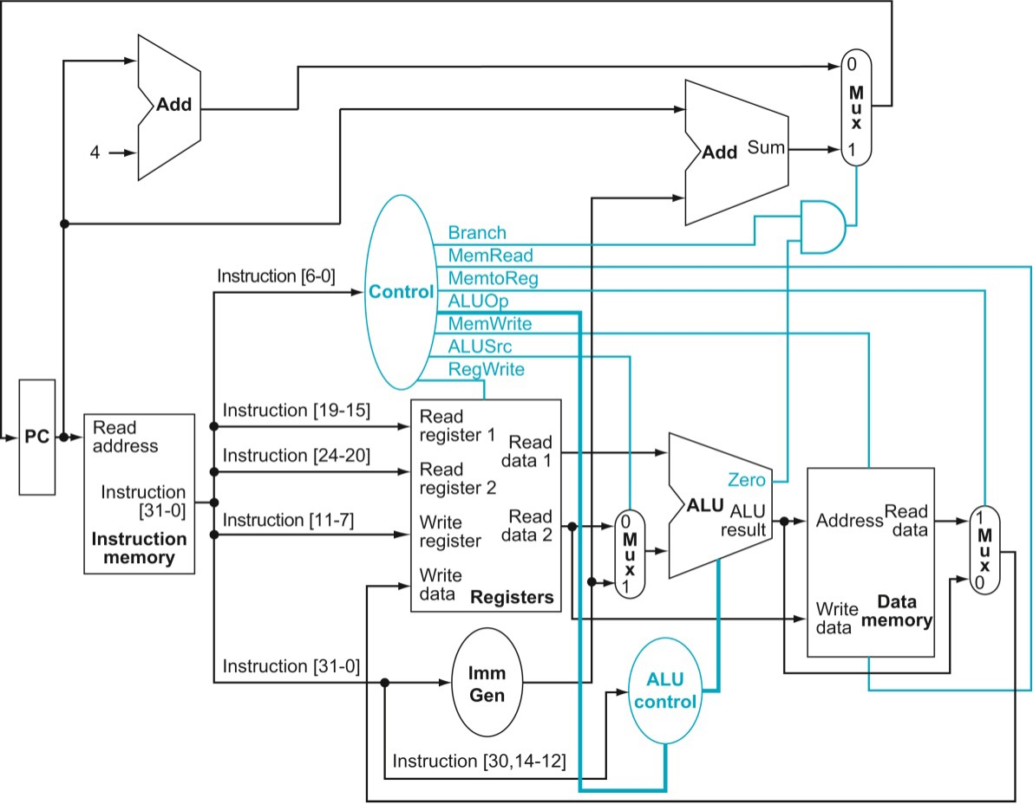

Part 3.2: Timing diagram:
Label the clock signal edges in the worksheet with the instruction steps listed in the practical guide. Indicate the edge where each instruction step should happen. Step 1a is given for you.
1a

Part 4.4: More types of branches
Complete the truth table below to generate a 1 when you want to take the branch (for each type of branch) and 0 when you don’t. Then construct a case statement in Verilog that assigns the PC’s input to the branch target when a branch should be taken.
HINT: The ALU is doing a subtract. If the result of the subtract is negative, it indicates that A < B. If it is positive or zero then A >= B.
Assume the “Branch” control signal is 1 because opcode is SB-type (branches only).
 | Funct3 | ALU.zero | ALU.result[31] | Take branch?
beq | 000 | 0 | x
beq | 000 | 1 | x
bne | 001 | 0 | x
bne | 001 | 1 | x
blt | 100 | x | (neg) 1
blt | 100 | x | (pos) 0
bge | 101 | x | (neg) 1
bge | 101 | x | (pos) 0

General Practical Questions:
- (Need.)

- (Performance.)
Explain how this single-cycle implementation might have a bunch of "unused time" during a clock cycle.

- (Correctness)
Describe the most important thing to test when implementing branches.

- (Iteration)
Describe whether implementing the branches gradually in three steps was a good idea and why or why not it was a good idea.

- What was the biggest challenge in implementing and testing the single cycle datapath? Explain in 100 words or less.
- What is the single biggest thing you learned from writing tests for this practical? Explain in 100 words or less.

