Lab 4 Worksheet
Rose-Hulman Institute of Technology - CSSE 232 Computer Architecture

Name: _________________________________________ Section: ____

NOTE: follow the instructions on the lab web page, it will have more details than this document.

In part 2 of the lab, you’re asked to complete the waveform on the next page. Complete the missing signals for dp_q_a and dp_q_b. Assume that all displayed values are hexadecimal and that both memory blocks are initialized to have the following values:
Address: Value:
@0x0000 0000 -> 0x0000 0000
@0x0000 0001 -> 0x0000 0000
@0x0000 0002 -> 0x0000 0000
@0x0000 0000 -> 0x0000 0000
@0x0000 0020 -> 0x1234 abcd

There are also some general lab questions after the waveform. Fill those out after you complete the lab.
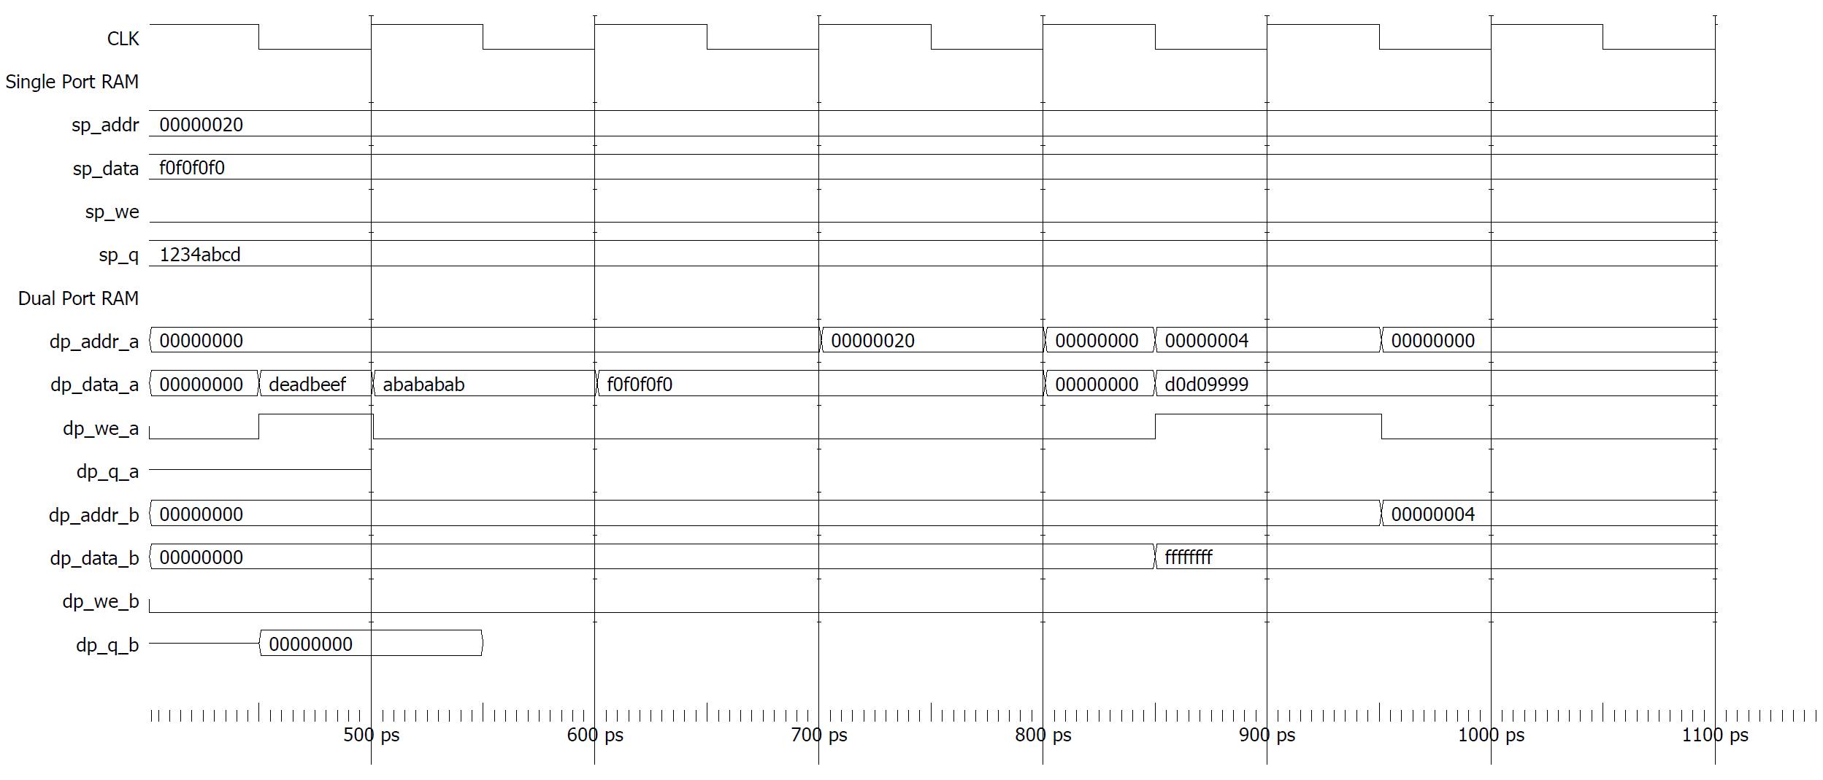
General Lab Questions:
- (Need.) Explain what purpose the RegisterFile will serve when you implement a processor.
- (Performance.) Identify if any of the modules created could be more efficient (for example, you could explain how you think the logic of one module could be made simpler with some extra work.)
- (Correctness) Describe your strategy for constructing RegFile tests; explain how you chose which tests to write.
- (Iteration) Briefly describe any first attempts or efforts you abandoned for one of the modules or tests you implemented. If you committed "in progress" work to git, then changed your mind and re-implemented it differently, that is a good thing to explain here.
- What was the biggest challenge in implementing and testing the RegisterFile? Explain in 100 words or less.
- What is the single biggest thing you learned from writing tests for this lab? Explain in 100 words or less.

