Summary 5 – Methods: Returning Values and the void keyword

- What is this?
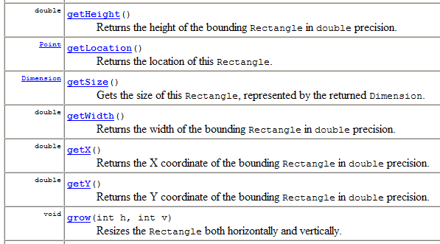
Some methods return a value, e.g. the length method of the String class:
String s = “Hello”;
int x = s.length();
The above sets x to 5.

Other methods just “do” things and don’t return a value, e.g. the println method of the PrintStream class:
System.out.println(“Hello”);
The above causes “Hello” to be printed, but nothing is returned from the call to the println method.

The keyword void indicates a method that does not return a value, e.g.
public void stop()

Pitfall: constructors never return a value, but must NOT have the void keyword in their definition. Here is a hard-to-spot error:
public void Eye() {
...
}
This looks like a constructor for the Eye class, but it is really a badly-named method!
- Examples (from the Rectangle class documentation)

Of the above methods, only the grow method does not return a value; the other methods return values, of various types.

- For further study:
  - Big Java, section 2.4 Method Parameters and Return Values
  - This summary’s author: David Mutchler

