Name: ______________________________________

Use this quiz to help make sure you understand the videos/reading. Answer all questions. Make additional notes as desired. Not sure of an answer? Ask your instructor to explain in class and revise as needed then.

Throughout, where you are asked to “circle your choice”, you can circle or underline it (whichever you prefer).

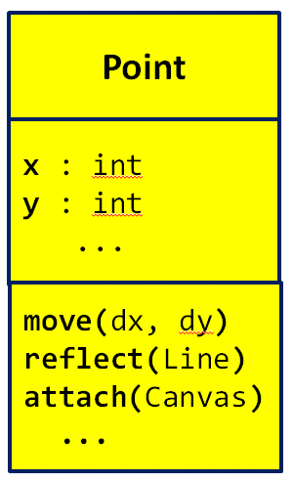
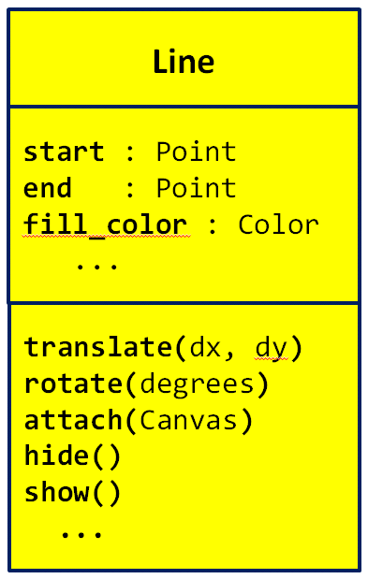
Video: Classes – The Concepts
- The diagrams to the right are called
_________ Class Diagrams, where
________ stands for Unified Modeling Language. (Fill in both blanks with the (same) 3-letter acronym for Unified Modeling Language.)
- Consider the two UML class diagrams shown above and to the right. What are the names of the two classes shown?

- Consider the UML class diagram for the Point class shown above. For that class:
  - What are the names of the two instance variables (aka fields) that are shown?

  - What do you think that those fields represent? (You can’t tell this authoritatively from the UML class diagram; just make your best guess based on the names of the fields.)

  - How many methods are shown?
  - How many arguments does the move method require?
  - How many arguments does the reflect method require?
  - How many arguments does the attach method require?
  - What kind of thing is the reflect method’s argument?
  - What kind of thing is the attach method’s argument?

- Consider the UML class diagram for the Line class shown on the previous page (and repeated to the right for your convenience). For that class:
  - What are the names of the three instance variables (aka fields) that are shown?

  - What do you think that those fields represent? (You can’t tell this authoritatively from the UML class diagram; just make your best guess based on the names of the fields.)

  - How many methods are shown?
  - How many arguments does the translate method require?
  - How many arguments does the hide method require?

- True or false: A single class can have many instances of that class. True False (circle your choice)
- True or false: For any particular class (say, the Point class),
any instance of that class uses the same NAMES for its
instance variables as any other instance of that class. True False (circle your choice)
- Consider two objects alpha and beta, both of which are instances of the same class. Suppose that both have an instance variable called time_of_day. True or false: The VALUE of alpha’s time_of_day is necessarily the same as the VALUE of beta’s time_of_day . True False (circle your choice)
- True or false: For any particular class (say, the Point class),
any instance of that class uses the same NAMES for its
methods as any other instance of that class. True False (circle your choice)
- Consider two objects alpha and beta, both of which are instances of the same class. Suppose that both have a method called sick_days_left() that returns a number. True or false: The value returned by a call to alpha’s sick_days_left() is necessarily the same as the value returned by a call to beta’s sick_days_left(). True False (circle your choice)

Video: Classes – Notation
In the following questions, we are referring to Point and Line classes per the UML class diagrams shown below. These classes are NOT part of RoseGraphics. That is why you will not see (and should not put) any “rg dots”.
- The following examples show two different attempts by two students to construct a new Point at (4, 3). Based on what you have learned about constructing objects in Python, which student(s) are correct and why? (Circle the ones that are CORRECT.)

# Anna
point_anna = Point
point_anna.x = 4
point_anna.y = 3

# Dalton
point_dalton = Point(0,0)
point_dalton.x = 4
point_dalton.y = 3

- A Point’s constructor takes an initial x and a y. Thus, both of the above examples are needlessly long. How would you instead construct the point using just one line of code?

(continues on the next page)

- Suppose you are told that a Line’s constructor takes a start and end point as its constructor arguments, as suggested by the UML class diagram to the right. What line of code would you write to create a Line between a point called point_mine and a new Point at (0, 5), putting the constructed object into a variable called line1.

- Assume that you have a Line object named line2 and a Point object named another_point. Write the statement that would cause the Point class’ reflect method to reflect another_point about line2 to obtain the reflected point. For your convenience, the Point class is repeated to the right.
That is, if another_point is the point labelled P in the diagram to the right, and if line2 is the line labelled l in the diagram, you are to write the statement that would obtain the point labelled P’ in the diagram, by using the reflect method of the Point class.
  - First assume that the reflect method RETURNS a new Point that is the reflected Point. Write the statement that obtains the reflected Point under that assumption:

  - Now assume that the reflect method MUTATES its given Point to be reflected about the given Line. Write the statement that obtains the reflected Point under that assumption:

- Suppose that you have two Line objects in variables line1 and line2, respectively. Write statements that set line1’s fill color to 'red' and line2’s fill color to 'blue'.

Video: Classes – Implementation
- Write the complete definition of a class called Dog that (so far) has nothing and does nothing.

- What is the name of the special method of the RoseWindow class that is called by the following statement:
window = rg.RoseWindow()

- Suppose that you have a class called Dog that has the following __init__ method:
class Dog(object):

def __init__(self, dog_name, age):
self.name = dog_name
self.age = age

When the following statements run, what will self.name and self.age be set to when __init__ runs?
  - fido = Dog('buster', 3)
self.name is set to _____________ self.age is set to _____

  - fluffy = Dog('brownie', 5)
self.name is set to ______________ self.age is set to _____

- Continuing the previous problem, what does each of the following PRINT statements print (or, if the statement has any error, just write ERROR), given the statements in the box below:
class Dog(object):

def __init__(self, dog_name, age):
self.name = dog_name
self.age = age

fido = Dog('buster', 3)
fluffy = Dog('brownie', 5)

print(fido.name) prints _____________________________
print(fido.dog_name) prints _____________________________
print(fido.age) prints _____________________________
print(buster.age) prints _____________________________
print(fluffy.name) prints _____________________________
print(fluffy.dog_name) prints _____________________________
print(fluffy.age) prints _____________________________
print(brownie.age) prints _____________________________
class Dog(object):

def __init__(self, dog_name, age):
self.name = dog_name
self.age = age
self.breed = 'poodle'

- Continuing the Dog class example, suppose we added a third line to __init__, as shown to the right.
  - Is that last line legal? If so, what is its effect?

  - If after constructing fido (per the previous problem), a statement included fido.breed, would that result in an error? If not, what would it evaluate to?

In the video you saw the definition of a Point class method called move_by that took two arguments and moved the Point’s coordinates (x and y instance variables) by those values. Keeping that example in mind:
- Write the definition of a Point class method called move_to that takes two arguments and moves the Point TO (not BY) the given coordinates.

- Write the definition of a Point class method called clone that takes NO arguments and returns a new Point whose x and y coordinates are the same as the Point’s coordinates.

