Name: ______________________________________

Use this quiz to help make sure you understand the videos/reading. Answer all questions. Make additional notes as desired. Not sure of an answer? Ask your instructor to explain in class and revise as needed then. Turn this in via the Session 10 Dropbox on our Moodle site.

Throughout, where you are asked to “circle your choice”, you can circle or underline it (whichever you prefer).

Video: Sequences [8:43 minutes]
- Sequences are powerful because:

- What gets printed by the program shown below when main runs?
(output continues, from second call to examples_of_indexing)
Length is _______
At indices 0, 1, 4:
____________
____________
____________
List them all:
____________
____________
____________
...[don’t bother doing all of the letters, just skip to the last one] ____________

Cool stuff:
____________
Last item:
____________

def main():
list1 = [74, 34, 13, 30, 4004]
string1 = 'Expert texpert!'

examples_of_indexing(list1)
examples_of_indexing(string1)

def examples_of_indexing(sequence):
length = len(sequence)
print('Length is', length)

print('At indices 0, 1, 4:')
print(sequence[0])
print(sequence[1])
print(sequence[4])

print('List them all:')
for k in range(len(sequence)):
print(sequence[k])
print()

print('Cool stuff:')
print(sequence[-1])

print('Last item:')
length = len(sequence)
print(sequence[length - 1])
Output
(fill in the blanks)
Length is _______
At indices 0, 1, 4:
____________
____________
____________
List them all:
____________
____________
____________
____________
____________

Cool stuff:
____________
Last item:
____________

Just take a wild guess and ask in class!
- Implement (here, on paper) the following function, per its specification.
def count_negative(seq):
"""
Returns the number of items in the given sequence of numbers
that are negative.

Precondition: The argument is a sequence of numbers.
"""

- Implement (here, on paper) the following function, per its specification.
def count_short_ones(seq_of_lists):
"""
The argument is a sequence of lists. Returns the number of
items in that sequence whose length is less than 3.

For example, if the argument is:
[ [3, 5], [3, 9, 0, 4], [5], [5], [], [9, 8, 7], [5, 6] ]
then this function returns 5, since 5 of the 7 lists in the
above sequence have length less than 3
(I have displayed those 5 lists in red.)

Precondition: The argument is a sequence of lists.
"""

Video: The Last Item in a Sequence [3:20 minutes]
- Given a sequence called seq that contains 10 items, write expressions for:
- The beginning item (element) in seq: ___________________________________
- The last item (element) in seq: _________________________________________
- Suppose that you have a list called my_list that contains 10 items. What error message appears if you attempt to access my_list[10]?

- Suppose that you have a string called my_string that contains 10 characters. What error message appears if you attempt to access my_string[10]?

- In Eclipse, when a run-time exception (error) occurs, how do you go straight to the line at which the exception occurred?

- Is that line always the line that is wrong? Yes No (circle your choice)
- What should you do if the exception occurred in the zellegraphics or new_create modules?

- In the two code fragments below, assume that the variable s has been assigned as its value some sequence. The code on the left (below) causes a run-time exception. The code on the right (below) does NOT cause a run-time exception. But both use the same expression len(s). Explain why the code on the left breaks (and is wrong) but the code on the right does not break (and is correct).
... s[len(s)] ...
for k in range(len(s)):
... s[k] ...

Video: Iterating Through a Sequence [11:35 minutes]
In each of the following problems, assume that there is a variable x that is a sequence of numbers.
- Write a loop that prints all the elements of x, backwards. For example, if x were the list [9, 4, 12, 88, 17], then your loop should print 17, 88, 12, 4 and 9, in that order.

- Write a loop that prints all the elements of x between indices 4 and 7, backwards. For example, if x were the list [9, 4, 12, 88, 17, 33, 20, 21, 22], then your loop should print 21, 20, 33 and 17, in that order. Assume that the sequence has at least 8 elements.

- Write a loop that prints every 3rd element of x, starting at index 1. For example, if x were the list [9, 4, 12, 88, 17, 33, 20, 21, 22, 5, 7, 77], then your loop should print 4, 17, 21 and 7, in that order. Assume that the sequence has at least 2 elements.

- Write a loop that prints all the elements of x that are greater than 10. For example, if x were the list [9, 4, 12, 88, 17, 33, 20, 21, 22, 5, 7, 77], then your loop should print 12, 88, 17, 33, 20, 21, 22 and 77, in that order.

Textbook Reading: Section 6.1 — Basic Properties of Lists (pages 278 - 283)

[You can do these problems even without doing the textbook reading, probably. Try them and ask questions as needed on Piazza. The last problem is especially interesting!]
- Write a statement that constructs a list containing three numbers (any three, you pick them, whatever you want) and assigns the variable numbers to that list.

- Continuing the previous problem, write the statement that changes the last element in the list to which the variable numbers refers, to 66. (So after this statement executes, the last element in the list will be 66, instead of whatever you set it to in the previous problem.)

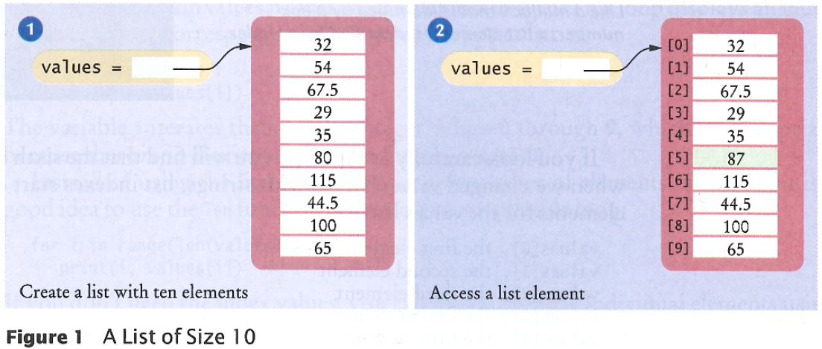
- Consider Figure 1 on page 279, as shown below for your convenience:
The left-hand-side of the figure shows the result of the statement:
values = [32, 54, 67.5, 29, 35, 80, 115, 44.5, 100, 65]
The right-hand-side of the figure shows the result of the additional statement:
values[5] = 87
Write a statement that modifies the right-hand-side of the picture to make the element which is 100 in the picture become -33.33.

- Suppose that the value x refers to a list. Write a statement that prints the number of elements in the list.

- What is the difference between the following two expressions?
numbers[3] numbers = [3]

- Suppose that the value numbers refers to a list of numbers. Write a loop that traverses (i.e., goes through) the list, making each number in the list one bigger than it was.

- [Modified version of Self Check problem 1 from page 282]. Define a variable called primes that refers to a list that contains the first six prime numbers (i.e., 2, 3, 5, etc).

- [Modified version of Self Check problem 2 from page 282]. Continuing the previous problem, what does the list contain after executing the following loop?

for m in range(6):
primes[m] = primes[m] + 1

- [Self Check problem 5 from page 282]. Define a variable (whose name can be whatever you choose for it) that refers to a list containing two strings, 'Yes' and 'No'.

- What does the following code snippet print, and what happens when the last of the statements executes? (Write the output directly to the right of the print statements.)
names = ['zoran', 'siti', 'elchin']
print(names[0])
print(names[2])
print(names[0][0])
print(names[2][4])
print(names[3])

- Read Computing & Society 6.1 Computer Viruses, on page 283. (For your convenience, I have pasted a copy of it on the next page of this quiz.) After reading it:
    - In November 1988, Robert Morris launched a computer virus (actually, a form of virus called a worm) that, through an error in his code, delivered a denial-of-service attack to computers on the Internet. He was convicted under the The Computer Fraud and Abuse Act. After appeal, what was his sentence?
________________ years probation
________________ hours of community service
________________ fine
    - His worm worked by attacking a program called finger that was written in the programming language C. If finger had been written (and run) in Python, would his attack have succeeded? Why or why not?

    - Look on the Internet for more about the Morris’ attack. (A Google search reveals plenty.) After reading a bit, do you think that his sentence was (circle your choice):
Much Somewhat About Somewhat Much
too lenient too lenient right too harsh too harsh
    - Your Google search probably revealed that Robert Morris’ father is also famous. What are some of the things for which he (the father) is famous? Which one of those things is particularly ironic given his son’s behavior?

