ME 317 Design For Manufacturing
Mini-Project 4
Identification of Manufacturing Method and Mechanical Dissection

Assignment:
- Purchase a disposable camera (with or without flash) and bring it to class Monday Feb. 4, 2008 (one camera per group).
- Take pictures of objects manufactured by different methods and report the method of manufacturing using the visual record as evidence.
- Disassemble and examine the camera in class.

Background
One benefit of this course should be should be an improved ability to recognize the method used to manufacture a particular part. This skill can be useful when reverse engineering someone else’s design or when considering manufacturing methods for your own design. The skill combines knowledge of the processes with deductive reasoning.

Also, since disposable cameras are a relatively mature design of a commodity product they should be good examples of design for manufacturing techniques and design for assembly techniques, especially for injection molded polymers. Disassembly and critical inspection will provide insight for later design.

Objectives/Goals
- Exercise your ability to identify the manufacturing method(s) used to make an object from the visual evidence (parting lines, surface marks, surface finish).
- Explore and evaluate the design and assembly of injection molded parts.

Deliverables
- (Due Feb. 4, 2008) – A group of 2-3 members disassembles a camera in class and answers questions per course handout (distributed at that time).

- (Due Feb. 7, 2008) – Each group of 1-3 members will turn in
  - A set of pictures that show
    - One Forged part
    - One Extruded or Roll Formed part
    - One Cast part (Sand, Investment, or Die)
Include should enough pictures of each part to show the features that help identify the manufacturing method.
  - Accompanying the pictures for each object is text that
    - names the manufacturing method.
    - states clear and convincing justifications (approximate and quantitative) from the visual evidence that justify your choice.

Format for Deliverable 2.
Pictures and text should be able to be viewed at the same time. One way to do this with hard copy pictures is to fasten the pictures to one side of a manila folder and fasten the text page to the opposite side of the folder. Since each group will have three example parts, there will be three manila folders.

For digital images, the photos and text can be printed on the same page.

There is no restriction on what camera can be used to acquire the images. Photos from the disposable camera are acceptable, but any photo you take of a part (no photos by people not in your group) with the camera of your choice is also acceptable.
Example
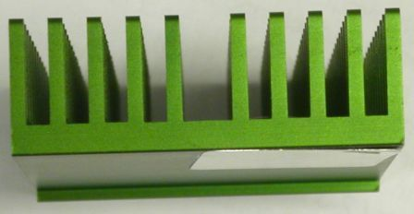

Square
Bottom
Grooves

Figure 1 Heat sink viewed perpendularly to presumed direction of extrusion
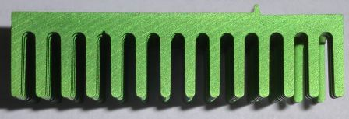

Angled
Surface
Marks

Figure 2 Heat sink viewed in presumed direction of extrusion
Radii

Manufacturing Method
The pictured heat sink is likely to be an extrusion with secondary machining

Justification
Features consistent with extrusion
- Constant cross section (figure 2)
- Use of aluminum
- Small surface lines (die marks) that are only parallel to the direction of extrusion (figure 1)
- Generous radii on features perpendicular to the direction of extrusion (figure 2)
Features consistent with machining
- Square bottom grooves perpendicular to extrusion direction (figure 1)
- Quasi-parallel angled surface marks perpendicular to extrusion direction (consistent with side milling cutter) (figure 2)

Evidence contradicting alternative manufacturing methods
Die Casting
- Lack of draft in likely direction of die motion
- Lack of ejection pin marks
Forging
- Lack of draft in likely direction of die motion
Powder Metal
- Aspect ratio of features is too long and thin
- Radii would require many feathered edges on punch

