Problem 16.138
(NOTE: This problem will be worth 30 points since there is no homework assigned on Wednesday)

Instead of just determining the forces exerted on the connecting rod when θ = 180°, determine the forces at B and D on the connecting rod as functions of θ and make plots of B_{x}, B_{y}, D_{x}, and D_{y}.

Hints:
- In order for crank AB to rotate at a constant angular velocity there must be a moment applied to it.
- Using kinematics you should be able to determine the acceleration of the center of gravity of BD so the only systems you will need to use are bar BD and the piston (both by themselves).

An answer to check you maple worksheet is given below:
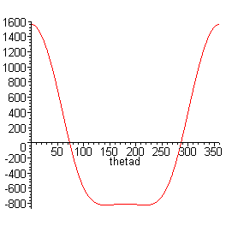
When θ = 180° the forces are:
B = 805 N (left)
D = 426 N (right).

A plot of B_{x} as a function of θ is shown at right.

