Example Problem - Le 25

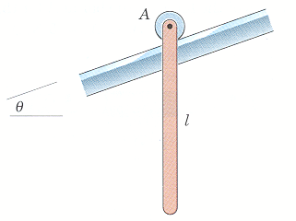
6/97 The slender rod of mass m and length l is released from rest in the vertical position with the small, i.e. negligible, roller at end A resting on the incline. Determine the initial acceleration of A.
(taken from Dynamics, 4th Edition by Meriam & Kraige)

