Example Problem - Le 23

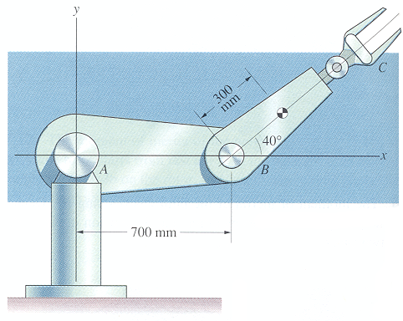
7.27 Arm BC has a mass of 12 kg and the mass moment of inertia about its center of mass is 3 kg-m². If arm AB has a constant clockwise angular velocity of 2 rad/s and arm BC has a counterclockwise angular velocity of 2 rad/s and a clockwise angular acceleration of 4 rad/s²,
determine:
a) the couple exerted on arm BC at B,
b) the reaction at B
(taken from Dynamics, 2nd Edition by Bedford & Fowler)

