Example Problem - Le 23

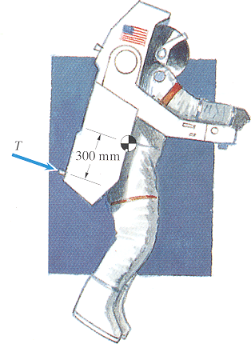
7.11 During an extravehicular activity, an astronaut fires a thruster of his maneuvering unit, exerting a force T=14.2 N for 1 second. It requires 60 s from the time the thruster is fired for him to rotate through one revolution. If you model the astronaut and maneuvering unit as a rigid body, what is the moment of inertia about their center of mass?
(taken from Dynamics, 2nd Edition by Bedford & Fowler)

