Example Problem - Le 21

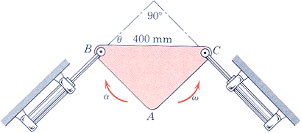
5.136 At the instant shown, θ=45 deg and the plate ABC has a counterclockwise angular velocity of 20 rad/s and a clockwise angular acceleration of 100 rad/s².
Determine:
a) the magnitude of the velocity of the piston attached to C,
b) the magnitude of the acceleration of the piston attached to C
(taken from Dynamics, 3rd Edition by Merriam & Kraige)

