Example Problem - Le 14

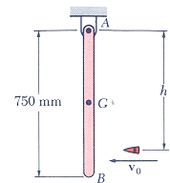
17.95 A 30-g bullet is fired with a horizontal velocity of 400 m/s into a 4-kg wooden beam AB suspended from a pin support at A. Knowing that h=600 mm and that the beam is initially at rest, determine:
a) the velocity of the mass center G of the beam immediately after the bullet becomes embedded.
b) the impulsive reaction at A, assuming that the bullet becomes embedded in 1 ms
(taken from Vector Mechanics for Engineers, 5th Edition by Beer & Johnston)

