Example Problem - Le 13

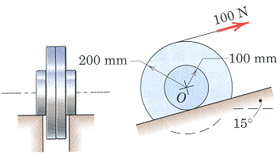
Ex. The wheel rolls up the incline on its hubs without slipping and is pulled by the 100-N force applied to the cord wrapped around its outer rim. If the wheel start from rest, compute its angular velocity after its center has moved a distance of 3-m up the incline. The wheel has a mass of 40-kg with a center of mass at O and has a centroidal radius of gyration of 150-mm.
(taken from Engineering Mechanics, 4th Edition by Meriam & Kraige)

P
2
unk eqs
ω₂ 1
E_{K2} 2
E_{G2} 3
E_{K1} 4
E_{G1} 5
W 6
v_{G,2} 7
I_{G} 8
s 9
z 10
r_{G/IC} 11

P
1

datum

${\text{15}}^{∘}$

Known:
$m=\text{40} \text{kg} P=\text{100} N k_{G}=0\text{.}\text{15} m$

Kinetics:
COE(FT) $\begin{aligned}{ΔE}_{\text{sys}}=W \\ \left(E_{K2}+E_{G2}\right)−\left(E_{K1}+E_{G1}\right)=W\end{aligned}$ (1)

$\begin{matrix}E_{K1}=0 & (2) & & E_{K2}=\frac{1}{2}{\text{mv}}_{G,2}^{2}+\frac{1}{2}I_{G}ω_{2}^{2} & (4) \\ E_{G1}=0 & (3) & & E_{G2}=\text{mgz} & (5)\end{matrix}$
$W=\text{Ps}≠P(3m)$ (6)
Kinematics:
$v_{G,2}=ω_{2}r_{G/{\text{IC}}}$ (7)
$r_{G/{\text{IC}}}=0\text{.}1 m$ (8)
$s=9 m$ (9)

Other:
$I_{G}={\text{mk}}_{G}^{2}=0\text{.}9 \text{kg}m^{2}$ (10)
$z=3\text{sin}({\text{15}}^{∘}) m$ (11)

Solving:
$ω_{2}=\text{30}\text{.}3 \text{rad}/s$

