Example Problem - Le 13
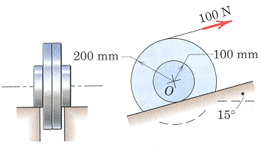
Ex. 6/9 The wheel rolls up the incline on its hubs without slipping and is pulled by the 100-N force applied to the cord wrapped around its outer rim. If the wheel start from rest, compute its angular velocity after its center has moved a distance of 3-m up the incline. The wheel has a mass of 40-kg with a center of mass at O and has a centroidal radius of gyration of 150-mm.
(taken from Engineering Mechanics, 4th Edition by Meriam & Kraige)

