Example Problem - Le 12

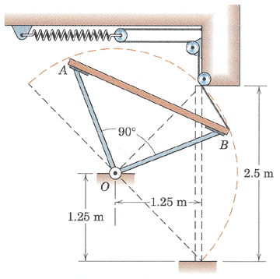
6.121 AB is the cross section of a garage door which is a rectangular 2.5m by 5m panel of uniform thickness with a mass of 200 kg. The door is supported by the struts of negligible mass and hinged at O. Two spring-and-cable assemblies, one on each side of the door, control the movement. When the door is in the horizontal open position, each spring is unextended. If the door is given a slight push from the open position and allowed to fall, determine the spring constant k for each spring which will limit the angular velocity of the door to 1.5 rad/s when edge B strikes the floor.
(taken from Engineering Mechanics, 4th Edition by Meriam & Kraige)

System: garage door, springs, and cable

Kinetics:
1
2
unk eqs

k 1
E_{K1} 2
E_{G1} 3
E_{S1} 4
E_{K2} 5
E_{G2} 6
E_{S2} 7
v_{G,2} 8
x 9
COE(FT)
${\text{mv}}_{G,1}$
datum
$I_{G}ω_{1}$
$I_{G}ω_{2}$

${\text{mv}}_{G,2}$

${ΔE}_{\text{sys}}=W=0$
$E_{K1}+E_{G1}+E_{S1}=E_{K2}+E_{G2}+E_{S2}$ (1)

$\begin{matrix}E_{K1}=0 & (2) & & E_{K2}=\frac{1}{2}{\text{mv}}_{G,2}^{2}+\frac{1}{2}I_{G}ω_{2}^{2} & (5) \\ E_{G1}=0 & (3) & & E_{G2}=−\text{mgh} & (6) \\ E_{S1}=0 & (4) & & E_{S2}=2\left(\frac{1}{2}{\text{kx}}^{2}\right) & (7)\end{matrix}$
Kinematics:
relate velocities $v_{G,2}=ω_{2}r_{G/O}$ (8)
dependant motion $2x+y=L ⇒ x=\frac{y}{2}$ (9)
Other:
$\begin{matrix}ω_{2}=1\text{.}5\text{rad}/s & r_{G/O}=1\text{.}\text{25}m & y=2\text{.}5m \\ m=\text{200}\text{kg} & h=1\text{.}\text{25}m & I_{G}=1/\text{12}{\text{mL}}^{2} {\text{kgm}}^{2}\end{matrix}$

Solving:
$k=\text{1270} N/m$

