Example Problem - Le 12

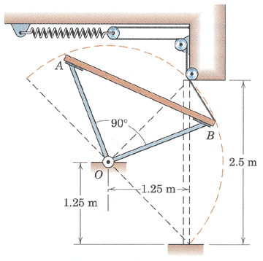
6.121 AB is the cross section of a garage door which is a rectangular 2.5m by 5m panel of uniform thickness with a mass of 200 kg. The door is supported by the struts of negligible mass and hinged at O. Two spring-and-cable assemblies, one on each side of the door, control the movement. When the door is in the horizontal open position, each spring is unextended. If the door is given a slight push from the open position and allowed to fall, determine the spring constant k for each spring which will limit the angular velocity of the door to 1.5 rad/s when edge B strikes the floor.
(taken from Engineering Mechanics, 4th Edition by Meriam & Kraige)

