Example Problem - Le 11

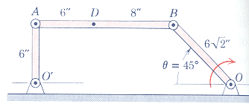
Ex. Arm OB of the linkage has a clockwise angular velocity of 10 rad/s in the position shown where θ=45º. Determine :
(a) the velocity of point A,
(b) the velocity of point D,
(c) the angular acceleration of link AB
(taken from Engineering Mechanics, 3rd Edition by Meriam & Kraige)

