Example Problem - Le 07

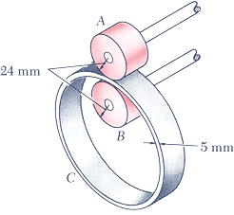
15.20 Ring C has an inside radius of 55 mm and an outside radius of 60 mm and is positioned between two wheels A and B, each of 24 mm outside radius. Knowing that wheel A rotates with a constant angular velocity of 300 rpm and that no slipping occurs, determine :
(a) the angular velocity of ring C and of wheel B,
(b) the acceleration of the points of A and B which are in contact with C.
(taken from Vector Mechanics for Engineers, 5th Edition by Beer & Johnston)

