Example Problem - Le 07
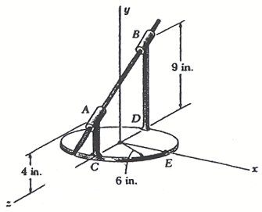
15.20 A circular plate of 6 in. radius is supported by two bearings A and B as shown. The plate rotates about the road joining A and B with a constant angular velocity of 26 rad/s. Knowing that, at the instant considered, the velocity of point C is directed in the positive x direction, determine :
(a) the velocity of point E,
(b) the acceleration of points E
(taken from an unknown source)

