Example Problem - Le 06

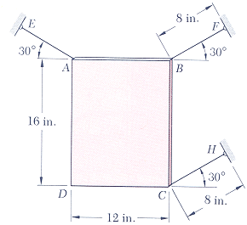
16.20 The thin plate ABCD weighs 16 lb and is held in position by the three inextensible wires AE, BF, and CH. Wire AE is then cut. Determine :
(a) the acceleration of the plate,
(b) the tension in wires BF and CH immediately after wire AE has been cut.
(taken from Vector Mechanics for Engineers, 5th Edition by Beer & Johnston)

