Example Problem - Le 06

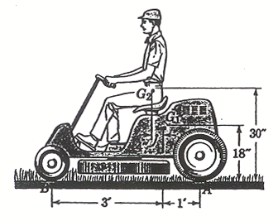
The riding mower has a weight of 280 lb with a center of mass at G₁. The operator weighs 180 lb with a center of mass at G₂. Calculate the minimum coefficient of static friction that will permit the front wheels of the mower to lift off of the ground as the mower starts to move forwards.
(taken from an unknown source)

