Example - Le 04
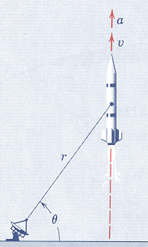
2.137 The rocket is fired vertically and tracked by the radar shown. When $θ={\text{60}}^{∘}$, other corresponding measurements give the values of $r=\text{30},\text{000} \text{ft}$, $\overset{¨}{r}=\text{70} \text{ft}/s^{2}$, and $\overset{˙}{θ}=0\text{.}\text{02} \text{rad}/s$. Calculate the velocity and acceleration of the rocket at this position.
Ans. $v=\text{1200} \text{ft}/s$
$a=\text{67}\text{.}0 \text{ft}/s^{2}$
(taken from Dynamics, 3rd Edition by Merriam & Kraige)

