Example Problem - Le 03

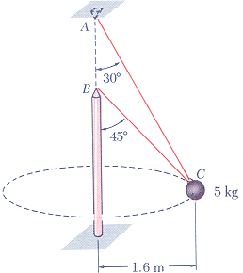
12.39 Two wires AC and BC are tied at C to a sphere which revolves at a constant speed v in the horizontal circle shown. Determine the range of the allowable values of v if the tension in either of the wires is not to exceed 40 N.
(taken from Vector Mechanics for Engineers, 5th Edition by Beer & Johnston)

