Name: CM Box: ___________

Circle your section:

Lui – 01 Lui – 02 Richards – 03 Richards – 04

Sanders – 05 Sanders – 06 Mech – 07

ES 202
Fluid & Thermal Systems

Examination II
January 23, 2006

Problem | Score
1 | / 20
2 | / 40
3 | / 40
Total | /100

Clearly show all work for credit.
Open table ONLY
One side of an 8.5” x 11” equation sheet is allowed.
Laptops allowed
No EES allowed

Density of water at standard conditions is assumed to be 1000 kg/m³ in this exam.

Problem 1 (20 points)
- (4 points) The same liquid fills both containers. If the base area A₁ is larger than the base area A₂ , compare the pressure at the base of the two containers.

- P₁ > P₂

- P₁ = P₂
h

- P₁ < P₂

- insufficient information to determine
(1)
(2)
base area A₁
base area A₂

- (6 points) A hydraulic device is used to raise a heavy object B on a large platform by putting a light object A (50 kg) on a small platform. The device is filled with a fluid with specific gravity of 1.1. Assume the weight of the two platforms to be negligible. Determine the mass of object B.

A
0.2 m
0.5 m
cross-sectional area = 2 m²
cross-sectional area = 0.1 m²
S.G. = 1.1
B

- (10 points) On dry land, a diver in his wetsuit and tank has a combined mass of 100 kg and average density is 900 kg/m³. He would like to be neutrally buoyant at a depth of 1.5 m in a swimming pool (ρ_{pool water} = 1000 kg/m³). 0.1 kg weights (ρ_{wt} = 4000 kg/m³) may be added to achieve this condition. How many weights should the diver add to his belt?
1
1.5 m
not drawn to scale
ρ_{pool water} = 1000 kg/m³
ρ_{diver} = 900 kg/m³
Problem 2 (40 points)
Compressed air at 620 kPa and 500 K enters a heat exchanger with a steady volumetric flow rate of 2.5 m³/sec. Thermal energy is added by heat transfer to the air stream. The hot compressed air is then fed into the turbine at 1500 K and the same pressure of 620 kPa. It exits the turbine at atmospheric conditions of 100 kPa. If the isentropic efficiency of the turbine is 78%, determine the following quantities:
- heat transfer rate in the heat exchanger;
- mechanical power output by the turbine;
- entropy generation rate in the turbine.

You may assume air to be an ideal gas under these operating conditions. DO NOT INTERPOLATE. USE THE CLOSEST VALUE IN THE TABLE.

P₃ = 100 kPa
heat exchanger
turbine
V = 2.5 m³/sec T₁ = 500 K
P₁ = 620 kPa
.
T₂ = 1500 K
P₂ = 620 kPa
η_{turb} = 78%

Problem 3 (40 points)
A tank containing liquid waste has an underground gate that opens to a sump as shown in the figure. The tank is vented to the atmosphere as is the sump. The gate is circular and makes an angle of 30º with the vertical as shown in the figure. It is supported through a diameter of the circle on a pivot rod at point B. You may neglect the weight of the gate in your analysis.
(a) What is the net force exerted on the circular gate due to the waste liquid and the air? Express your answer in terms of the horizontal component B_{x} and the vertical component B_{y}.
(b) What restraining moment M_{B} will be necessary to keep the gate closed?
(c) It has been proposed to seal the tank and pressurize the space above the waste liquid so that the pressure above the liquid would be P = 10 kPa (gage). How would this change the magnitude of B_{x}, the horizontal component of the pressure force? How much would it change?
3 m
1 m
30º
Profile of circular gate
Waste liquid
ρ = 1200 kg/m³
Pivot rod
B
P_{atm} = 100 kPa
Sump
x
y

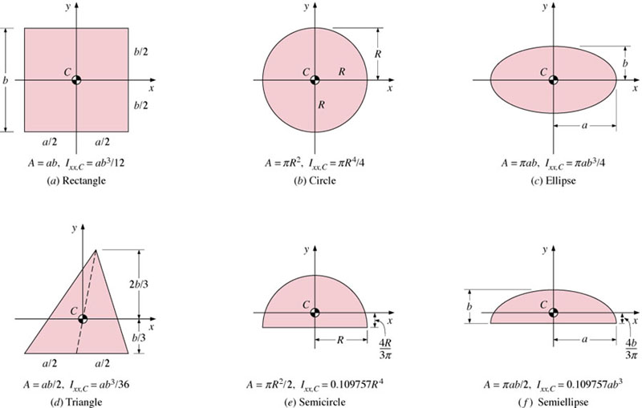

Cengel & Turner, Fig 11-6 – will be provided on the exam

