Name CM Box ___________

Circle one:

Lui – 01 Lui – 02 Sanders – 03 Sanders – 04

Mayhew – 05 Mayhew – 06 Richards – 07 Richards – 08

ES202
Examination II
February 10, 2004

Problem | Score
1 | /24
2 | /24
3 | /22
4 | /15
5 | /15
Total | /100

Show all work for credit
Open book, closed notes
One side for equations/notes
Laptops allowed

Problem 1 (24 points)
Gate AB is 2 meters wide into the paper and pivots about point A. The gate will open to let fresh water out when the ocean tide is dropping. At what level h will the gate first open? Develop an equation with h as the only unknown. DO NOT SOLVE THE EQUATION.
Sea Water
sg = 1.025
Fresh water

1 m

9 m

h

A

B

stop

Problem 2 (24 points)
The following piping system is made of 700 ft of commercial steel pipe with an 18-inch inside diameter. It has a sharp edged entrance. The two smooth 90º elbows are flanged. The power output of the ideal turbine is 700 horsepower.
Determine the required value of H to achieve the design flow rate of 4,200 cubic feet per minute.

10 ft
Turbine
H
water

Water properties @ 60 °F

water

Problem 3 (22 points)

(a) (10 Points) A cube of solid material that weighs 445 N is lowered into a tank containing a layer of water over a layer of mercury. The cube is 300 mm on a side. The layer of water is 500 mm deep, and the mercury beneath it is also 500 mm deep. Determine the depth of the bottom of the block when it has reached equilibrium.

Cube: 300 mm × 300 mm × 300 mm
Mercury
Water
500 mm
500 mm

Problem 3 (continued)
(b) (12 Points) Calculate the difference in pressure between the centers of tank A and tank B.

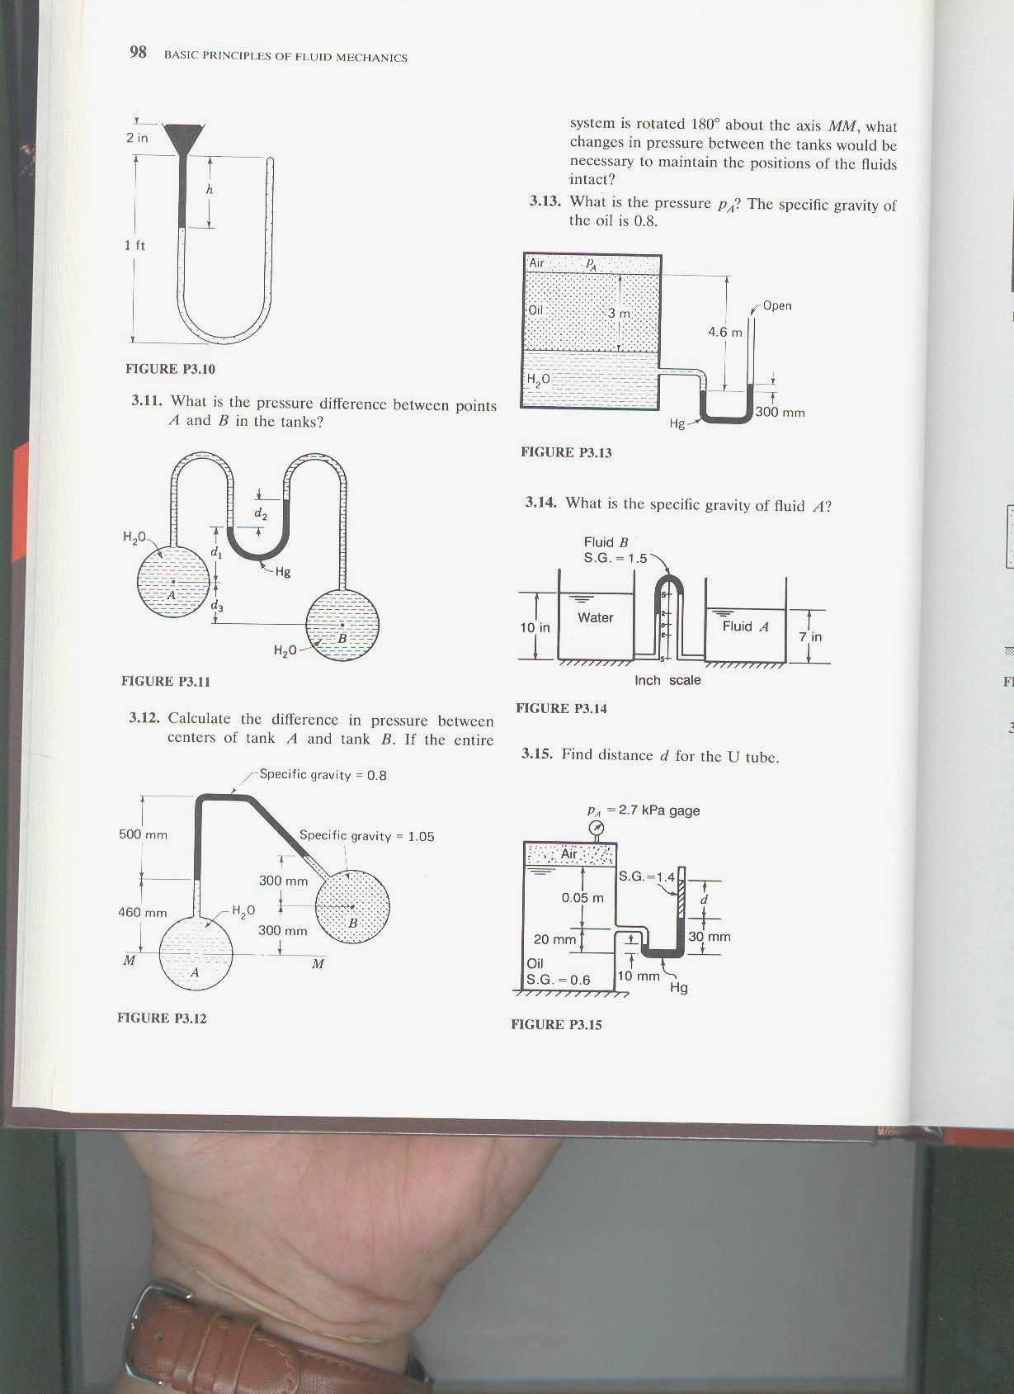
Problem 4 (15 points )
Fill in the blanks in the table below. Show your work.
Assume:
4
∇
Open to atmosphere
z
1
2
3


Water tank
- The flow has no losses.
- The water is incompressible.
- The pipe has a uniform diameter.
- The pipe diameter is much smaller than the diameter of the tank.

Station | P  ( kPa gage) | V  (m/s) | Z  (m)
1 | 0 gage | 0 | 3 m
2 | 0 gage |  | 0.5 m
3 |  |  | 3 m
4 |  |  | 6 m

Problem 5 (15 points)

Assume there is no loss in every part of this problem.

- (3 points) Consider a steady flow through an expansion in the following figure, circle the correct answer:
h₁
h₂
flow
    - h₁ < h₂

    - h₁ = h₂

    - h₁ > h₂

- (3 points) Consider a steady flow through an expansion as Part (a) but with a slightly different measuring device, circle the correct answer:
h₁
h₂
flow
    - h₁ < h₂

    - h₁ = h₂

    - h₁ > h₂

Problem 5 (continued)

- (3 points) Consider the pressure measured at Point 1 located on the exit plane of a circular pipe which is connected to a large reservoir. If the fluid in the pipe and the reservoir is stationary, circle the correct answer:
H
1
ρ
open to atmosphere

    - P₁ < P_{atm}+ ρ g H

    - P₁ = P_{atm}+ ρ g H

    - P₁ > P_{atm}+ ρ g H

- (3 points) Consider the pressure measured at the same Point 1 again. If the fluid flows from the reservoir into the pipe, circle the correct answer:
H
1
ρ
open to atmosphere

flow

    - P₁ < P_{atm}+ ρ g H

    - P₁ = P_{atm}+ ρ g H

    - P₁ > P_{atm}+ ρ g H

- (3 points) Consider the pressure measured at same Point 1 again. If the fluid flows from the pipe into the reservoir, circle the correct answer:
H
1
ρ
open to atmosphere

flow

    - P₁ < P_{atm}+ ρ g H

    - P₁ = P_{atm}+ ρ g H

    - P₁ > P_{atm}+ ρ g H

