Team:_____________________________________

- These are the holes we intended (all initial here):__________________________________
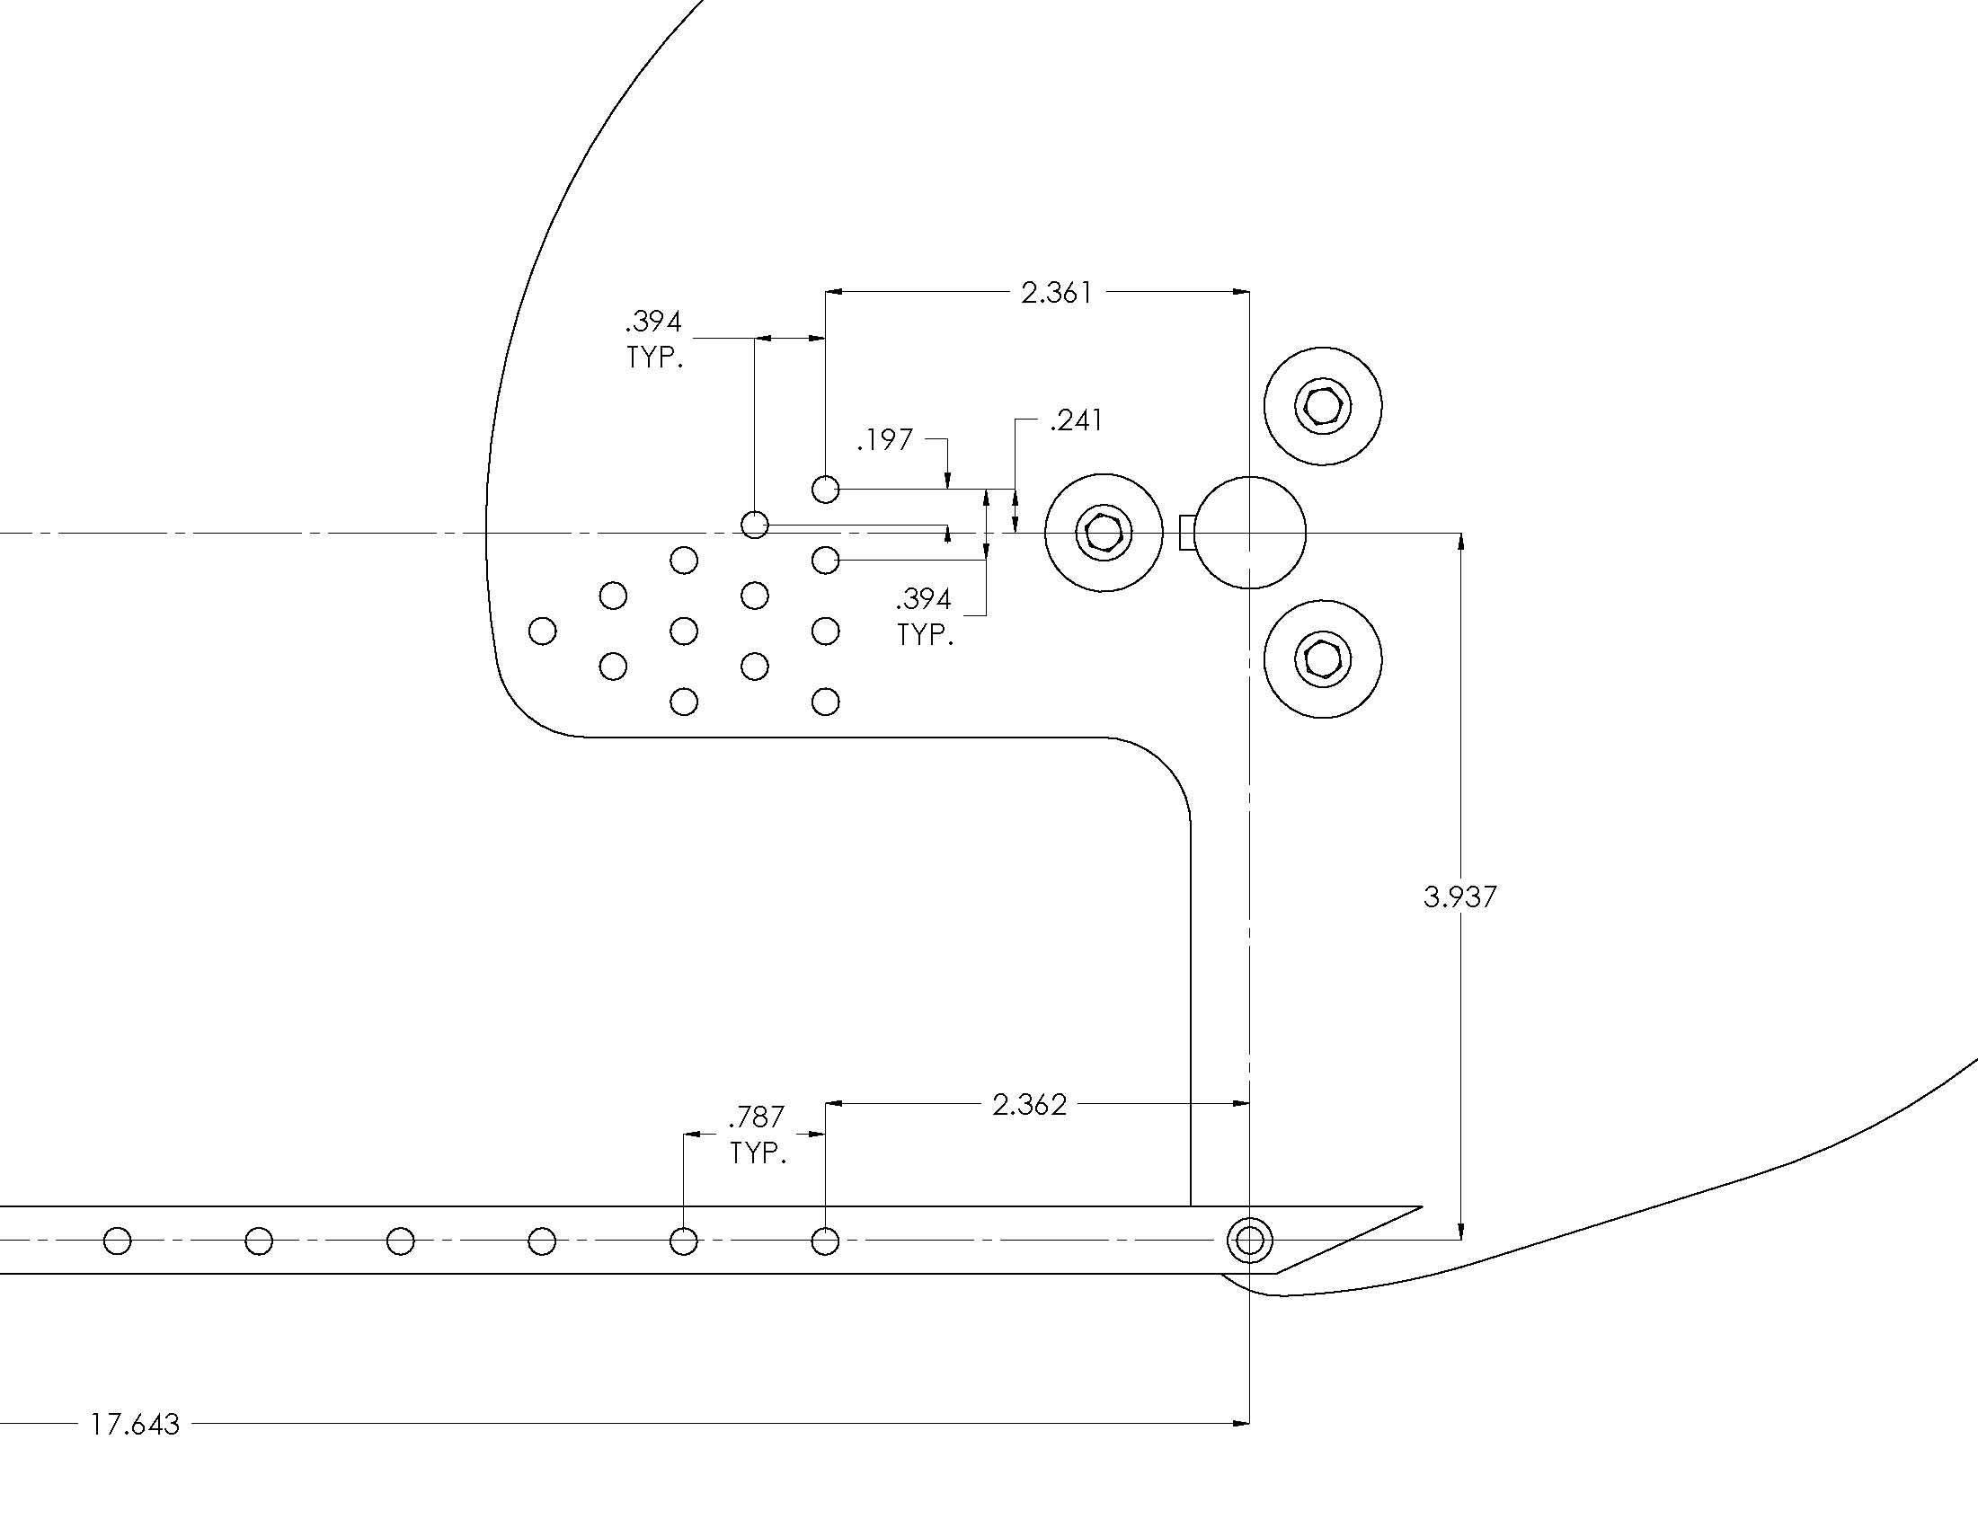

- Choose one:
___ At least two of us will attend with our regularly scheduled section
___We need to test our link during ____ th hour

- We have inspected our part and agree that it was manufactured as specified, and has no obvious manufacturing flaws (all initial here):________________________________

