EM121, Statics and Mechanics of Materials I
Project Spring 2011

Objective:
Your team is to design a link which will secure a rotating blade while minimizing the weight of the link. Assume that a novel helicopter rotor blade has been developed which requires the blade to be offset from a radial line that passes through the center of rotation of the rotor. The concept for holding the blade in place has been developed and is shown in Figure 1.
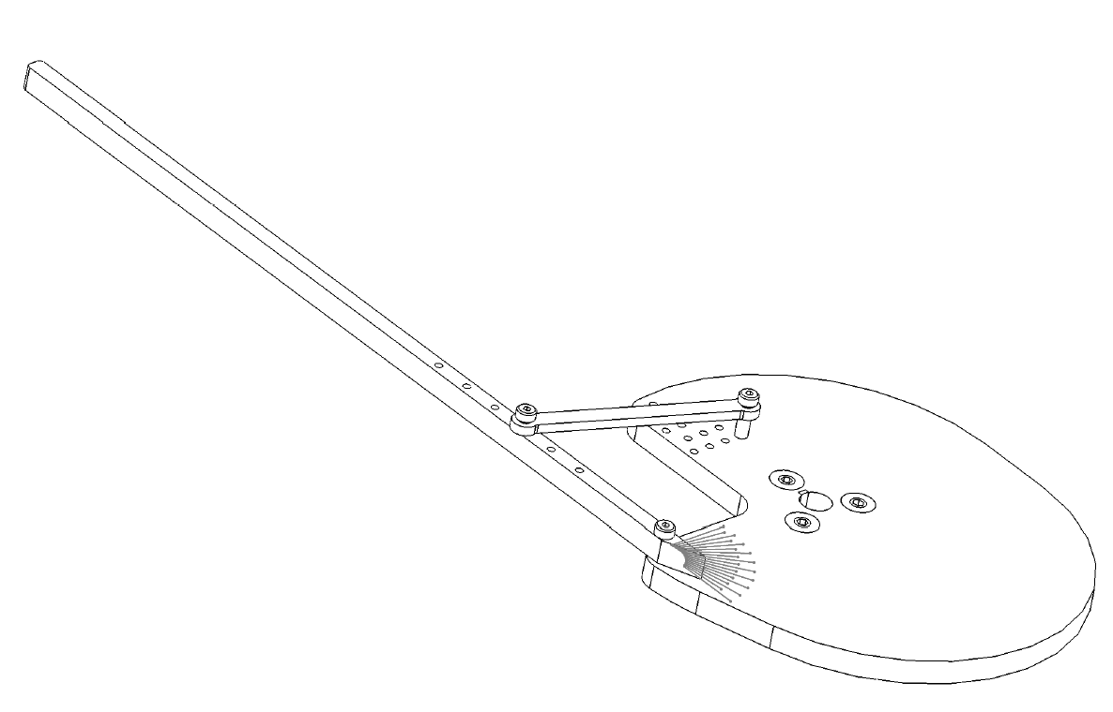
helicopter
blade
your
link
rotation
(clockwise)
base
plate

Figure 1
Isometric View of Rotor and Blade Assembly

Your link must hold the blade in place without excessive deflection up to a rotational speed of 1300 rpm. To determine if there is excessive deflection or failure of the link, a small paper doll will be placed just outside the circle traced by the spinning blade. If the doll is not damaged after the blade reaches 1300 rpm the deflection of the link will be judged acceptable. The blade must be held at the angle shown in Figure 2 (within ± 5º when the link is first assembled).

Fabrication:
The material that you will use to create the link is Nylon 6/6 sheet (a rigid plastic). We supply the material, and the thicknesses available to you are 0.062 inches, 0.094 inches, and 0.124 inches. The manufacturer’s material property data sheet has been posted on the “Projects” page of the course website, along with tensile test results for specimens fabricated from Nylon sheets purchased for these projects.

Rotor Description:
A portion of a dimensioned drawing of the rotor assembly is shown in Figure 2, and the blade details are shown in Figure 3. One end of your link will be joined to the blade at one of the holes that are spaced 0.79 inches apart. You are free to select which of these holes you use. The other end of your link will be joined to the rotor at the holes that have the 0.39 inch spacing as shown on Fig. 2. You are free to select which of these holes you use. The shoulder diameter of the shoulder bolts that will hold the link is 0.250 inches. The prototype mechanism is in the Rotz Lab. You are encouraged to visit the Rotz Lab to view the mechanism, however, don’t turn the rotor mechanism on.

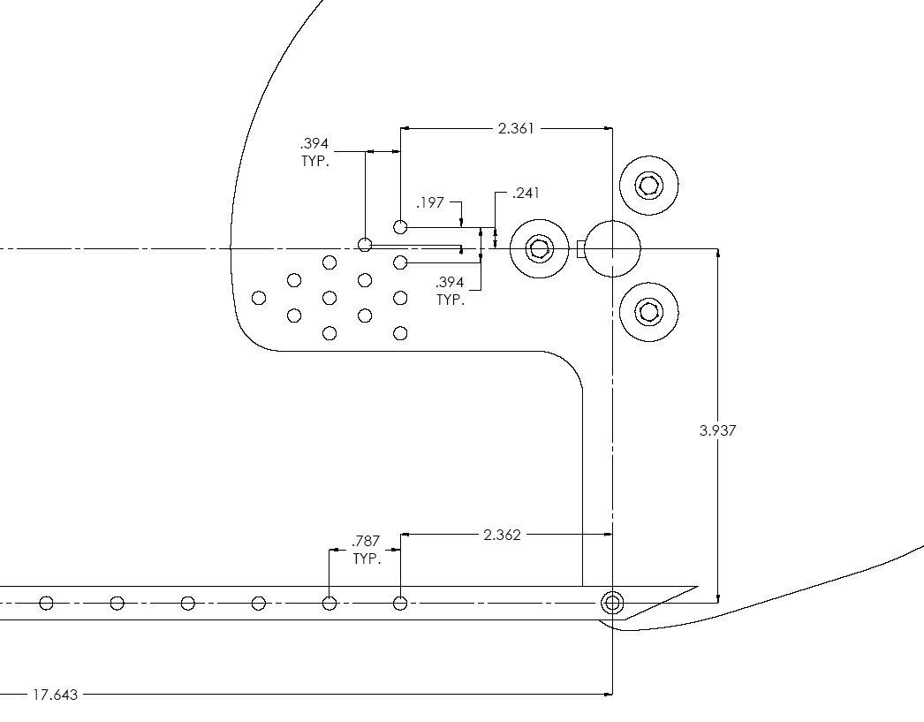

Figure 2
Dimensioned Drawing of Rotor Assembly
(all dimensions in inches)

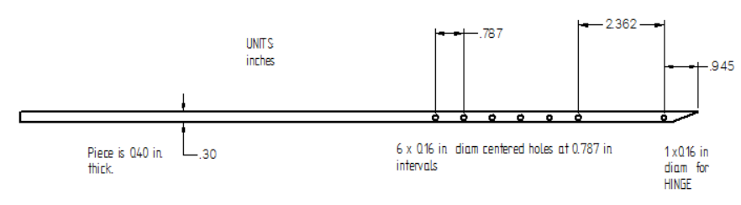
Figure 3
Blade Details
(Blade is Aluminum)

Deliverables
- Doll (due Friday, May 6 by the end of class).
  - The doll should be a rolled piece of plain white copier paper with a diameter of 1.5 inches and a height of 2.5 inches.
  - Feel free to decorate your doll. Do not fill the doll with red paint or anything similar, as amusing as that might initially seem.
  - Your doll must have your team name written on it.
- A CAD file of your link design (due Sunday, May 8 by 11:30 PM).
  - Send this as an email attachment to your instructor.
  - The CAD file must be in the dxf format that defines the outline of your link in a way that is appropriate for our laser cutting machine (see instructions on the “Projects” webpage).
  - The name of the file must be given as Sec#_teamname_thickness.dxf (for example: “Sec3_ATeam_062.dxf”)
- Present design to class for Design Review (Friday, May 13 during class).
  - More details on the requirements for the Design Review will be posted on the “Projects” webpage.
- Written report (due to your instructor Friday, May 20 by 5:00 PM).
  - More details on the requirements for the report will be posted on the “Projects” webpage.

Testing (Contest):
Date: Wednesday May 18
Location: Meyers M137 Lecture Hall
Times: by section
Section 3 (Olson): 1st hour
Section 4 (Olson): 2nd hour
Section 5 (Adams): 3rd hour
Section 6 (Adams): 4th hour
Section 1(Toohey): 5th hour
Section 2 (Toohey): 6th hour
Section 7 (Fine): 7th hour
Section 8 (Fine): 8th hour
If your team cannot have at least two team members present during the assigned section time, we can move your group to compete with a different section. However, this must be arranged in advance-- not later than Monday May 16.
Grading:

Design Review: 25%

Report (Documentation): 50%

Performance 25%
Does it Function?
(The link holds the blade at the correct and at 1300 rpm your doll is uninjured)
- No: your performance score is 55.
- Yes: your performance is based on the weight of your link (light is good)
      - Top in section: 100
      - Top third in section: 95
      - Middle third in section : 85
      - Bottom third in section: 75

Frequently Asked Questions: These will be posted on the “Labs” page of the course website as they are accumulated.

Additional Design Information:
We can reasonably expect there to be at least two kinds of external forces acting on the blade, which will have to be carried by the link and the pivot. The first kind of force would simply be due to the angular acceleration of the aluminum blade. The second kind of force would be due to air drag on the blade.

To calculate the forces due to the fact that the blade is spinning at a constant angular velocity, you would find the centroid (!) of the part of the blade past the pivot point, and then the resulting forces would act there, pointing radially outward from the center of rotation. You should be able to figure out the forces by using material you learned in physics.

For the forces due to air drag, we will need some new information. The air drag on any small slice of the blade at these speeds is proportional to the square of the air velocity on that small slice.
$$\text{dF}={\text{kV}}^{2} \text{dx}$$
Hence, the distributed force on the blade goes like the square of the distance from the center of rotation, much like the distributed loads on beams that we covered just before break. The constant of proportionality is
$$k=\frac{1}{2}ρ h C_{D}$$
where
ρ | = | Air density
h | = | Height of the blade, 0.4”. (This is the cross-sectional area of bar per unit length.)
C_{D} | = | Coefficient of drag, typically 1.0 for bluff bodies such as our blade.

