Exam 3
Spring 2009-2010
Name: _____________________________ CM: ______

Problem 1 (20 pts) ________

Problem 2 (18 pts) ________

Problem 3 (32 pts) ________

Problem 4 (30 pts) ________

Total ________

Be sure to show all work to receive full credit. However, “given” and “find” are not necessary.

Problem 1 – Short Answer -- 20 points

(a) Consider the Free Body Diagram shown below:

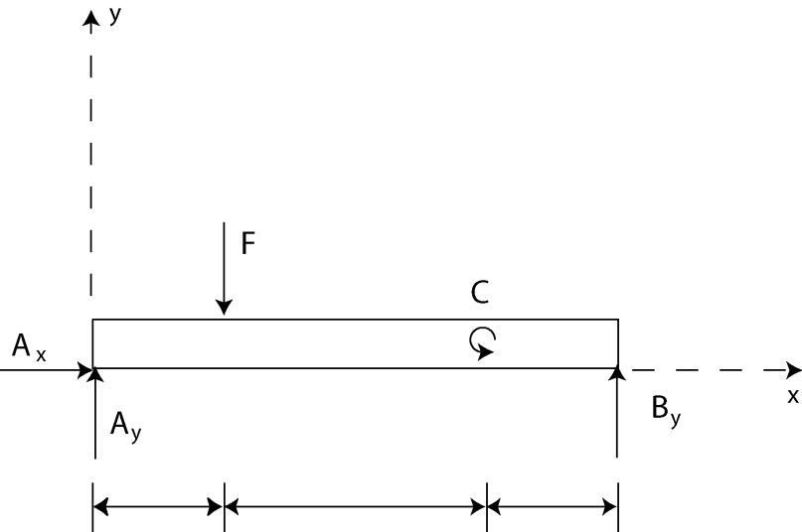
$$l_{3}$$
$$l_{1}$$
$$l_{2}$$

Here
$$F$$ | = | 200 lb
$$C$$ | = | 1000 ft-lb
$$l_{1}$$ | = | 1 ft
$$l_{2}$$ | = | 2 ft
$$l_{3}$$ | = | 1 ft

The sum of the moments about point A for this FBD should be written as:
(i) $−Fl_{1}+B_{y}\left(l_{1}+l_{2}+l_{3}\right)=0$
(ii) $−Fl_{1}+C\left(l_{1}+l_{2}\right)+B_{y}\left(l_{1}+l_{2}+l_{3}\right)=0$
(iii)$−Fl_{1}+C+B_{y}\left(l_{1}+l_{2}+l_{3}\right)=0$
(iv)$−Fl_{1}−C+B_{y}\left(l_{1}+l_{2}+l_{3}\right)=0$
(v) None of these. The correct answer is_______________________________________

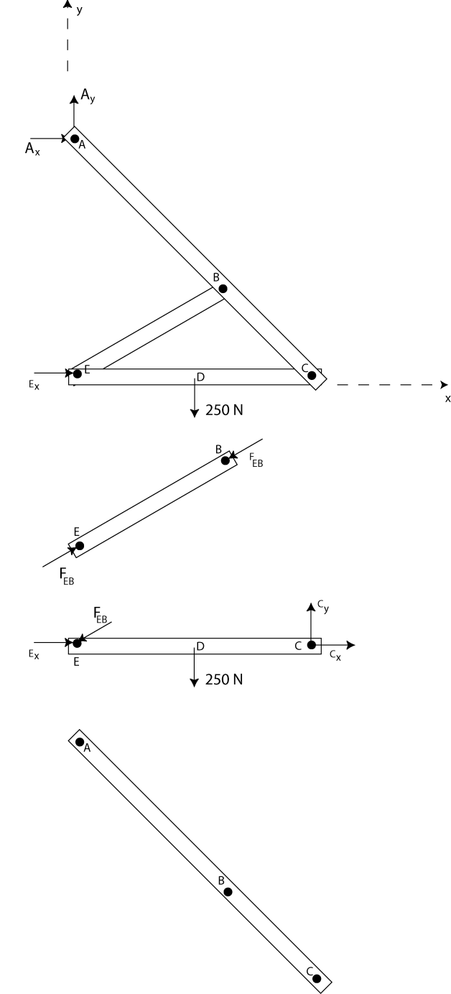
(b) The frame ABCDE has the free body diagram shown below. In addition, we have drawn free body diagrams of members EB and EDC. Add the appropriate forces and labels to the free body diagram of member ABC. Make sure that the forces and labels are consistent with the existing free body diagrams.
(c) A slender rod of length L and weight W is held in equilibrium as shown below, with one end against a frictionless wall and the other end attached to a cord. Circle the free body diagram for AB which is most appropriate for this problem. (If none of the pre-drawn FBDs is appropriate, add your own forces to the rod.)
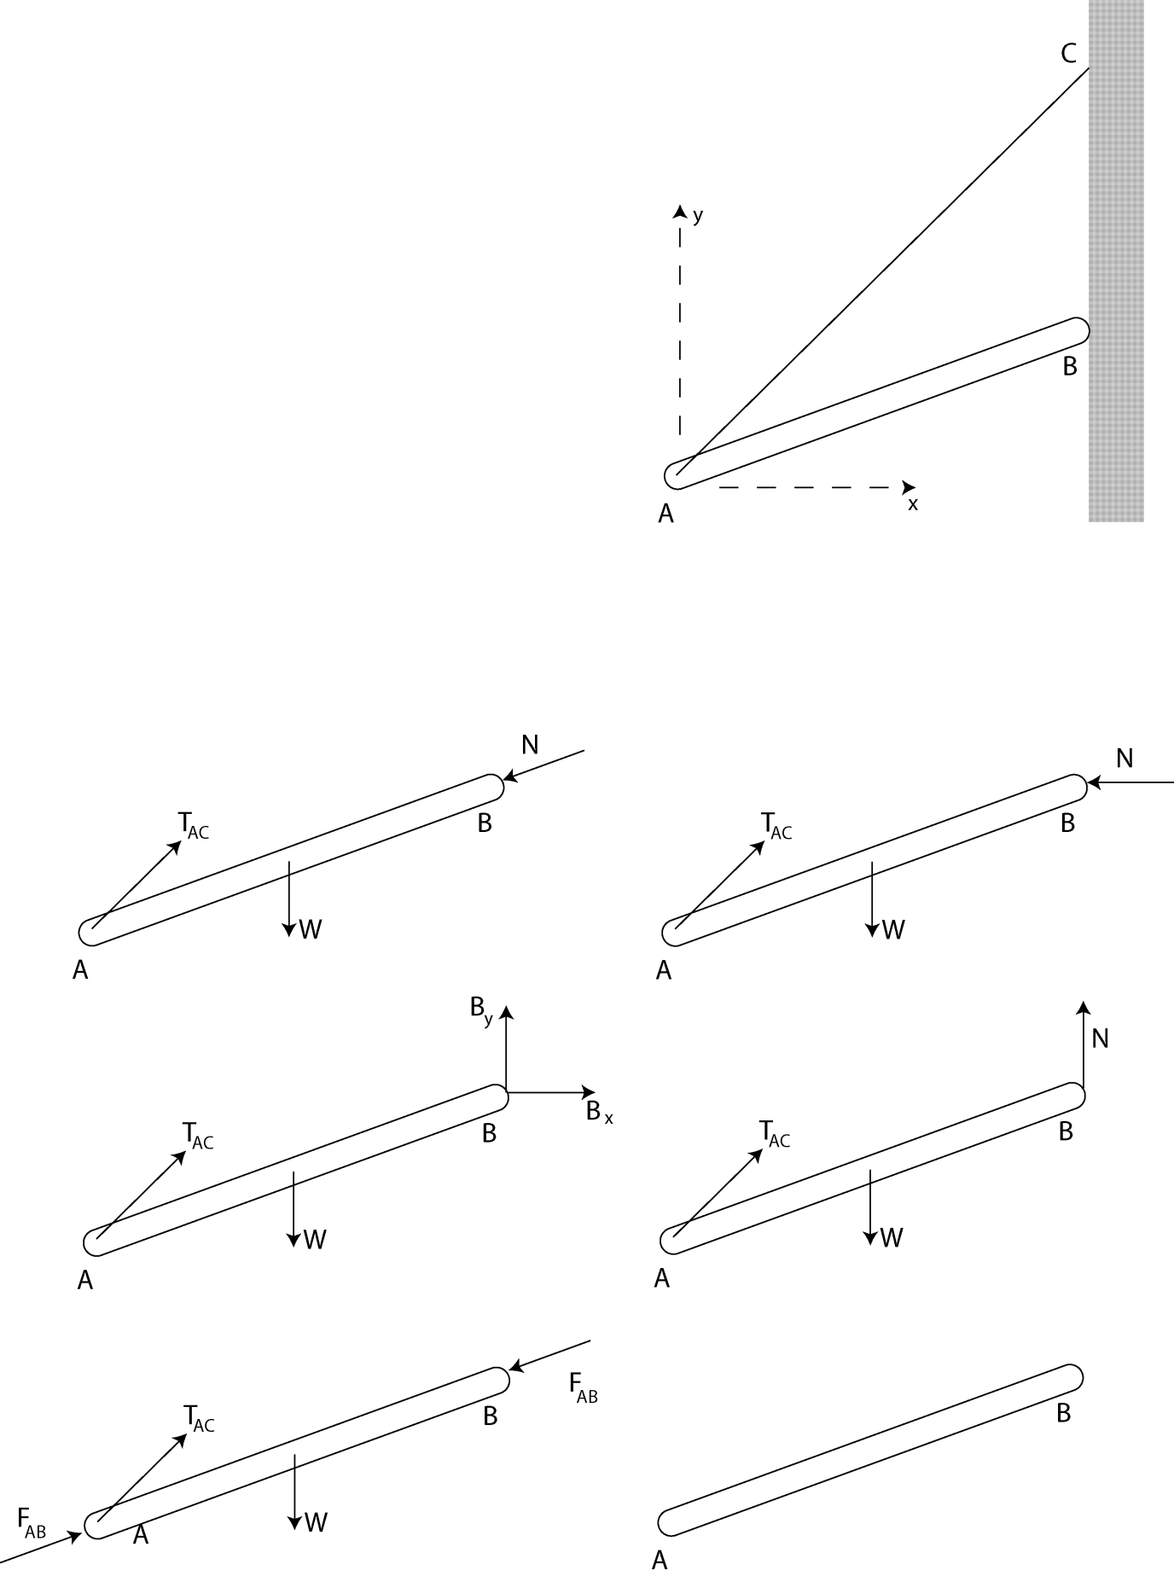

Problem 2 – Short Answer -- 18 points
Two crates having weights W_{A} and W_{B} are stacked on a conveyor belt as shown in the figure. Crate A is connected to a wall via a cable. The coefficients of static and kinetic friction between any two surfaces are μ_{s} and μ_{k}, respectively. The centers of gravity of the crates are at their geometric centers.
A
L
H
H
B
H/2
For parts a) and b) assume the two crates stick together and the conveyor belt continuously slips underneath crate B.

- What is the friction force exerted by the conveyor belt on block B?
  - μ_{k}W_{B} to the right
  - μ_{k}W_{B} to the left
  - μ_{k}(W_{A} + W_{B}) to the right
  - μ_{k}(W_{A} + W_{B}) to the left
  - (L/H)W_{A} to the right
  - (L/H)W_{A} to the left

- What is the friction force exerted by block B on block A?
  - μ_{s}W_{A} to the right
  - μ_{s}W_{A} to the left
  - μ_{k}(W_{A} + W_{B}) to the right
  - μ_{k}(W_{A} + W_{B}) to the left
  - (L/H)W_{A} to the right
  - (L/H)W_{A} to the left

For part c) assume that crate B sticks to the belt and crate A tips over.

- What is the friction force exerted by block B on block A?
  - μ_{s}W_{A} to the right
  - μ_{s}W_{A} to the left
  - μ_{k}(W_{A}) to the right
  - μ_{k}(W_{A}) to the left
  - (L/H)W_{A} to the right
  - (L/H)W_{A} to the left
Problem 3 – 32 points
The smoke stack located on the North side of Moench Hall is supported in part by a cable. The cable is attached to the stack at point A and to the roof of Moench at point D, with coordinates (0, -100, 60) ft. During a storm, a 40-mph-wind blowing from the southwest exerts a force, $\overset{⃑}{F}$ = (150 î - 400 ĵ) lb, on the stack at point C (80 ft above the ground). Answer the questions below. (Neglect the weight of the smokestack.)
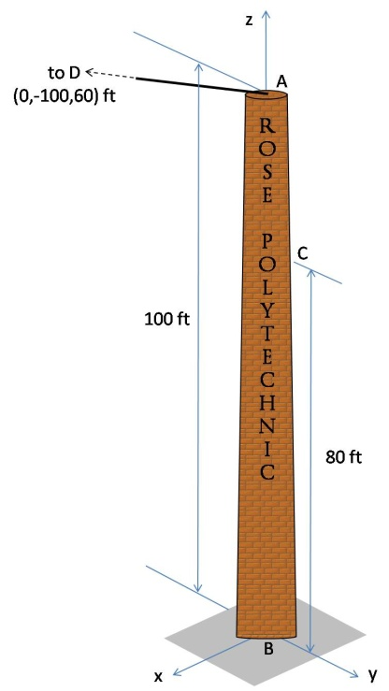
(a) Draw the free body diagram of the smoke stack during the storm.

The correct equation of equilibrium for the forces acting on the smoke stack is
$\sum{F}={\overset{⃑}{T}}_{AD}+\overset{⃑}{B}+\overset{⃑}{F}=0$.

(b) ${\overset{⃑}{T}}_{AD}$ should be written as
- $${\overset{⃑}{T}}_{AD}=T_{AD}\left(0\hat{i}−0.8575\hat{j}+0.5145\hat{k}\right)$$
- $${\overset{⃑}{T}}_{AD}=T_{AD}\left(0\hat{i}+0.9285\hat{j}+0.3714\hat{k}\right)$$
- $${\overset{⃑}{T}}_{AD}=T_{AD}\left(0\hat{i}−0.7071\hat{j}+0.7071\hat{k}\right)$$
- $${\overset{⃑}{T}}_{AD}=T_{AD}\left(0\hat{i}−0.9285\hat{j}−0.3714\hat{k}\right)$$
- $${\overset{⃑}{T}}_{AD}=T_{AD}\left(0\hat{i}−100\hat{j}+60\hat{k}\right)$$
- None of these (explain) _______________________________
(c) $\overset{⃑}{F}$ should be written as
- $\overset{⃑}{F}=427$ lb
- $\overset{⃑}{F}=150\hat{i}$ lb
- $\overset{⃑}{F}=150\hat{i}−400\hat{j}$ lb
- $\overset{⃑}{F}=−400\hat{j}$ lb
- None of these (explain) _______________________________

The correct equation of equilibrium for the moments acting about point B at the base of the smoke stack is: $\sum{{\vec{M}}_{B}}={\overset{⃑}{r}}_{BA}x{\overset{⃑}{T}}_{AD}+{\overset{⃑}{r}}_{BB}x\overset{⃑}{B}+{\overset{⃑}{r}}_{BC}x\overset{⃑}{F}+{\overset{⃑}{M}}_{B}=0$
(d) ${\overset{⃑}{r}}_{BA}$ should be written as
- $${\overset{⃑}{r}}_{BA}=0\hat{i}−100\hat{j}+100\hat{k}$$
- $${\overset{⃑}{r}}_{BA}=0\hat{i}+0\hat{j}+100\hat{k}$$
- $${\overset{⃑}{r}}_{BA}=0\hat{i}+0\hat{j}+80\hat{k}$$
- $${\overset{⃑}{r}}_{BA}=0\hat{i}−100\hat{j}−40\hat{k}$$
- None of these (explain)________________________________
(e) ${\overset{⃑}{r}}_{BB}$ should be written as
- $${\overset{⃑}{r}}_{BB}=0\hat{i}+0\hat{j}+0\hat{k}$$
- $${\overset{⃑}{r}}_{BB}=0\hat{i}−100\hat{j}−40\hat{k}$$
- $${\overset{⃑}{r}}_{BB}=0\hat{i}+0\hat{j}+80\hat{k}$$
- $${\overset{⃑}{r}}_{BB}=0\hat{i}−100\hat{j}+100\hat{k}$$
- None of these (explain)________________________________
(f) ${\overset{⃑}{r}}_{BC}$ should be written as
- $${\overset{⃑}{r}}_{BC}=0\hat{i}+0\hat{j}−80\hat{k}$$
- $${\overset{⃑}{r}}_{BC}=0\hat{i}+0\hat{j}−20\hat{k}$$
- $${\overset{⃑}{r}}_{BC}=0\hat{i}+0\hat{j}+80\hat{k}$$
- $${\overset{⃑}{r}}_{BC}=0\hat{i}−100\hat{j}+100\hat{k}$$
- None of these (explain)________________________________

Problem 4 – 30 points
Set up the following problem completely, but do not solve. Clearly number your equations and list your unknowns. The equations should be sufficient to determine all forces acting on member ABCD of the frame depicted below. The connections at A, B, C, E, and F are frictionless pins. Ignore masses of the members.

A
B
C
D
P = 100 lb
E
F
L1=3in
L2=5in
L3=8in
L4=4in
L5=7in
7in

