EM 121 Statics and Mechanics of Materials I – Diagnostic Quiz

Name_______________________________________ Section_________

This quiz is supposed to help us find out where you are with respect to your peers and what you may wish to review that will help you in Statics. This will be checked, but no grade will be assigned.

For each question, circle a letter indicating whether you are
a) certain of your answer
b) fairly confident
c) feeling plus/minus
d) pretty uncertain
e) guessing

1. For the triangle shown

α
b
c
β
90=γ
a

- Write c in terms of a and b. (a,b,c,d,e)

- Write the cosine of angle α in terms of a, b, and c. (a,b,c,d,e)

- Write the tangent of angle β in terms of a, b, and c. (a,b,c,d,e)

- What is the sum of α+β+γ equal to (in degrees)? (a,b,c,d,e)

- Wind is blowing at 20 mph in the direction shown.
20 mph
y
30o
x

  - What component of the wind is blowing in the x-direction only? (a,b,c,d,e)

  - What component of the wind is blowing in the y-direction only? (a,b,c,d,e)

3. Use the following equations to find the numeric values for x, y, and z. (a,b,c,d,e)

9 = 2x + 3y - z
-1 = x - y
15 = 6x + y

4. Vector A=1i+2j+3k and vector B=3i+2j-1k

- The dot product of the two vectors, A·B= (a,b,c,d,e)

- The cross product of the two vectors, A×B= (a,b,c,d,e)

5. Vector A has magnitude of 5 and is in a direction normal to the surface shown.

x
y
20o
A
α

- Find the component of vector A that is in the x-direction. (a,b,c,d,e)

- What is angle α (in degrees)? (a,b,c,d,e)

6. Which vector polygon correctly represents the vector addition A + B = C ?

(a,b,c,d,e)

A
C
B
C
A
B
A
B
C
A
B
C

- Solve for the following (n=constant):

$\int{r^{n}}\text{dr}=$ (a,b,c,d,e)

$\int{4x^{{−1}/2}}\text{dx}=$ (a,b,c,d,e)

- For the line shown,
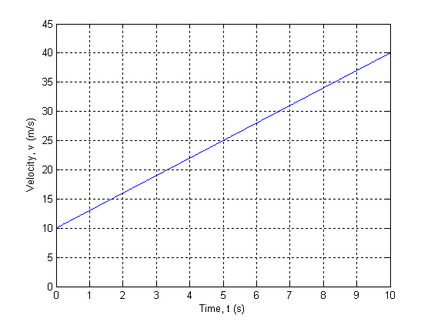
- Determine the area under the curve. (a,b,c,d,e)

- What does the area under the curve represent physically? (a,b,c,d,e)

- Write the equation of the line. (a,b,c,d,e)

